
Life Science
A curriculum and activity guide for Carlsbad Caverns National Park

Middle School Ecology
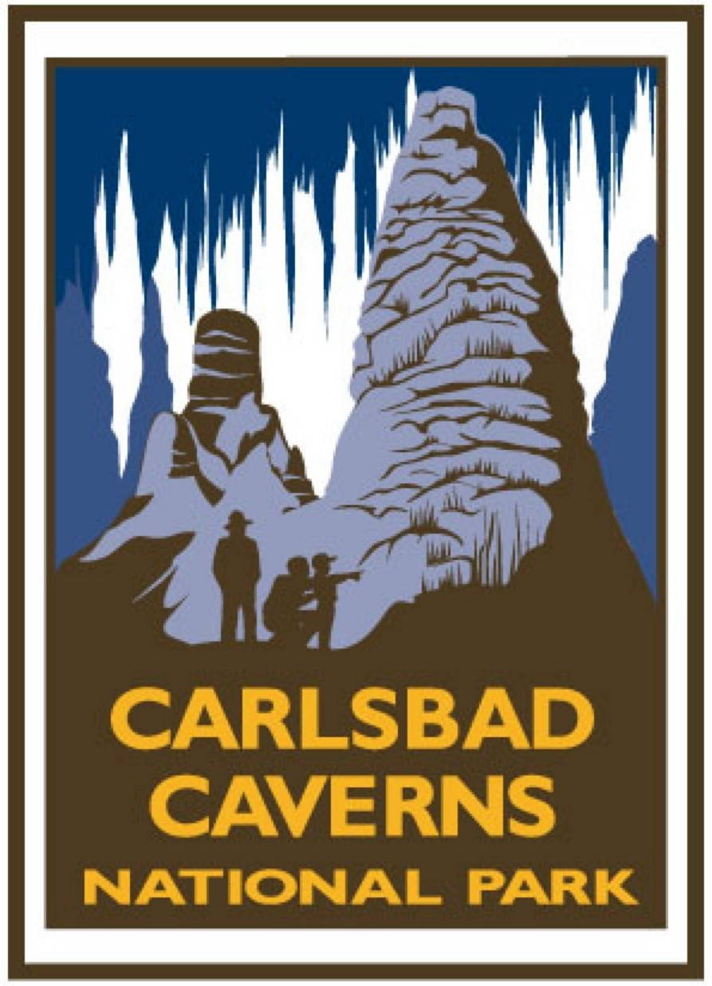
Life Science
Ecology Curriculum

- Introduction 1

Curriculum unit overview and activities

The Biosphere 2
- Ecosystems
- Oh, Deer! A game utilized to assist students in seeing
the plan of nature in order to understand the need to
protect Earth’s resources. 3
- Where Do I Belong? A lesson to introduce students to
ecosystems, habitats, and niches of living things. 6
- Parts to a Whole An activity to allow students to
distinguish between the characteristics that make up
an individual, a population, a community, and an ecosystem. 9
- Move Over, Please! A project that allows students to
see what happens when a plant population is too dense. 13
- Food Chain/ Food Web
- What’s Cookin’? Students will learn the basics of food
chains and food webs through various ways such as
whole class activities, journaling, oral discussions, and
small group activities. 15
- Biomes
- Biomes! An activity that introduces the characteristics
of six biomes (desert, tundra, ocean, grasslands, forest,
and rainforest). 22
- Desert Biome
- Why’s It So Hot? An activity to introduce students
to the various features of the desert. 26
- Scenic Sculpture An activity using salt dough to
reconstruct desert landforms. 31
- How Do They Survive? An experiment to show the
differences in temperature on the surface, below the
surface of the desert, an in microhabitats. How do
plants and animals survive? 36
- Great Deserts of the World An activity using the world
map to identify and locate the major deserts of the world,
even the often forgotten Chihuahuan desert!!!! 40

Soil 46
- Let’s Get Down and Dirty – Soil Science A hands-on activity
that introduces the basics of soil science and allows students
to observe and identify different types of soils. 47
- Succession and Soil Compaction Students will examine
the influence of soil compaction on plant and animal habitat
and on water infiltration. 52

Water 54
- All the Water in the World An activity to help students
visualize and understand the percentage of water that is
safe for drinking. 55
- How Much Water Do You Use? An activity to help students
identify how much water they use and find ways to conserve
this valuable resource. 59
- What’s In There? An activity that helps student
understanding of water pollution and its potential effects
on wildlife and human habitats. Students will practice
techniques used by water quality examiners in their area. 64
- Sediment as a Pollutant An activity that allows students
to understand how sediment gets into bodies of water and
its effects on life. 68
- Water Pollution An activity to demonstrate the effects of
detergents and fertilizers on aquatic life. 71

Fire 75
- Fire 101 A lesson/activity designed to introduce students
to the fire triangle. 76
- The Tree Ring Mysteries A lesson that allows students
to explore dendrochronology (studying the past by looking at
tree rings) and debate controversy over prescribed burns. 79

Conservation 85
- We’re All Connected An activity that demonstrates the
interrelationship of plants and animals in an ecosystem. 86
- Are You Ready? An activity designed to help students
learn to prepare for backcountry travel. 101
- Where Do We Camp? An activity designed to help
students learn about campsite selection. 111

- Benchmarks and Standards 115

Glossary 122

Resources 127


Introduction
This curriculum guide was developed for middle school teachers to be used as a resource aid in the classroom. While it was designed as a project sponsored by Carlsbad Caverns National Park and written by local area teachers from the Carlsbad School District, Carlsbad, New Mexico, the information is applicable anywhere in the country. The curriculum guide follows a format that is intended to be user-friendly and resource-rich: a unit overview provides general information concerning the specific topic and follow-up activities supplement the lesson. Content standards and benchmarks (specific to New Mexico), a glossary, and additional resources are also provided.
The education office at Carlsbad Caverns National Park hopes you find this curriculum guide useful and beneficial. For additional information concerning other curriculum materials, contact the Education Specialist, Carlsbad Caverns National Park, 3225 National Parks Highway, Carlsbad, New Mexico 88220.

Biosphere
Biosphere is defined as the system of living things and their environment. Within a biosphere we have ecosystems, which focus on the habitat and the interrelationships between the plants and animals. In this unit students will participate in a game designed to allow them to see the plan of nature in order to help them understand the need to protect Earth’s resources. Students will learn to distinguish the identifying characteristics of ecosystems, habitats, and niches of living things. In the lesson, What’s Cookin’?, students will learn the basics of food chains and food webs.
In this unit six biomes (a large region on the Earth that has a certain climate and certain kinds of organisms) will be identified. If you were to travel along the surface of the Earth from one latitude to another, you would also move from one biome to another. Each biome is described in terms of its climate and its living things. The plants and animals that survive in a biome are adapted to the conditions in that biome.
Particular attention will be paid to the characteristics of the Desert biome. Deserts cover roughly one-third of the Earth’s land surface. Yet deserts aren’t all dryness and desolation. This unit will provide activities that allow students to create various desert formations and participate in the development of microhabitats. Students will also identify the great deserts of the world and design brochures that will identify the distinguishing characteristics of each desert.

Oh Deer!
How does our world affect us?
Summary: This lesson is designed to introduce students to the basic needs of survival and how changes in an ecosystem can affect animal life.
Duration: 1 class period
Setting: Outside
Vocabulary: limiting factors, habitat, drought, fire, deforestation, uncontrolled hunting, population
Standards/Benchmarks Addressed: SC1-E1, SC1-E2, SC2-E1, SC3-E1, SC4-E1, SC4-E2, SC4-E5, SC6-E1, SC6-E2, SC6-E3, SC6-E4, SC6-E5, SC6-E6, SC6-E7, SC11-E2, SC11-E3, SC11-E4, SC11-E5, SC11-E6, SC11-E7, SC11-E8, SC14-E1, SC15-E2, SC16-E1, SC16-E2, SC16-E3

Objectives
Students will:
- identify and describe food, water, and shelter as the three essential components of habitat.
- define limiting factors and give examples.
- recognize that fluctuations in wildlife populations are natural as ecosystems constantly change.
- create a line graph depicting the population cycles as the Oh Deer game is played.
Background
There are many factors that influence the number of plants and animals in a habitat. Climate is an extremely important variable that influences both the diversity of species and the number of plants and animals an area can support. Another important variable is limiting factors. Limiting factors are resources, such as food, water, shelter, and nesting sites, that are in short supply and restrict the population sizes of living organisms. These factors serve to balance the number of plants and animals that can survive in an area at one time.
Other limiting factors like disease, predation, and competition for resources can also impact populations. If any of the limiting factors change the plant and animal populations change as well. Some changes may cause the population to increase while others may cause the population to decrease.
For example, if there are more plants than usual in an area, populations of animals that eat that plant may increase. If one animal’s population increases, the population of animals that eat that animal might also increase. Increases in population are not always good. A population could grow too large for the environment to support. Other changes in limiting factors can cause a population to decrease. If a population becomes diseased, the population may decrease and the population of animals that eat the diseased animal will also decrease. In nature, populations usually balance themselves.
Predator and prey relationships also play an important role in animal populations. If the balance between predator and prey is changed, populations are changed. The deer population in some areas has grown too large because there are very few natural predators. Mountain lions and wolves are the natural predators of deer. Wolf and mountain lion populations have decreased due to over-hunting and habitat loss. This loss of a natural predator for the deer, along with other factors, has led to overpopulation of deer in some areas.
Materials
None
Prep
Have two parallel lines on the playground or classroom floor 10 to 20 yards apart.
Procedure
Warm up: Ask the students what living organisms need in order to survive. List their ideas and discuss the basic needs: food, water, shelter, and space. What kinds of things limit the population growth of animals? List ideas and discuss these limiting factors: drought, fires, deforestation, and uncontrolled hunting. Now we are going to play a game to see how these needs and limiting factors affect the wildlife in the environment.

Activity
- Divide class into groups by counting off by fours. All the students who share a number meet at a different location in the room (best if played outdoors because of the space needed).
- Have two parallel lines marked off on the playground or floor about 10 to 20 yards apart.
- Have all the Ones meet at one of the parallel lines. The Ones represent deer. The other students will stand on the opposite line and represent the components of the habitat: food, water, shelter, and space. The deer will go out and search for one of the components of habitat.
- Explain the signals needed for the game. Here are the signals for the deer and the habitat components (they will be the same for both).
  - Food – clamp your hands over your stomach
  - Water – put your hands over your mouth
  - Shelter – hold your hands together over your head
  - Space – hold your arms straight out at your sides
Have the students stand on the appropriate lines facing away from each other and decide which component they will represent (or be looking for). Students cannot change what they are or what they are looking for during the round; they may change before beginning the next round. If the deer finds the habitat component it is looking for it takes the student back to the deer line. This represents that the deer has survived and reproduced. If the deer fails to find the component it is seeking it dies and becomes part of the habitat side. (As the game is played keep track of the number of deer after each round- this will be used to make a line graph showing population trends corresponding to environmental factors.) Continue this process for a total of fifteen rounds.
- After the fifteen rounds discuss the activity and what the students concluded about the environment’s impact on animal populations. Discuss that increases and decreases in the animal population are natural. In the beginning the herd grows, then some must die as the habitat is depleted.
- Review with students what limiting factors are: drought, fire, deforestation, uncontrolled hunting. Play the game again including some of the possible limiting factors. (Be sure to keep count of the number of deer and the conditions that were involved in each round, so the students can see the relationship between the limiting factors and their effect on the population.)
  - If there is a drought no student on the habitat side can choose water as their symbol.
  - If there is a fire no student on the habitat side can choose food or shelter as their symbol.
  - If there is deforestation no student on the habitat side can choose shelter as their symbol.
  - If there is uncontrolled hunting have 4 or 5 students become hunters (determine an appropriate hand signal to use).
Discuss the results of the game with the use of limiting factors and their results on the wildlife population. Be sure that the students understand that humans can be a limiting factor on population growth.
Wrap Up: Have the students describe what they learned from the game. They should also construct two line graphs depicting the population cycle of both games and describe why the populations increased and decreased during the games.
Assessment
Teacher observation, participation, line graphs and explanations.

Where Do I Belong?
What is an ecosystem?
Summary: This lesson introduces students to ecosystems, habitats, niches, and interactions among living things.
Duration: 1 class period
Setting: Classroom
Vocabulary: ecology, habitat, niche, ecosystem, abiotic factors, biotic factors, biome, predation, population, community, predator, prey, competition, parasitism, mutualism, commensalism, producer, consumer, decomposer
Standards/Benchmarks Addressed: SC1-E1, SC1-E2, SC2-E1, SC3-E1, SC4-E1, SC4-E2, SC4-E5, SC6-E1, SC6-E2, SC6-E3, SC6-E4, SC6-E5, SC6-E6, SC9-E1, SC10-E2, SC11-E1, SC11-E2, SC11-E3, SC11-E4, SC11-E5, SC11-E7, SC12-E2, SC14-E1, SC16-E1

Objectives
Students will:
- define ecology and relate ecosystems, communities, populations, habitats, and niches to one another.
- define producer, consumer and decomposer.
- describe a food chain, food web, and energy pyramid.
- compare competition, predation, commensalism, mutualism and parasitism.
Background
The biosphere is the part of the Earth that contains all living things. Each ecosystem that we study is part of the biosphere. A system is a group of things that interact with one another. The organisms that make up the living part of an ecosystem are called biotic factors. An organism depends on other biotic factors for food, shelter, protection, and reproduction. Nonliving things that we find in an ecosystem are called abiotic factors. Abiotic factors have an effect on the type and number of organisms living in an ecosystem. Some abiotic factors include soil, water, temperature, and sunlight.
All populations living in an area make up a community. A population is a group of individuals belonging to the same species whereas a community is made up of all the populations of living things in a given area. A community cannot be considered apart from their physical environment. Communities are made up of species that are intimately linked through feeding relationships. Food chains and webs of desert species, for example, emphasize the remarkable adaptations of desert organisms and the interdependence of species. Animals in every habitat must solve two important problems: 1) finding enough food for themselves and 2) making sure they don’t become food for others.
Communities and their physical environment are called ecosystems. An ecosystem is a community of interlocking parts, which act upon each other in life’s grand plan. It contains a balanced mix of living things and non-living materials that interact in order to form a self-contained ecological unit. In an ecosystem there is a one-way flow of energy through living things and a cycling of nonliving materials. Plants and animals are parts of most ecosystems and so are other living things called microbes. Plants use the sun’s energy to produce food which, in turn, animals consume to get their energy. Most ecosystems also have three nonliving parts: soil, water, and air.
By studying an ecosystem we can see how communities are influenced by their physical surroundings. A stream, for example, depends on supplies of carbon, phosphorus, nitrogen, water, and energy. At the same time, populations alter their physical environment. Stream animals reshape the stream by digging into its banks. Even by dying, a stream animal changes the characteristics of its environment by contributing organic matter to the streambed.
Within each large ecosystem, smaller ecosystems can be found, for example, a decaying tree in a forest. As the tree decays, it returns to the soil and recycles minerals in a series of processes. Fungi and lichens or decomposers permeate and then soften the bark. Insects, such as termites or beetles, attack the heartwood. In turn, animals feed on the insects. Waste materials from the animals are deposited on the ground providing a rich fertilizer for the soil.
Limiting factors control animal population sizes in a given area of habitat. Limiting factors are resources, such as food, water, shelter, and nesting sites, that are in short supply and restrict the population sizes of living organisms. These factors serve to balance the number of plants and animals that can survive in an area at one time. As a result, a balance is maintained with the environment. Only a certain number of animals and plants can thrive in a limited space –when there are too many animals the resources are depleted and the animals and environment suffer. Climate is another extremely important variable that influences both the diversity of species and the number of plants and animals an area can support. Interactions between organisms on different levels of the food chains also influence the number of plants and animals found in an area. Thus, the populations of predator and prey species are closely linked. Predators provide an important check on the population size of their prey and reduce the risk that the prey population will increase to the point that it will exceed the available food.
Materials
Science magazines
Science textbook
Procedure
Warm up: Draw a connections web on the board. Start by writing an animal’s name on the board and circling it. Ask the students to name things that are connected to the animal (interactions with other organisms, food, shelter…). Draw lines to the other factors until the web is very complex. Point out that the web has abiotic and biotic factors. Explain that this web on the board is not even a fraction of the interactions happening in a natural ecosystem. Define ecosystem, abiotic factors, and biotic factors.

Activity
- Habitat vs. Niche- ask students to define the terms habitat and niche. What do you think your habitat or niche is. Explain the main differences and similarities of the two terms. Stress that a niche is much like an occupation, or the organism’s role, while the habitat is its home.
- Describe an Animal’s Habitat and Niche—hand out several science magazines. Tell the students to pick out any organism from the magazine (it can be a plant, animal, insect, reptile…). What do you think this animal’s habitat is? Its niche? Do you think it has any relationships with other organisms? If so, what kinds?
- Introduce the Five Specific Interactions- List the five types of interactions on the board and give an example of each (predation, competition, parasitism, mutualism, and commensalism).
- Students will now write a paragraph involving a predator (mountain lion, coyote, fox, snake, etc…) through the eyes of its prey (mouse, insect, deer, etc…). Discuss what each student wrote.
Wrap Up: Have the students create an animal that does not already exist. Draw a picture of the animal and define its habitat and its niche. They must also describe two specific interactions it has with another living organism (predation, commensalism, mutualism, or competition).
Assessment
Collect the students’ pictures. Did the students define the animal’s habitat and niche? Did the students describe two interactions the animal has with another organism?

Extensions
Materials needed: 2-liter bottle, sand, aquatic plants, gravel, scissors, ruler, water, fish (1 goldfish or guppy per student), fish food
- As a class, brainstorm and discuss factors needed for an ecosystem. Inform the students they are going to be creating an ecosystem in a 2-liter bottle. Each student will be given a 2-liter bottle, sand, gravel, aquatic plants, water, and eventually one fish to add to their ecosystem.
- Have students draw a plan for their ecosystem and get it approved by you before they begin constructing their ecosystem. Students must be sure that the ecosystem is safe for the fish.
- After the plan has been approved the students can start constructing their ecosystems. Students should be able to explain how the fish will be able to survive in the ecosystem, and what they (students) must provide in order for the fish to survive.
Materials needed: 5 cm soil, jar, water, aquatic plant, 1 cup mixed bird seed
Have students observe and describe succession (the series of changes that naturally take place in a community over time) by conducting the following experiment using soils, water, seeds, a plant, and a jar. First, place 5cm of soil in a jar and fill with water to a depth of 7.5 cm. Place the uncovered jar on a windowsill, allowing the contents to settle overnight. Plant an aquatic plant in the jar. As time passes, do not replace the water that evaporates from the jar. Once or twice a week, have students add three or four seeds (use mixed birdseed) to the jar. As long as water remains in the jar, the seeds should germinate and then die. Continue adding seeds even after the water evaporates; this evaporation is a metaphor for a warming, drying climate. As the water evaporates, the aquatic plant will die, but the birdseed may find the environment suitable for growth. When seedlings begin to sprout start adding water to represent rainfall. Have students illustrate what they saw happen to their pond. What did they learn about environmental change?

Parts to a Whole
How does it all fit together?
Summary: Student will be creating a visual representation that distinguishes the relationship between an individual of a species, its interactions with others (living and non-living) around them, and the role of limiting factors.
Duration: 1 week
Setting: Classroom
Vocabulary: population, community, ecosystem, limiting factors, competition, drought
Standards/Benchmarks Addressed: SC1-E1, SC1-E2, SC2-E1, SC2-E3, SC3-E1, SC4-E1, SC4-E2, SC4-E5, SC6-E1, SC6-E2, SC6-E3, SC6-E4, SC6-E5, SC6-E6, SC9-E1, SC10-E2, SC11-E1, SC11-E2, SC11-E3, SC11-E4, SC11-E5, SC11-E6, SC11-E7

Objectives
Students will:
- be able to distinguish between the characteristics that make up an individual, a population, a community, and an ecosystem.
- define the terms population, community, ecosystems, and limiting factors.
- predict the effect of drought on populations of plants and animals in a habitat.
Background
All populations living in an area make up a community. A population is a group of individuals belonging to the same species whereas a community is made up of all the populations of living things in a given area. A community cannot be considered apart from its physical environment. Communities are made up of species that are intimately linked through feeding relationships. Food chains and webs of desert species, for example, emphasize the remarkable adaptations of desert organisms and the interdependence of species. Animals in every habitat must solve two important problems: 1) finding enough food for themselves and 2) making sure they don’t become food for others.
Communities and their physical environment are called ecosystems. An ecosystem is a community of interlocking parts, which act upon each other in life’s grand plan. It contains a balanced mix of living things and non-living materials that interact in order to form a self-contained ecological unit. In an ecosystem there is a one-way flow of energy through living things and a cycling of nonliving materials. Plants and animals are parts of most ecosystems as well as other living things called microbes. Plants use the sun’s energy to produce food which, in turn, animals consume to get their energy. Most ecosystems also have three nonliving parts: soil, water, and air.
By studying an ecosystem we can see how communities are influenced by their physical surroundings. A stream, for example, depends on supplies of carbon, phosphorus, nitrogen, water, and energy. At the same time, populations alter their physical environment. Stream animals reshape the stream by digging into its banks. Even by dying, a stream animal changes the characteristics of its environment by contributing organic matter to the streambed.
Within each large ecosystem, smaller ecosystems can be found, for example, a decaying tree in a forest. As the tree decays, it returns to the soil and recycles minerals in a series of processes. Fungi and lichens or decomposers permeate and then soften the bark. Insects, such as termites or beetles, attack the heartwood. In turn, animals feed on the insects. Waste materials from the animals are deposited on the ground providing a rich fertilizer for the soil.
Limiting factors control animal population sizes in a given area of habitat. Limiting factors are resources, such as food, water, shelter, and nesting sites, that are in short supply and restrict the population sizes of living organisms. These factors serve to balance the number of plants and animals that can survive in an area at one time. As a result, a balance is maintained with the environment. Only a certain number of animals and plants can thrive in a limited space—when there are too many animals the resources are depleted and the animals and environment suffer. Climate is another extremely important variable that influences both the diversity of species and the number of plants and animals an area can support. Interactions between organisms on different levels of the food chains also influence the number of plants and animals found in an area. Thus, the populations of predator and prey species are closely linked. Predators provide an important check on the population size of their prey and reduce the risk that the prey population will increase to the point that it will exceed the available food.
Can human population be a limiting factor? The size of the human population affects virtually every environmental condition facing our planet. As human population grows, demands for resources increase; pollution and waste grow as well resulting in millions of plants and animals facing the threat of extinction. Consequently, it is evident that human population takes its toll.
Materials
Poster board
Colored pencils
Markers
Procedure
Warm up: On the chalkboard make four columns with the headings: Individual, Population, Community, and Ecosystem. Define each of these. Explain to the students that individuals make up populations, which in turn make up communities, which in turn make up ecosystems.
(Review background information as necessary)
Imagine the plant and animal populations in the Chihuahuan Desert. Ask students if they think that the area could support an unlimited number of species. Also ask them to consider what might limit the number of individual animals and the number of species (drought, fire, heat, and predators). Students should consider what happens to all the populations of plants and animals during the drought (the numbers of all decrease). Discuss why limiting factors are important to a habitat (It controls animal populations, thus balance is maintained with the environment. Only a certain number can thrive in a limited space. Too many animals will deplete the resources.).
Activity: Explain to the students that there are several ecosystems. Ask students to name some that could be found in the Chihuahuan Desert or more specifically Carlsbad Caverns National Park (riparian area, cave ecosystems (which can include the twilight zone, varied temperature zone, and the constant temperature zone), desert, and forest).
Discuss the concept of an energy pyramid. Explain that it depicts the species of a habitat in their appropriate hierarchical levels (producer, consumer, etc.). The pyramidal shape is formed because the energy decreases as you move up the levels. This happens because each time an animal eats another animal or plant, 90 percent of the energy contained in the food source is lost due to the digestion process. Therefore, only about 10 percent of the energy is actually transferred to the next level of the food chain.
Explain to the students that they will be working in groups to create an Energy Pyramid. Each group must choose an ecosystem located in our area. They will then identify an individual species they’d like to follow through the relationships of individual, population, community, and end with the ecosystem.
Each team will receive poster board, colored pencils, and/or markers. Pictures from magazines to use for the pyramid could also be an option.
Wrap Up: Groups will present their Energy Pyramid to the class in a ten-minute presentation.
Assessment

Pyramid rubric
Extensions
Each student should select a specific species and conduct library research about how change in their local climate might affect their selected animal.
Parts to a Whole
Energy Pyramid | Self Evaluation | Teacher Evaluation | Comments
Visual: |  | /12
Includes an energy pyramid colored and labeled (consider quality and appeal).
Energy Pyramid is visually attractive (fills the page, colorful, neat).
Illustrations distinguish the relationships between the individual, population, community and ecosystem.
Written: |  | /8
Information is accurate.
Proper grammar, spelling, etc.
Presentation: |  | /8
Presenters followed appropriate speaking rules (eye contact, voice, enthusiasm).
Presentation quality, organization, information, and appeal.
Teamwork: |  | /4
Are the efforts of each team member clearly demonstrated, or did it appear to be the work of one or two?
Responsibility: |  | /4
Turned in on due date and presented in class with visual aids.
4 - no mistakes 3 - few mistakes 2 - many mistakes 1 - incomplete (however is present) 0 - not evident or not included

Percentages: Visual _____ Written _____ Presentation _____ Teamwork _____ Responsibility _____ Overall_____

Move Over Please!
What happens when a plant population is too dense?

Summary: This project explores the effects of plant population density.
Duration: 2 weeks
Setting: Classroom/lab
Vocabulary: population, overcrowding
Standards/Benchmarks Addressed: SC1-E1, SC1-E2, SC2-E1, SC2-E2, SC2-E3, SC3-E1, SC4-E1, SC4-E3, SC4-E4, SC4-E5, SC5-E1, SC5-E2, SC6-E1, SC6-E2, SC6-E3, SC6-E4, SC6-E5, SC6-E6, SC6-E7, SC11-E2, SC11-E3, SC11-E4, SC11-E5, SC11-E7, SC12-E2, SC14-E1

Objectives
Students will:
- work with the scientific method in order to see what happens when a plant population gets too dense.
- make a chart to record the growth of plants.
Background
Nature is an amazing thing. It has the ability to regulate itself in order to promote a healthy habitat for all living things. In order to maintain a healthy environment nature has a natural cycle of population increases and decreases.
If a population becomes too crowded the plants or animals must compete for the resources (food, water, shelter, and space) available. This creates an unhealthy environment, which causes the plants and/or animals to suffer.
Plants are modular and do not move around. As a consequence, plants can get larger so both biomass and the numbers of plants are indicators of plant population size. As the population increases (in numbers or biomass) either survival or reproduction will be reduced by the limits imposed by resources, competition, predation, or by space limits. Competition is high because of the fixed nature of their location and the fixed nature of resource availability. Competition is mitigated by other factors such as predation, disease, and mutualistic interactions.
The degree of intra- and inter-specific competition is described by the self-thinning rule (also called Yoda’s rule or the 3/2 power rule). This rule states that as plant population density increases plant size decreases due to resource limitations.
Materials
2 small milk cartons
Potting soil
Water
Radish seeds
Metric ruler
Marker
Pie pan
Measuring cups
Procedure
Warm up
Ask the following questions:
- What do you think will happen if the plants are too close together?
- Will there be enough food, water, and sunlight?
- What else might be in short supply?
Have students write their answers in a science journal.

Activity
- Do the experiment using the following directions.
  - Cut off the top of each carton and punch three holes into the bottom of each of the cartons.
  - Label the cartons A and B.
  - Fill each carton ¾ full with potting soil.
  - In carton A, plant three radish seeds about one centimeter apart. In carton B, plant 20 radish seeds about ½ centimeter apart.
  - Place both cartons in a pie pan. Water each carton with about ¼ cup of water. Water each carton every 3-4 days. Keep the soil damp.
  - Observe and measure all the plants in each carton after one week and then again a week later. Keep a record of plant growth in a journal.
- Make a chart comparing the plant growth in both cartons A and B. Answer the follow-up questions:
- In which carton were the plants taller?
- In which carton were the plants fuller?
- In which carton were the plants more crowded?
- What might have caused the difference in the way the plants grew?
- What might happen to the soil when the plant population becomes too dense?
- Do you think that overcrowding might cause similar problems in other populations such as animals and humans?
Wrap Up: Students must explain what they learned through this activity and answer the initial question: What do you think will happen if the plants are too close together? Will there be enough food, water, and sunlight? What else might be in short supply?
Assessment

Collect the students’ journals. Did they answer the initial questions and keep a running log on plant growth? Did the students answer the follow-up questions? Did the students summarize what they learned from the activity?

What’s Cookin’?
How are living things linked in the Ecosystem?
Summary: This lesson will help students understand how energy flows within an undisturbed habitat. Students will learn about the flow and about the interdependence of organisms.
Duration: 1 week
Setting: Classroom
Vocabulary: primary consumers, secondary consumers, tertiary consumers, scavengers, detritivores, predators, herbivores, carnivores, primary producers, photosynthesis, thermodynamics
Standards/Benchmarks Addressed: SC1-E1, SC2-E1, SC2-E2, SC2-E3, SC3-E1, SC4-E2, SC4-E5, SC5-E2, SC5-E3, SC6-E2, SC6-E3, SC6-E4, SC6-E5, SC6-E6, SC9-E1, SC11-E1, SC11-E2, SC11-E3, SC11-E4, SC11-E5

Objectives
Students will:
- Recognize the food web and the living things that are a part of it.
- Discuss the elements of a food web and their impacts on the world.
- Have a better understanding of the interdependency of all living things in an ecological system.

Background: A Close Look at Energy
There are two important laws of thermodynamics that are fundamental to understanding how energy behaves in living systems. The First Law states: Energy can be changed from one form to another, but it can never be created or destroyed. Energy transformation occurs all the time in living systems: photosynthesis converts light energy into chemical energy, mammals convert the chemical energy in their food into the heat needed to keep their bodies warm. The First Law also tells us that in any energy conversion, the energy that exists after the conversion is exactly equal to the energy that existed before, however, the quality doesn’t remain the same. The first law may lead us to believe that there will always be enough energy, yet anyone who has attempted to start a car with no gas can attest to the fact that though there once was gas (chemical energy) in the vehicle it was converted to energy of movement and now is no longer there.
The Second Law states: In all energy exchanges and conversions, the potential energy of the final state is always less than the potential energy of the initial state. In other words, every time energy changes form, there is less useful energy after the change than before. Almost every time energy changes form, some of the energy turns into “low quality” heat that is “lost” to the surrounding environment. The energy still exists, but is no longer easily used. Ecologists express the energy quantities in an energy pyramid. The pyramid shows how many producers(plants) are needed to feed the primary consumers (mice) that are needed to feed the secondary consumers (snakes) that are needed to feed the top predator (a coyote). Understanding the Laws of Thermodynamics and applying them to the food pyramid allows one to see why there needs to be more mice than coyotes in a desert.
Let us follow the energy flow. Energy of life starts in the sun. It is passed along from one organism to another; from plants to plant eaters, on to the animals that eat them and so on. An animal’s use of the sun’s radiant energy begins with the “capture” of that energy by photosynthetic plants (and certain microorganisms) that convert light energy to chemical energy in the form of carbohydrates. Each organism is described by its position in the energy flow, and because plants capture the sun’s energy and make their own food, they are called primary producers. What makes humans, and every other non-photosynthetic species (all animals), possible is that all other organisms can utilize the plant’s stored energy. Animals (or the plants themselves) can break down the glucose and other food molecules produced by plants into water and carbon dioxide in a process called respiration. Respiration is photosynthesis in reverse. During respiration, the stored chemical energy captured originally by the plant is released for use by the plant-eater. Primary consumers are the herbivores, or plant-eating animals, that feed almost exclusively on photosynthetic plants; also called primary consumers. Other animals called secondary consumers prey on primary consumers. Secondary consumers are the carnivores. Tertiary consumers are the carnivores that feed on secondary consumers. Detritivores are organisms that feed on small bits of dead material and waste from each level. As each of these organisms dies, its components are broken down by digestion or by various decomposers, such as bacteria and fungi. There is also another type of consumer. Scavengers, which include earthworms and vultures, are animals that eat dead animals. They play a crucial role in the recycling of nutrients for further use in the ecosystem. In the real world many animals eat more than one kind of animal. Also, most prey animals are eaten by more than one kind of predator. This producer-consumer-decomposer sequence in a food chain represents a flow of both energy and matter. Thus the depiction of a simple chain turns into a complex web.
Consider this. Each individual from each species is concerned most basically with obtaining energy—energy to keep going, energy to grow, and energy to reproduce—in sum, energy for survival. Ultimately, all that energy comes from the sun through plants and the medium of photosynthesis. It ultimately returns to the universe as waste heat from cellular respiration.
Materials
Owl pellets*
Paper towels
Bone diagram
Tweezers or toothpicks
Procedure
Warm up: Write the words shrews, grazing insects, sun, owl, grass. Ask students why they think these five words would be placed together and what they have in common. Students should answer that they are all in a food chain. Explain that the students will be completing an activity that will enable them to see evidence of connections within a food chain. Review key terms such as primary producer, primary carnivore, and herbivore.
Activity: Students will pair up. Each pair should receive an owl pellet. Have students begin taking apart the pellet. Students should examine the various bones they find. Have them compare these bones to a bone chart. After identifying the various types of bones found discuss what we can conclude from these findings. Refer back to the original words on the board and ask students to draw an illustration showing the food chain represented in this activity.
Explain to the students that the class will be making a food web mural. Students will choose any ecosystem, for example the Chihuahuan Desert. Once they’ve identified an ecosystem the student will pick a plant or animal that lives there and through research, determine its place in the web. Once students have determined its place they should also identify its predators and prey. When students have completed their findings they will place their information on the class food web model.
Wrap Up: Discuss the completed food web.
Assessment
Research on their animal or plant.
*Carolina Biological Supply Co.

2700 York Road
Burlington, NC 27215
1-800-334-5551
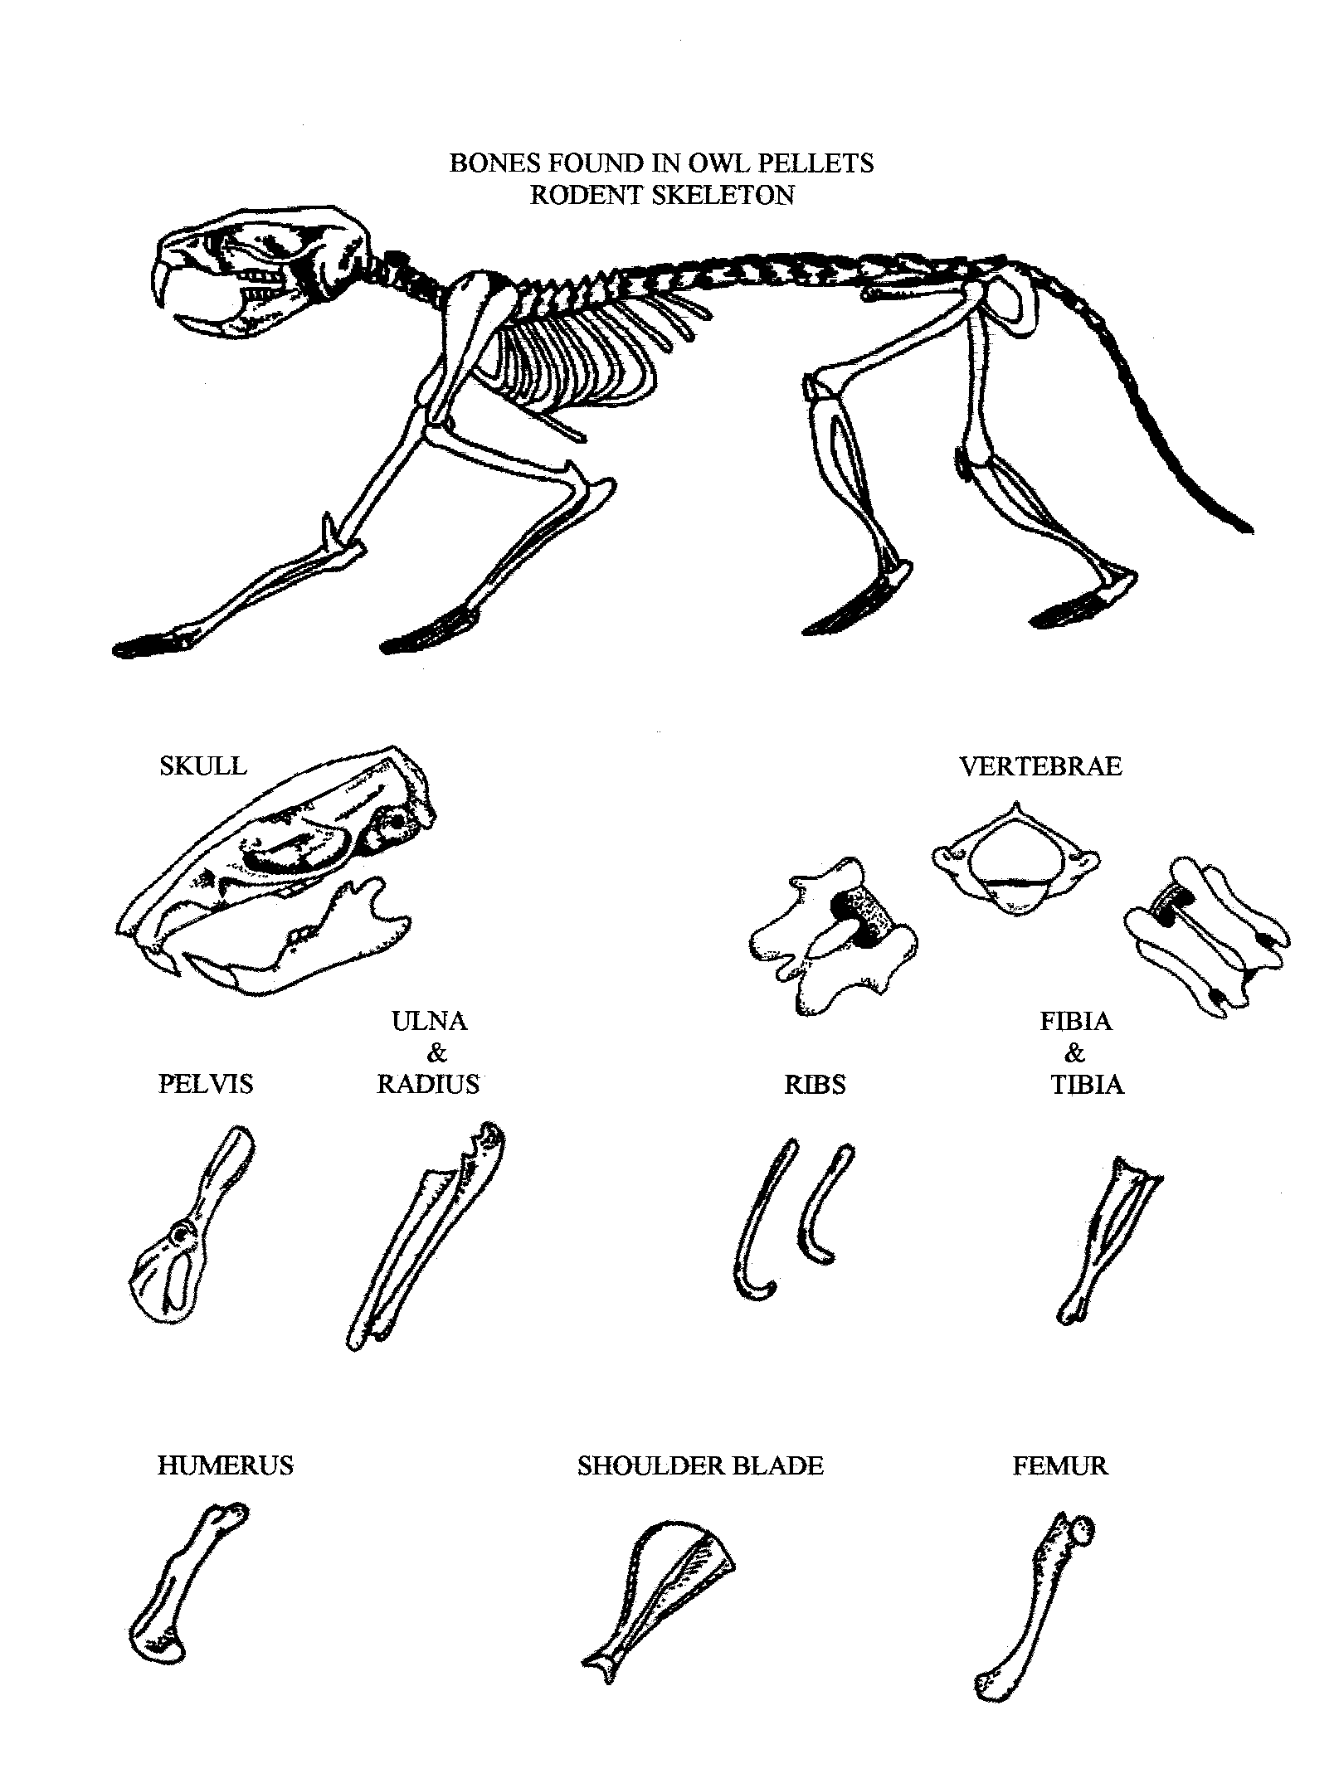
What’s Cookin’?
Research Format

Name:__________________
One way ecologists show a community’s energy flow is through food chains and food webs. A food chain shows what one type of animal eats and what its prey eats in turn. A food web goes a step further, showing the relationships among many animals in a community. It shows who eats what and who eats whom within a community. A web that includes all the animals and plants in a small patch of the Chihuahuan Desert, for instance, would have hundreds of strands.
Use this information for review as you complete your research.
An animal’s use of the sun’s radiant energy begins with the “capture” of that energy by photosynthetic plants. Because plants capture the sun’s energy, they are called primary producers. A primary consumer is a plant-eating animal, or herbivore. Primary consumers are preyed on by other animals, the secondary consumers, and so on, in what is termed the food chain. As each organism dies, its components are broken down by digestion or by various decomposers, such as bacteria and fungi. This producer-consumer-decomposer sequence in a food chain represents the flow of both energy and matter.
Use the shape below to label and illustrate the plants and animals in your chain (use one for each illustration).

What’s Cookin’?
Research Format

What’s Cookin’?
Research Format

Name:__________________

1. Identify your plant or animal. ___________________________

2. Determine where your plant or animal fits in the diagram and write its name in the box.

3. Complete the diagram by filling in the boxes.
sun
________________________
Primary producers
(Plants and other photosynthetic organisms)
_____________________________
Primary consumers
(herbivores)
___________________________
Secondary consumers
(Snakes, foxes, toads)
______________________________
Tertiary consumers
(eagles, owls, and other predators)
Decomposers
(decomposition to raw materials
by bacteria
and fungi)

Biomes!
What are the seven biomes?
Summary: This lesson introduces the students to characteristics of the seven biomes (grassland, ocean, forest, desert, rainforest, taiga, and tundra).
Duration: 1-2 class periods
Setting: Classroom
Vocabulary: biome, grassland, ocean, desert, forest, rainforest, taiga, tundra
Standards/Benchmarks Addressed: SC1-E1, SC2-E3, SC3-E1, SC5-E2, SC6-E1, SC6-E2, SC6-E3, SC6-E4, SC6-E5, SC6-E6, SC11-E2, SC11-E3, SC11-E4, SC11-E7

Objectives
Students will:
- comprehend the distinct differences in the characteristics of the seven biomes.
- create a poster depicting the characteristics of the seven biomes.
Background
Each environment has different kinds of organisms. One factor that influences where organisms live is climate. Climate is the average weather of a region over a long period of time. Two basic factors influence both climate and weather. These factors are precipitation and temperature. Weather is the result of the day-to-day changes in these factors. Climate is the average of these factors over a long period of time.
A biome is a region characterized by certain kinds of plant life, animal life, and climate. The plants and animals that survive in a biome are adapted to the conditions of that biome. Each biome is described in terms of its climate and its living things. The plants and animals that survive in a biome are adapted to the conditions in that biome.
Some researchers say there are six land biomes on the Earth, however we included the ocean as a separate biome. That brings us to a total of seven biomes on the Earth. These biomes include the desert, grassland, forest, rainforest, taiga, tundra, and the ocean.
The tundra is a biome that is cold and receives little precipitation. Winters in the tundra are long, dark, and very windy. Summers in the tundra are very short. There are only about eight weeks of the year when conditions are right for plants to grow. Most of the soil in the tundra is frozen all year. This frozen soil is called permafrost. Few plants can survive in the tundra, because the growing season is so short. The plants that do grow are adapted to grow very quickly. The most common plants are grasses, mosses, and lichens. The animals that live in the tundra have special adaptations that allow them to survive in the very cold environment. These animals include: caribou, lemmings, arctic foxes, snowy owls, and wolves.
The taiga is a biome in which the main type of plant life is evergreen trees. This biome has long, hard winters and constant snow cover. However, there is no permafrost in the taiga. The most common plants in the taiga are conifers. Because conifers keep their leaves all year, little sunlight reaches the forest floor. The only plants that can survive with very little sunlight are ferns and mosses. The animals that reside in the taiga have adapted to living in these conifer forests. These animals include: porcupines, crossbill, and moose.
The deciduous forest is a biome named for the broad-leaved trees found there. The climate is temperate. Temperate means that it is not very hot or very cold. The plants of the deciduous forest include deciduous trees (maple, oak, and beech) and many wildflowers along the forest floor. The animal life in the deciduous forest is very diverse. It includes: squirrels, deer, rabbits, black bears, hawks, foxes, insects, worms, birds, frogs, slugs, and snakes.
The tropical rain forest is a biome that has high temperatures and a large amount of rainfall. Tropical rain forests are found only near the equator. The tropical rain forest changes very little from season to season. There are more living things in the tropical rain forest than in all other biomes combined. It has been estimated that 50% of all living things live in the rain forest. However, this biome only covers 2% of the Earth’s land mass. Some of the plants in the rain forest include hanging vines and sandbox trees. The animals of the rain forest are adapted to live only in one level of the rain forest. Few animals move from one level to the next. There is so much diversity in the rain forest it is hard to identify all the plants and animals that live there. Some of the animals that live in the rain forests include: hummingbirds, sloths, monkeys, toucans, and parrots.
The grassland in temperate regions is a biome that has cold winters, warm summers, and uneven precipitation. As you might guess, grasses are the main kinds of plant life in the grasslands. Many insects live in the grassland. They include: ants, locusts, and grasshoppers. The grass also provides the appropriate habitat for many other animals. These animals include: prairie dogs, burrowing owls, hawks, coyotes, and wolves.
The desert is a biome that receives less than 10 inches of rainfall each year. Most people think that the desert is always hot. That is not true. A desert can also be very cold. Desert plants have adapted to living with very little water. Some of these plants include: cacti, creosote bush, and other small-leaved plants. Desert animals have also adapted to prevent water loss. These animals include: snakes, lizards, and kangaroo rats.
An ocean is a large body of salt water. There are four major oceans on the Earth: Pacific, Atlantic, Arctic, and Indian. Since these oceans are all connected water can flow from one ocean into another. The same is true with animal and plant life. The ocean is alive with a great deal of plants and animals. Seaweeds, sea snakes, whales, whelks, penguins, porpoises, tuna, and tunicates are just a few of the many organisms that live in the ocean.
Materials
Butcher paper
Drawing materials
World map
Science textbook
Procedure
Warm up: Ask the students if they have ever heard the term biome. Explain what a biome is. Ask the students to brainstorm possible biomes and discuss the seven biomes: grassland, ocean, desert, forest, rainforest, taiga, tundra

Activity
- Look at the world map with the class and discuss where some of the biome regions can be found. Divide the class into groups of 2 to 4.
- Each group will be given a large piece of butcher paper. The students will then divide that piece of paper into seven different sections, one for each of the biomes discussed.
- Students are to research and fill up as much space as possible in each of the biome sections with pictures and facts about plants, animals, and weather characteristics for each particular biome. The groups should discuss between themselves what should go into each biome section and why it belongs there.
Wrap Up: Students will present their work and explain some things that make each biome distinct: a particular plant, animal, and weather characteristic.
Assessment

Students should be able to answer the following questions (teacher may use any format: game, written, discussion):

What is a biome?
- What is the climate like in the desert? How does it compare with the climate in the tundra?
- What is the climate like in the rainforest? How often does it rain?
- In what biome would you find a cactus?
- In what biome(s) would you find a wolf?
- If you find a wolf in more than one biome, how is it possible?
- Because of the harsh hot and dry conditions of the desert, what characteristics would a plant (and animal) have in order to survive there?
- What might the waxy coating and spines on the plants in the desert tell us about the weather there? How might this relate to the plant life in Carlsbad Caverns National Park?
- How do animals of the forest, grassland, tundra, taiga, desert, and rainforest differ form the animals of the ocean?
- What biome-like region is Carlsbad Caverns National Park located in?
Name: ____________________

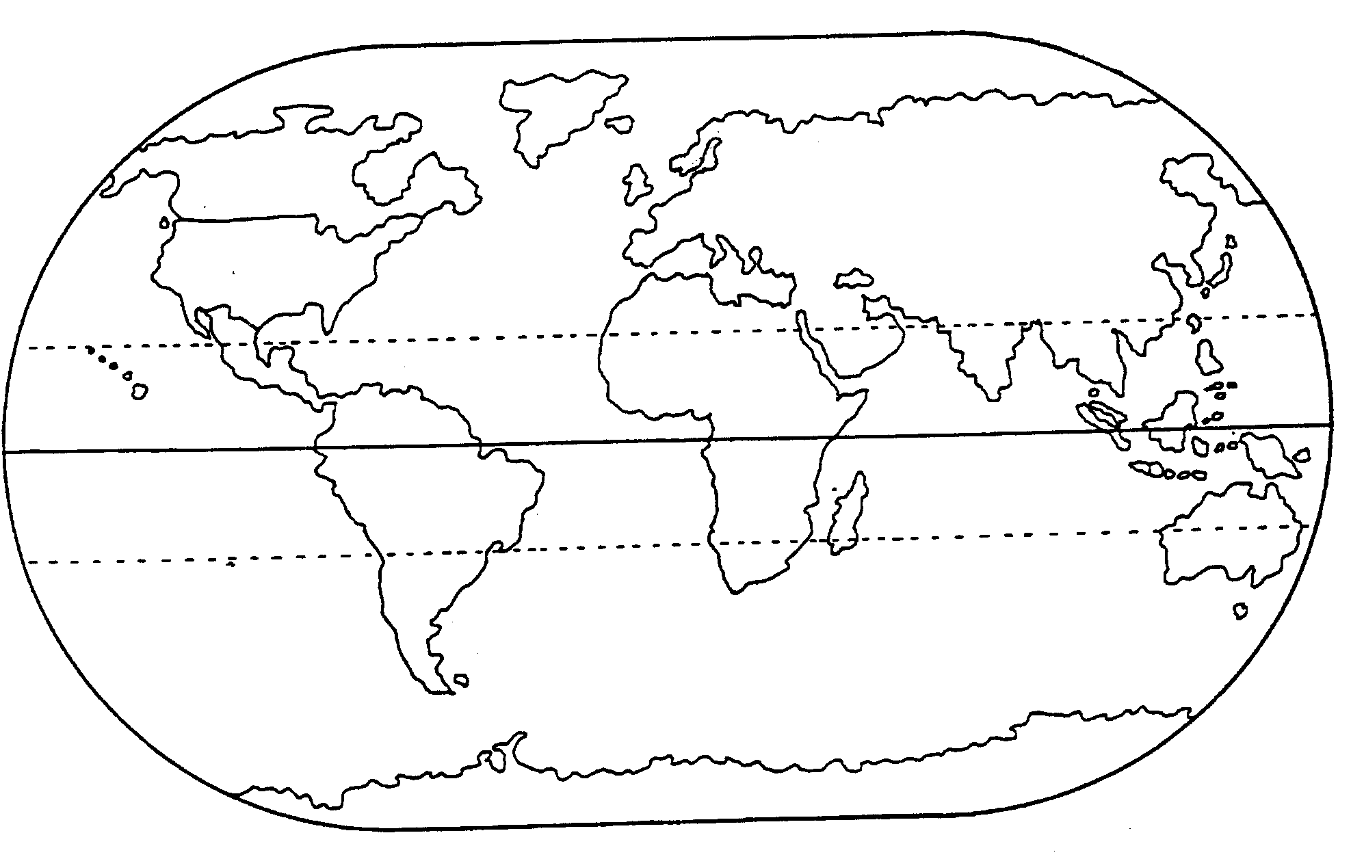
Directions: Outline, color, and label your specific desert on the world map.

Why’s it so Hot?
What are the distinguishing features
of a desert and how are they formed?
Summary: Students will explore the various factors that contribute to the formation of a desert.
Duration: 1 class period
Setting: Classroom and outside
Vocabulary: arid, desert, evaporation, precipitation, desertification, rain shadow
Standards/Benchmarks Addressed: SC1-E1, SC2-E1, SC3-E1, SC4-E1, SC4-E5, SC5-E2, SC6-E1, SC6-E2, SC6-E3, SC6-E4, SC6-E5, SC6-E6, SC11-E1, SC11-E4, SC11-E5

Objectives
Students will:
- understand the physical characteristics of a desert biome.
- be able to identify four major reasons why deserts are formed.
Background
Imagine a place with only a few drops of water to drink all year long; a place where the sun can be so hot that rocks are too hot to touch. A desert is an area that receives less than 10 inches of precipitation per year and has a high rate of evaporation (if the annual evaporation rate of an area is higher than the annual amount of rainfall, the area is considered a desert). Deserts cover roughly one-third of the Earth’s land surface. There are about 20 major deserts in the world, spread out on five continents. Many people may think that deserts are all the same. In fact, deserts are among the most varied and interesting landscapes on earth. Their barren appearance is misleading because an amazing variety of wildlife and plants have evolved adaptations enabling them to survive the harsh environment. Some deserts have rolling dunes while others have a flat surface of smooth stones. Deserts also vary in terms of the altitude in which they are found.
It is important to recognize the relationship between the Earth’s geography and its climate. There are four major reasons why deserts form. Deserts occur as a result of more than one of these factors: latitude, ocean currents, rains shadows, and central location on a continent.
Rain shadow deserts are created by prevailing winds that reach a mountain range. As they rise quickly and cool, they lose most of their moisture as rain. By the time the winds cross over the mountains and move down the far side, they are very dry. The dry winds will create a “rain shadow” desert if the area on the far side of the mountain does not receive moisture in some other way.
Inland deserts are formed because they are just too far from moisture-filled ocean winds. Air that picks up its moisture over the oceans has already dropped that moisture as rain by the time it reaches these mid-continental regions.
Latitude deserts are found along one of two lines of latitude, 30 degrees north or 30 degrees south. Many deserts form because they lie in zones of high atmospheric pressure, where dry air is descending. As the descending dry air warms up, it absorbs much of the moisture in the area.
Cold current deserts are created when moisture-laden air traveling east over the ocean cools as it crosses cold ocean currents (along the western coasts of Africa, South America, and North America). Since cool air holds less moisture than warm air, the cooling air masses drop most of their moisture over these cold currents. By the time the air reaches the west coast of the continent, it is very dry.
Materials
Map of the United States
Colored pencils
Two buckets of water
Sponges
Ruler
2 shallow pans
Salt
Stopwatch
Chalkboard
Procedure
Warm up: Ask students to brainstorm what they think they know about deserts, their characteristics, and how they are formed. Write responses on the board. Give students the definition of a desert. Explain that they will be performing an activity that will allow them to observe how evaporation affects living things in the desert. Using a map of the United States, ask students to locate the four deserts in the North American continent.
Activity: In these activities, students will get a chance to find out how evaporation affects living things in the desert and how it helps shape the way many desert areas look.

- Show students how water evaporates by wiping a damp sponge across a chalkboard. Explain that the water evaporated or changed from a liquid to an invisible gas called water vapor.
- Next, ask students how heat affects evaporation. To show how heat affects the evaporation rate, complete these two demonstrations.
- Place one pan in a sunny, open area and the other in a shady area. Fill each pan with exactly two inches of water. Leave the pans in place several hours, then measure the amount of water in each pan. Does one pan now have less water?
- The second demonstration shows how quickly rainfall evaporates off the hot desert ground with a sidewalk graffiti demonstration. Take a bucket of water, some sponges, and a stopwatch to an outside area. Locate a shady sidewalk area and a sunny one. Have the students write their initials on the sunny sidewalk with a damp sponge. With the stopwatch time how long it takes for their letters to evaporate completely. In which area did the water evaporate more quickly?
Explain to the students that they will be researching the four deserts located on the North American continent. Divide students into four groups. Assign each group a desert to study. Each group should complete research on their assigned desert. Include the name, type, size and location, how the desert was formed (rain shadow, high pressure, inland, latitude, or cold current), physical features, examples of plants and animals (what are their indicator species), and special facts. Pass out a map of North America to each group. Each group will provide a physical outline of their assigned desert.
Wrap Up: Groups will present their information to the class.
Assessment
See research rubric.
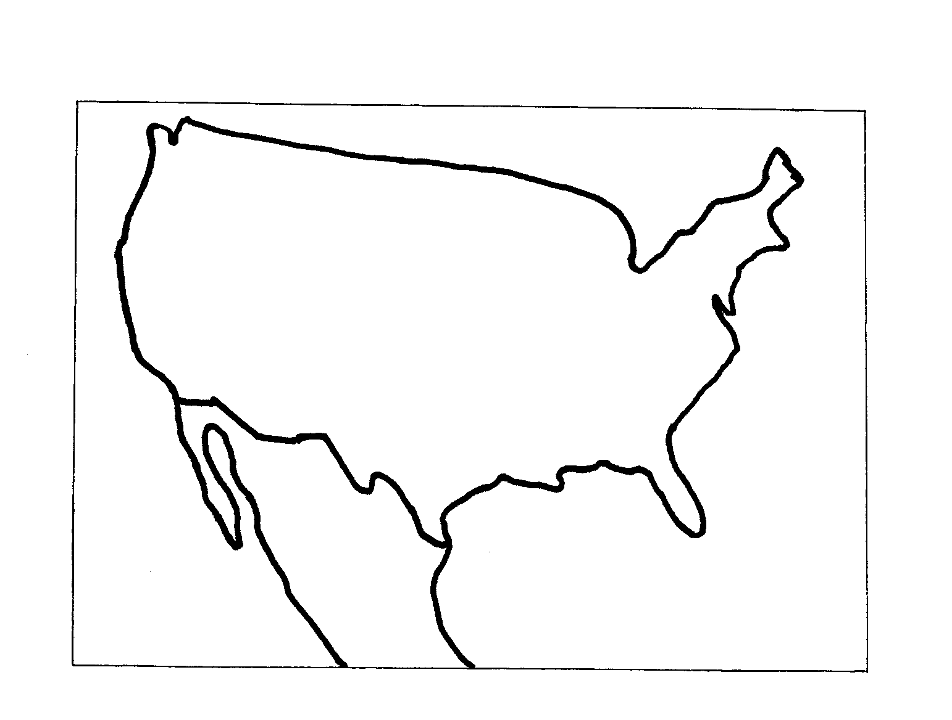
Name: ____________________

Directions: Use the following map to color and label the physical outline of your assigned desert.

North American Desert Research
Research on North American Deserts | Self  Evaluation | Teacher  Evaluation | Comments
Visual: |  | /4
Includes North American map with location outlined, colored, and labeled (consider quality and appeal).
Written Report: |  | /20
Includes content about animal life (identifies indicator species).
Includes content about plant life (identifies indicator species).
Includes location or geography.
Written in complete sentences (neat, proper grammar, spelling, etc.)
Cites 3 references (at least one internet site).
Presentation: |  | /4
Organization of information, quality, etc.
Teamwork: |  | /4
Are the efforts of each team member clearly demonstrated, or did it appear to be the work of one or two?
Responsibility: |  | /4
Turned in on due date and presented in class with visual aids.
4 - no mistakes 3 - few mistakes 2 - many mistakes 1 - incomplete (however is present) 0 - not evident or not included

Percentages: Visual ____ Written Report ____ Presentation ____ Teamwork ____ Responsibility ____ Overall ____

Scenic Sculpture
How are these desert landscapes created?
Summary: Through a hands-on activity, students will explore the factors contributing to desert formations and construct 3-D models.
Duration: 2 class periods
Setting: Classroom
Vocabulary: alluvial fan, arroyo, butte, dune, erosion, mesa, wadi, arch, playa, canyon, columns, weathering
Standards/Benchmarks Addressed: SC1-E1, SC2-E1, SC2-E3, SC3-E1, SC4-E1, SC4-E5, SC6-E2, SC6-E3, SC6-E5, SC6-E6, SC12-E1, SC12-E3, SC12-E7

Objectives
Students will:
- identify various desert landforms.
- identify causes of desert landforms.
- construct a 3-D model to illustrate the features seen in a desert.
Background
Deserts landscapes have been described in terms ranging from breathtaking to barren. Although you see no autumn foliage or lush deep greens of summer the desert landscapes are distinct and varied. Cracked salt flats, deep rock canyons, golden arches, and towering sand dunes are all part of desert landscapes, along with arroyos, playas, buttes, and other landforms. In order to determine how the formations are created it is necessary to take a look at the various factors that create a desert.
It is important to start by defining a desert because it is here that we first begin to see the process. Deserts are defined as an area that receives less than 10 inches of precipitation per year and has a high evaporation rate. Evaporation rates can be from seven to fifty times high as the rate of precipitation. The dry air of the desert allows 90 percent of the incoming solar radiation to strike the Earth’s surface as compared to 40 percent in humid climates. It is no wonder then that deserts truly are the hottest places on earth. The same dry air that allows the radiation to penetrate during the day also allows the accumulated heat to be radiated back to the sky at night. Therefore, deserts are also known for their extremes in day and nighttime temperatures.
If you were to look closely at a map of the Earth you would see that deserts aren’t randomly scattered. In fact, it is important to recognize the relationship between the Earth’s geography and its climate. Deserts are located where they are because of four main factors: latitude, rain shadows, cold currents, and central location on a continent.
Most deserts are found along the lines of latitude: 30 degrees north or 30 degrees south. This occurs because of the way air circulates in the tropics. Rain shadow deserts form when a mountain cuts off a low-lying area’s rain supply. As moisture-laden winds travel over mountains they rise and cool thus dropping their moisture on the western side of the mountain. Cold currents are caused by ocean winds being cooled as they blow across very cold currents near shore. This cold, dry air holds little to no moisture and therefore, as it blows inland, a desert is created. The many deserts are found in a central location on a continent. Any air that picked up moisture over the oceans has already dropped it as rain before it reaches the mid-continent region.
What does the dryness have to do with desert formations? For one thing, forces of wind, water, and weathering are given more power by the high evaporation rate. Wind is one of the primary factors in sculpting the desert. A sandblasting effect occurs when dry sand, pebbles, and dirt are picked up and blown with great force. Because of the dry surfaces and sparse soil-anchoring vegetation, we see sand particles blown into high dunes.
Water is an even more powerful erosive force than wind. Rainfall and riverflow are infrequent in desert areas. And yet, it is not uncommon to experience flash flooding. When rain does come to a desert, it often falls heavily, washing away soil, transporting rocks and sand, and cutting deep gashes in the surface. When streams and riverbeds fill with water, sediment is eroded and carried with enormous power. This mud, sand, and water slurry scours everything in its path. An example of this is the Colorado River creating the Grand Canyon. Flood waters running down a mountain drop their load of sediment, forming alluvial fans.
Weathering is how exposure to the elements breaks down rocks. One form occurs when the rapid heating and cooling of the desert causes rocks to expand and contract, building up strain. This strain can build up until a rock cracks. It’s a slower process, and a more subtle contributor to desert formations than wind and water, but just as important. In many deserts sand helps shape the way desert landscapes look. Although water can erode rock surfaces without sand, sand increases the amount of erosion that takes place.
Materials
Water
Flour
Salt
Measuring cups
Sandpaper
Cardboard (at least 14”x18”)
Small plastic bowls
Paints
Bowls
Chalk
Procedure
Warm up: Pass out a small sheet of sandpaper to each student. Ask them if they know what sandpaper is used for (it helps grind and smooth rough surfaces on wood and other materials). Explain that water or wind-carried sand can also grind, just as sandpaper does. For example, during a sandstorm in the desert, the wind may blow hundreds of pounds of sand around at speeds of over 10 miles per hour for several days. As the grains constantly bounce and grind they begin to wear rock surfaces down. Hand each student a piece of chalk and allow them to experience the abrasiveness of the sandpaper by rubbing it against the chalk. Remind the students that this same effect can be caused by water too.
Refer to the background information that stated how the Colorado River was made.
Activity: Students will make salt dough clay and then create a desert scene that depicts a variety of landforms found in a desert.
Step 1 – Have students combine ½ cup of salt and 1 cup of flour in a bowl. Students will then slowly add water and stir until the dough is the consistency of bread dough.
Step 3 – The teacher will name a landform and then give the definition. Students will be expected to write down all definitions, and then based on the description only, form their interpretation of that landform. Once finished, teachers will show pictures of each landform named. Students will assess their formation and make the necessary changes.
Step 4 – Each student will be given a piece of cardboard and will be instructed to create a desert landscape that would include seven of the eleven types of landforms defined. Students should label each landform.
Step 5 – Students may be allowed to paint their formations. Keep in mind the colorings of the various formations are often due to the different minerals found as opposed to vegetation.
Wrap Up: As a review play a quick game of “What am I?” Students will be given a definition or a picture and asked to provide the name. This can be played for fun or for bonus points.
Assessment

Topographical desert formations made of salt dough, quiz.
Scenic Sculpture
Landforms Quiz
Name: _______________________

Students should draw a picture of each type of landform listed:
1. arroyo | 2. butte
3. wadi | - alluvial fan
- dune | 6. canyon
- playa | 7. arch

Desert Formation Model

Desert Formations | Self Evaluation | Teacher Evaluation | Comments
Visual: |  | /12
7 of 11 types of landforms discussed are depicted.
Formations are accurate.
Painted formations represent realistic coloring.
Written: |  | /8
Provides a definition for each landform.
Identifies an area in which each landform can be found.
Presentation: |  | /4
Organization of information, quality, etc.
Responsibility: |  | /4
Turned in on due date and presented in class with visual aid.
4 - no mistakes 3 - few mistakes 2 - many mistakes 1 - incomplete (however is present) 0 - not evident or not included

Percentages: Visual ______ Written ______ Presentation ______ Responsibility ______ Overall______

How Do They Survive?
What is a microhabitat and how does it
help plants and animals survive?
Summary: Students will describe the various ways in which plants and animals of the desert adapt by participating in an activity that examines microhabitats as one type of adaptation.
Duration: 1 class period
Setting: Classroom
Vocabulary: burrow, microhabitat, adaptation
Standards/Benchmarks Addressed: SC1-E1, SC1-E2, SC2-E1, SC2-E2, SC2-E3, SC6-E2, SC6-E3, SC4-E4, SC4-E5, SC5-E2, SC6-E1, SC6-E2, SC6-E3, SC6-E5, SC6-E6, SC11-E2, SC11-E3, SC11-E5

Objectives
Students will:
- interpret the results of their experiment in order to determine if their hypothesis was supported.
- explain how animals and plants use microhabitats as a means of survival.
- explain what a microhabitat is.
- understand how life cycles of plants and animals help them cope with desert conditions.
Background
A variety of organisms live in almost any habitat you could name. The desert, for example, is a challenging habitat for the plants and animals that live there. Yet for thousands of years plant and animal species have adapted and thrived in these arid lands. How? Because each organism has its own way of life which often requires a different environment from that of other organisms, plants and animals inhabit specific microhabitats within the environment of a general habitat. This microhabitat allows them to accommodate their needs and survive the harshness of the desert. A microhabitat is simply a small, distinctly specialized habitat.
For some animals their respite is the cool interior of a burrow. Rattlesnakes, kit foxes, and kangaroo rats spend most of the day resting in underground burrows. They choose the night for their active period to avoid the intense dehydrating heat of the daytime sun. During the day, the cool microclimate of their burrows helps protect them. How cool is it? While the soil surface up top may be 165 degrees Fahrenheit, their underground dens may be a livable 80 degrees Fahrenheit. In their cozy microhabitat, these animals can conserve their energy for nighttime hunting or seed gathering expeditions. Astonishingly, over half of all vertebrate animals, including those that live in caves and the soil, are nocturnal.
During the dry times, animals such as the spadefoot toad, an amphibian that lives in the American Southwest, can be found in a burrow dug with its spade-shaped back feet. It will continue to lie dormant until the sound of raindrops hitting the surface awakens the toad. At that point the race is on. Within approximately 8-10 days the cycle of finding a mate to laying the eggs to becoming a toad will be complete.
Some plants use combined strategies of dormancy and an accelerated life cycle. The seeds of the sand verbena will remain dormant (sometimes for years) until there is enough rain. When there is sufficient rain, they grow quickly, making their flowers and seeds and then dying all within a period of a few weeks. Some plants bloom at night in order to minimize water loss.
An arroyo, a ditch carved by water in desert regions, makes for the perfect microhabitat for javelinas. When the steep banks erode, shallow cavities are created that provide warmth in the winter and cool in the summer.
Cave entrances can provide a microhabitat for a variety of plant and animal species and provide growing conditions similar to a forest. It is not uncommon to find a fringe of green around the entrances to caves. Upon closer examination, evidence of animals such as birds, snakes, skunks, or mice living in the mouth of the cave can be found.
A variety of microhabitats can be found in any environment. Plants and animals find “their place” in logs, under boulders, in cacti, or even under a refuse can. Places such as a shady area under a tree or shrub are microhabitats because they provide a home for shade loving plants or respite for the desert lizards.
The above mentioned areas are only a few of the vast array of microhabitats found in an environment. The challenge is to locate some in your area. A hike is a great way to discover your world. When hiking an area such as the desert here are a few things to look for:
- Cuplike nests tucked in cholla cacti, where cactus wrens raise their young;
- Mounds where kangaroo rats live;
- Lizards basking on rocks;
- Young cacti growing under “nurse” trees or plants;
- Shallow pits in the ground where javelinas have been digging for roots;
- Cavities in cacti, where woodpeckers or owls nest
Materials
3-5 gallon terrarium
Sand (enough to fill the bottom 5 inches)
1 large, flat, dark-colored rock
12-inch scientific thermometer
Desk lamp with 100 watt bulb
Paper towel tube
Full sheet of paper
1 craft stick
Scissors
Graph paper
Procedure
Explain to the students that there are a variety of ways in which plants and animals adapt in order to survive. Today’s focus will be on the use of microhabitats as a means of survival.
Warm up: Write the word microhabitat on the board. Ask students for a definition. Explain that a microhabitat is a small area within a habitat that provides special conditions. These special conditions can include shelter, moisture, darkness, etc.
Activity: Students will create a microhabitat in order to determine how animals find small cooler climates amid the harsh conditions of the desert.
- Let the sand sit in the classroom overnight so that it will be room temperature. Place the paper towel tube lengthwise in the bottom of the terrarium (cutting if necessary). Cut a hole approximately ¾ inch in diameter on the topside of the tube. Roll up a sheet of paper and insert it into the hole in the paper towel tube. Fill the terrarium with sand (5 inches deep). Place the rock on the top of the sand. Clear an area on one side in order to create a shady overhang. Position the heat source so that it is 5-6 inches above the terrarium. Mark the center of the terrarium with a craft stick. This is the place where the temperature readings will be taken. Mark an X on the rock with a permanent marker to show where that temperature will be measured. Do not turn on the lamp until you are ready to begin the experiment.
Students will be divided into 6 groups. Each group will form a hypothesis regarding the temperatures within the microhabitat. Students will also tell why they made their hypothesis. Students will record temperatures in four locations, four times a day. A temperature reading will be taken in the burrow, under the rock, on the surface of the rock, and on the surface of the sand. The temperatures will be taken at times to be determined. After one day of taking temperatures a pattern should emerge. You may continue to take readings for another day in order to determine consistency in the pattern.
Wrap Up: Explain to the students that the five areas in the terrarium were used to simulate microhabitats found in the desert. Conduct a follow-up discussion based on the results of the experiment. Students should attempt to explain why or why not their hypothesis was valid.
Assessment
Students should create a graph to depict the results of the experiment and give a written response on what caused the variety of temperatures to exist within the terrarium.
Students will research various types of microhabitats that plants and animals utilize.
Extension
Students could go on their own microhabitat search and locate the variety of microhabitats found in their area.
How Do They Survive?
Microhabitat Research

Microhabitats | Self Evaluation | Teacher Evaluation | Comments
Visual: |  | /12
4-fold with illustrations should depict microhabitats.
Illustrations should be colorful, detailed, and fill the page.
Graph should be included (look for accuracy).
Written: |  | /16
Provides a paragraph in response to the graph analysis.
(What caused the variety of temperatures.)
Provides a definition of microhabitat.
Identifies the type of plant/animal that uses the microhabitat.
Identifies an area in which each of these animals and their microhabitats can be found.
Responsibility: |  | /4
Turned in on due date and presented in class with visual aid.
4 - no mistakes 3 - few mistakes 2 - many mistakes 1 - incomplete (however is present) 0 - not evident or not included

Percentages: Visual ______ Written ______ Presentation ______ Responsibility ______ Overall______

Great Deserts of the World
Are they all alike?
Summary: In this activity students will study the various aspects of the Chihuahuan Desert and by comparing it to other deserts of the world come to appreciate its uniqueness.
Duration: 1 class period
Setting: Classroom
Vocabulary: desert, arid, humidity, flash flood
Standards/Benchmarks Addressed: SC3-E1, SC4-E5, SC5-E2, SC6-E2, SC6-E3,
SC6-E4, SC6-E5, SC6-E6, SC12-E1, SC12-E3

Objevtives
Students will:
- locate some of the great deserts of the world on a map.
- research information about specific deserts of the world.
- create a travel brochure that includes specific information about their desert.
Background
Whether it is Death Valley or Takla Makan (translated, the place from which there is no return), these deserts are deserving of their name. Dry and often desolate, the desert can be a tough environment for humans. Sand dunes, solid rock, or pebbled ground can stretch for hundreds of miles, without a glimpse of shade in sight. People traveling with enough water to survive the daytime heat may freeze on cool nights or become lost in dust or sandstorms. Yet, deserts aren’t all dryness, dunes, and desolation. They can have an array of colorful cacti, interesting creatures, flash floods, bizarre rock formations, tree-sized cacti, salty lakes, and high mountains.
The desert is a biome, a geographic area that supports a certain kind of climate and certain community of plants and animals. In the Sonoran Desert you’ll find cacti of many shapes and sizes. The Australian Desert supports an abundance of lizards, from the geckos measuring in at 2 inches to the monitor that can grow to be 7 feet long. The Sahara Desert is home to 3.5 million square miles of hot, windy vastness. You’ll find little wildlife along its rock and sand-filled floor. As you can tell, exactly what you’ll see in a desert depends on which one you visit.
How are deserts formed? There are four major reasons why deserts form. Deserts occur as a result of more than one of these factors: latitude, ocean currents, rains shadows, and central location on a continent.
Rain shadow deserts are created by prevailing winds that reach a mountain range. As the winds rise quickly and cool, they lose most of their moisture as rain. By the time the winds cross over the mountains and move down the far side, they are very dry. The dry winds will create a “rain shadow” desert if the area on the far side of the mountain does not receive moisture in some other way.
Inland deserts are formed because they are just too far from moisture-filled ocean winds. Air that picks up its moisture over the oceans has already dropped that moisture as rain by the time it reaches these mid-continental regions.
Latitude deserts are found along one of two lines of latitude, 30 degrees north or 30 degrees south. Many deserts form because they lie in zones of high atmospheric pressure, where dry air is descending. As the descending dry air warms up, it absorbs much of the moisture in the area.
Cold current deserts are created when moisture-laden air traveling east over the ocean cools as it crosses cold ocean currents (along the western coasts of Africa, South America, and North America). Since cool air holds less moisture than warm air, the cooling air masses drop most of their moisture over these cold currents. By the time the air reaches the West Coast of the continent, it is very dry.
There are about 20 major deserts in the world, spread out on five continents. Despite their differences, deserts have two things in common: their dryness and high rate of evaporation. The desert is the hottest biome on earth. Most other biomes are insulated by their humidity (water vapor in the air). While a forested area may have 80-90 percent humidity, the desert will have only 10-20 percent. The humidity in the air reflects and absorbs the sun’s energy, therefore lack of humidity results in more of the sun’s energy reaching the ground.
There are two main types of deserts: hot and cold. Most of the world’s deserts are hot deserts. That means they have hot daytime temperatures during most of the year. Cold deserts have daytime temperatures that during certain times of the year plunge below freezing. Many cold deserts get over half of their moisture from snow. In most deserts, air temperature falls quickly at night and rises quickly during the day.
Deserts may get little rain on average. But they often get huge amounts all at once. Storms may be strong and flash floods are not uncommon. Places like the Sahara may get rain only once in 20 years. When it does rain, they can receive a decade’s worth in just a few hours.
Some deserts experience dust or wind storms. Dust storms are stirred up by the wind. These dust clouds, thousands of feet high, can block out the sun. Soil from the Sahara can be carried all the way to Paris. These storms can make it difficult to breathe and can quickly dehydrate an animal. Particles of sand rubbing against one another during a sandstorm can create such static electricity in the air that people suffer from headaches.
The soils vary from sandy, salty, crumbly, or very rocky. Soil may be rich in minerals, but often lacks organic matter (decayed plants and animals). This is because there are fewer plants and animals in the desert to start with.
Common plants can include cacti, yucca, salt bush, creosote bush, and a variety of annuals. Desert plants have adapted a variety of methods to reduce water loss and increase water storage.
Some deserts have abundant wildlife that include a large number of lizards and small mammal species. Desert animals have some impressive ways of handling the challenges of desert life.
(See fact sheet for additional desert information).
Materials
World map
Paper
Brochures
Procedure
Warm up: Bring in travel brochures from a variety of places (from all biomes). These can be obtained from a local travel agency. Ask students what types of trips they have been on before. Have students examine the brochures and discuss the advertising techniques they see applied. Explain to the students that they will be creating travel brochures for the great deserts of the world. Discuss the background information with the class.
Activity: Explain to the students that they will be working in groups to create a brochure of their assigned desert. Students will research specific information about each desert (location, size, temperature, rainfall, interesting fact), and then use this information to create a travel brochure.
Students will be placed into nine groups in order to research the following deserts:
- Arabian
- Australian
- Chihuahuan
- Gobi
- Kalahari
- Mojave
- Patagonia
- Sahara
- Sonoran
Wrap Up: Groups will present their brochures to the class.
Assessment

Desert Travel Brochure
Evaluate maps for accuracy.
Great Deserts of the World
Desert Name | Type | Location and Size | Formed By | Physical Features | Examples of Plants and Animals
Arabian | Hot | Arabian Peninsula  Covers 900,000 sq. mi. | High pressure | Covered almost entirely by sand, has some of the most extensive sand dunes in the world | Acacia, oleander, saltbush  Desert locust, dromedary camel, gazelle, jackal, lizards, oryx
Australian | Hot | Australia  Covers 890,000 sq. mi. | High pressure  Rain shadow | Sandy, stony | Acacia, casurarina tree, eucalyptus, saltbrush, spinifex grass  Blue-tongued lizard, dingo, fat-tailed mouse, kangaroo, rabbit-eared bandicoot, hopping mouse, thorny devil
Chihuahuan | Hot | North Central Mexico and SW US (AZ, NM, TX)  Covers 175,000 sq. mi. | High pressure | High plateau covered by stony areas and sandy soil  Many mountains and mesas | Cacti, Chihuahuan flax, creosote bush, lechuguilla, mesquite, Mexican gold poppy  Coyote, diamondback rattlesnake, javelina, kangaroo rat, roadrunner
Gobi | Cold | Northern China and Southern Mongolia  Covers 450,000 sq. mi. | Rain shadow  Inland | Covered by sandy soil and areas of small stones called Gobi | Camel’s thorn, grasses  Bactrain camel, gazelle, gerbil, herboa, lizards, onager, wolf
Kalahari | Hot | Southwestern Africa  Covers 200,000 sq. mi. | High pressure | Covered by sand dunes and gravel plains | Acacia, aloe, baobab tree, tamarisk tree  Gazelle, gerbil, ground squirrel, hyena, jackal, sandgrouse, springbok
Mojave | Hot | Southwestern US  (AZ, CA, NV)  covers 25,000 sq. mi. | Rain shadow  High pressure | Covered by sandy soil, pavement, and salt flats | Creosote bush, desert sand verbena, Joshua tree, mesquite  Bighorn sheep, chuckwalla, coyote, jackrabbit, sidewinder, zebra-tailed lizard
Patagonia | Cold | Argentina  Covers 153,000 sq. mi. | Rain shadow | Covered by stony and sandy areas | Cacti, grasses, shrubs  Patagonia fox, Patagonia hare, puma, rhea
Sahara | Hot | Northern Africa  Covers 3.5 million sq. mi. | High pressure | Covered by mountains, rocky areas, gravel plains, slat flats, huge areas of dunes | Acacia, grasses, tamarisks  Addax antelope, dorcas gazelle, fennec, fox, Horned viper, jackal, herboa, sandgrouse, spiny tailed lizard
Sonoran | Hot | Southwestern US (CA)  Parts of Mexico (Baja)  Covers 120,000 sq. mi. | High pressure  Rain shadow | Covered by sand, soil, and gravelly pavement  Gets more rain than any other N. Am. desert | Agave, Coulter’s globemallow, creosote bush, desert Mariposa lily, mesquite, ocotillo, paloverde, saguaro  Coati, elf owl, gila monster, kangaroo rat, pack rat, roadrunner, sidewinder, tarantula

Great Deserts of the World
Brochure Rubric
Desert Brochure | Self Evaluation | Teacher Evaluation | Comments
Visual: |  | /12
Includes a world map with location outlined, colored, and labeled (consider quality and appeal)
Brochure is visually attractive (fills the page, colorful, neat)
Brochure contains points of interest of the given desert (these may include plants, animals, locations specific to that desert)
Written: |  | /12
Information is accurate.
Proper grammar, spelling, etc.
Advertising techniques are evident (desert presented as a top attraction)
Presentation: |  | /4
Organization of information, quality, etc.
Teamwork: |  | /4
Are the efforts of each team member clearly demonstrated, or did it appear to be the work of one or two?
Responsibility: |  | /4
Turned in on due date and presented in class with visual aids.
4 - no mistakes 3 - few mistakes 2 - many mistakes 1 - incomplete (however is present) 0 - not evident or not included

Percentages: Visual ____ Written ____ Presentation ____ Teamwork ____ Responsibility ____ Overall ____
Name _____________________________

Directions: Outline, color, and label your specific desert on the world map.

Soil
Desert soils have some very unique characteristics. Desert soils are usually mineral rich. However, they have less organic materials (decaying plant and animal material) than other soils. This organic material produces nitrogen that is important for plant growth and helps the soil hold water. Windblown and rain-dissolved particles create a dark sheen called “desert varnish.” Some minerals in the desert soil cement the soil together forming what is known as “hardpans,” commonly known as caliche, a hard crust that makes the soil less permeable to rainwater. In some parts of the desert tiny plants and small plantlike organisms such as lichens create a fragile living crust on the desert soil. This living crust can be found in Carlsbad Caverns National Park.
This unit will focus on the basics of soil science through two hands-on activities. In the first activity, Let’s Get Down and Dirty, students will participate in a hands-on experiment to identify different soil types and their water holding ability. In the second activity, Succession and Compaction, students will examine the influence of soil compaction on plants, animals, and on the water infiltration rate.

Let’s Get Down and Dirty!
What is in our soil and how much water does it hold?
Summary: This lesson is designed to help students understand the characteristics of different soils and their water-holding ability.
Duration: 1 class period
Setting: Classroom
Vocabulary: soil, stony soil, sandy soil, clay soil, loam, peat soil, desert varnish, hardpans
Standards/Benchmarks Addressed: SC1-E1, SC1-E2, SC2-E1, SC2-E2, SC2-E3, SC3-E1, SC4-E1, SC4-E3, SC4-E4, SC4-E5, SC5-E1, SC5-E2, SC6-E1, SC6-E2, SC6-E3, SC6-E4, SC6-E5, SC6-E6, SC6-E7, SC12-E2, SC14-E2, SC16-E3

Objectives
Students will:
- investigate soil samples and determine the basic components of those soils.
- determine how much of a soil is rock.
- test the water-holding ability of different soil samples.
Background
Soil is the part of the ground where plants grow. Soil is a mixture of tiny particles of rock and rotting plant and animal material, with water and air between them. Soils help plants grow in two ways. First, soil holds the plants into place. Second, soil contains nutrients that plants need in order to survive. These nutrients include water, a nutrient needed by all living things. Water is absorbed into the soil and can be used by plants and other living organisms to stay healthy and survive.
There are many different types of soil. Each type of soil absorbs water at a different rate. The main types of soil focused on in this lesson are stony soil (soil that contains mostly rocks), sandy soil (soil that contains mostly sand), clay soil (soil that contains fine particles, and is heavy, cool, and damp), loam (soil that contains sand and clay), and peat soil (soil that contains decayed plants).
Desert soils have some very unique characteristics. Desert soils are usually mineral rich. However, they have less organic materials (decaying plant and animal material) than other soils. This organic material produces nitrogen that is important for plant growth and helps the soil hold water. Windblown and rain-dissolved particles create a dark sheen called “desert varnish.” Some minerals in the desert soil cement the soil together forming what is known as “hardpans,” commonly known as caliche, a hard crust that makes the soil less permeable to rainwater. In some parts of the desert tiny plants and small plantlike organisms such as lichens create a fragile living crust on the desert soil. This living crust can be found in Carlsbad Caverns National Park.
Biologists at Carlsbad Caverns National Park must be aware of the soil types and water infiltration rates of these soils in order to conserve the plant life in the park for future generations.
Materials
Soil samples (stony soil, sandy soil, clay soil, loam, peat soil)
Styrofoam cups (all the same size)
Glass jars (the cups should fit into the mouth of the jars)
Measuring cups
Bowl
Fine mesh screen
Paper towel
Magnifying glass
Procedure
Warm up: Ask the students, “When you think of soil what comes to mind?” List the students’ responses. Discuss what soil is.

Activity
- Have five stations around the room set up for students to observe the five soil samples (stony soil, sandy soil, clay soil, loam, peat soil). Have the students use the small mesh screen to filter out the different size particles, and use a magnifying glass to observe the characteristics of each type of soil. Have the students write their observations in a science journal. After all students have had a chance to observe the five soil samples discuss their observations as a class. Have them try to identify what each soil sample is.
- Ask the students, “Do all soils store the same amount of water?” Use the same five soils and have the students test the water-holding ability of each soil. Have students follow these directions:
  - Each student should have 5 Styrofoam cups and 5 jars. The students should punch a small hole in the bottom of each of the Styrofoam cups.
  - Line each cup with a circle of paper towel. Fill each cup ½ full of soil. Put only one soil type in each cup. Have students label each cup with the soil type and record it on the data sheet.
  - Place each Styrofoam cup into the mouth of a jar. Pour an equal amount of water (1 to 2 cups) over the soil in each can.
  - When each cup stops dripping have students measure the amount of water in the jar. To do this they must pour the water out of the jar into a measuring cup. Record the amount of water in each jar on the data sheet next to the corresponding soil sample.
  - Have students write up the results of the water-holding ability of each type of soil. Have them explain which soil they feel would be best for planting crops.
Wrap Up: Have the students answer the following questions:
- Does the water drain more rapidly through some soils than others? Why do you think this happens?
- When the water stopped dripping from the cups were the jars equally full? If not, which soils retained the most water? Which soils held the least amount of water?
- Which soil do you think would be best for planting crops? Why?
Assessment
Write-up of soil characteristics, Lab write-up (water-holding ability), and answers to wrap up questions.
Extensions

Salt Flats: Salt flats and pans can be found in most deserts. They were formed when large bodies of water repeatedly evaporated and left behind a residue of salt. In some saltpans there is still water present. In other places the ground is completely covered with a crust of salt.
- To show your class how a salt flat is formed, stir 5 tablespoons of table salt into 2 cups of warm water. Pour the solution into a glass loaf pan. Make a paper ruler and tape it to the side of the pan so kids can easily read the depth of the water. Place the pan on a sunny windowsill. Have the students check the pan every day and use a highlighter to mark the water level. Continue to do this until all the water evaporates. Then pass the pan around and ask: Where did the water go? What is the residue?
- Make a salt lake by filling a pie pan with an inch or two of sand and covering it with the water solution (same mixture as above). Set it in a sunny windowsill. Have the students observe what happens as it evaporates. Ask: What did the water leave behind? How does this compare to what real salt flats and pans look like? (Discuss the salt flats around Carlsbad, New Mexico; bring in pictures to show students.)
- Students will set up an experiment using different kinds of soils—sandy, stony, clay, loam, and peat—and compare their findings with the original exercise.
Soil Observation Lab

Name _________________________

Use the small mesh screen to filter out the different size particles in each soil type. Use the magnifying glass to observe the five soil types. Note the characteristics (particle sizes, consistency, texture, living matter, and non-living matter) of each type in the correct column on the following chart.

Soil Type | Characteristics
Stony soil

Sandy soil

Clay soil

Loam

Peat soil

Water-Holding Ability Lab: Using the five soil samples—stony soil, sandy soil, clay soil, loam, and peat soil—test the water-holding ability of each soil.
Lab Directions:
- You will need 5 Styrofoam cups and 5 jars. Punch a small hole in the bottom of each of the Styrofoam cups.
- Line each cup with a circle of paper towel. Fill each cup ½ full of soil. There should be one soil in each cup. Label each cup with the soil type.
- Place each Styrofoam cup into the mouth of the jar. Pour an equal amount of water (1 to 2 cups) over the soil in each cup.
- When each cup stops dripping measure the amount of water in the jar. To do this pour the water out of the jar into a measuring cup. Record the amount of water in each jar on the data sheet next to the corresponding soil sample.
Soil Type | Amount of water put into the soil | Amount of water filtered out of the soil | Amount of water held by the soil
Stony soil
Sandy soil
Clay soil
Loam
Peat soil

Based on the information obtained through this investigation, which soil type do you feel would be best for planting crops? Why?
________________________________________________________________________________________________________________________________________________________________________________________________________________________________________________________________________________________________________________________________________________________________________________________________________________________________________________________________________________________________________________________________________________________________________________________________________________________________________________________________________________________________________________________________________________________________________________________

Succession and Soil Compaction
Does soil compaction affect plant and animal life?
Summary: Students will compare two study sites to see if soil compaction affects the plant and animal life.
Duration: 1 class period
Setting: Outdoors
Vocabulary: succession, soil compaction, water infiltration rate
Standards/Benchmarks Addressed: SC1-E1, SC1-E2, SC2-E1, SC2-E2, SC3-E1, SC4-E1, SC4-E2, SC4-E4, SC4-E5, SC5-E1, SC5-E2, SC6-E1, SC6-E2, SC6-E3, SC6-E4, SC6-E5, SC6-E6, SC6-E7, SC11-E4, SC11-E6, SC12-E2, SC14-E3, SC16-E1, SC16-E2, SC16-E3

Objective
Students will examine the influence of soil compaction on plant and animal habitats and on the water infiltration rate.
Background
Going into the desert should be a treasured experience. As you travel in the pristine wilderness, such as the Chihuahuan Desert of Carlsbad Caverns and Guadalupe Mountains National Parks, be sure to leave no trace. A very valuable lesson that needs to be learned is the effects of human impact on the soils of this delicate area. When hiking in the desert, stay on an established trail. There are cryptogamic soils (living soils such as lichens) that are easily destroyed. Walking off the trail also leads to unnecessary erosion and can harm the fragile plant life that grows near the trail.
Although soil type is the most important factor in determining the water infiltration rate of soil, another important factor is compaction. Highly compacted soils and high traffic areas are often less permeable and this leads to the destruction of plant and animal life.
Soil structure is important because it determines the ability of soil to hold and conduct water, nutrients, and air necessary for plant root activity. Some research has been conducted on soil compaction and its effects on plant growth. Soil compaction occurs when soil particles are pressed together, reducing pore space between them. Heavily compacted soils contain few large pores and have a reduced rate of both water infiltration and drainage from the compacted layer. This occurs because large pores are the most effective in moving water through the soil when it is saturated.
Soil compaction can have both desirable and undesirable effects on plant growth. Slightly compacted soil can speed up the rate of seed germination because it promotes good contact between the seed and soil. In addition, moderate compaction may reduce water loss from the soil due to evaporation and, therefore, prevent the soil around the growing seed from drying out. Excessive soil compaction impedes root growth and therefore limits the amount of soil explored by roots. This, in turn, can decrease the plant’s ability to take up nutrients and water.
There are several causes of soil compaction, both natural and man-induced. Raindrop impact is a natural cause of compaction. We see it as soil crust that may prevent seedling emergence. Wheel traffic is a major cause of soil compaction. Excessive driving on delicate soils with four-wheel-drive vehicles usually causes wheel traffic compaction.
The effect of compaction on plant growth depends on the crop grown and the environmental conditions that crop encounters. In general, under dry conditions some compaction is beneficial, but under wet conditions compaction decreases yields.
Materials
Ice pick
Tin cans
Water
Paper
Pencils
Procedure
Warm up: Ask students if they think hard packed soil affects the plants and animals that live there. Do they think the hardness of the soil affects the water infiltration rate? Discuss the students’ answers. Explain that they are going to do a project to see the effects of soil compaction on water infiltration, plants, and animals.
Activity
- Have the students select two sites on the school campus. One site should be a high traffic site where students often congregate. The other site should be a site where there is little or no student traffic.
- Students will work in small groups to observe and classify the natural cover and litter (living and dead plants, insects, human impact) of each site. Have the students sketch their findings in a journal.
- Students will measure the soil’s compaction at each site by recording the average depth to which an ice pick penetrates the soil when dropped several times from a height of 3-4 feet. Students should record their average depths in their journals.
- Students will measure the water infiltration rate of each site. This can be done by placing a tin can with both ends cut out, into the soil, filling it with a known quantity of water (the water amounts must be exactly the same), and recording the length of time necessary for all of the water to penetrate into the soil.
- Students will compare the data obtained from the two sites and discuss the effects and relationships of soil compaction and living organisms.
Wrap Up: Students write a paragraph on the following question: “Do you feel that soil compaction has an effect on the water infiltration rate and plant and animal life?”
Assessment
Collect journals and sketches

Water
People that live in the desert need to be extra careful with water usage. We only have a limited supply of fresh water to drink and use. That is why it is important that we use water wisely and protect our water supplies whenever and wherever possible. If we each save a small amount of water each day, our combined savings will add up to millions of gallons each year. Unlike traditional desert people, most of us tend to take water for granted. We turn on the tap and it is always there. We wallow in hot baths, take long showers, and water our lawns to an unnatural perfection. We are probably the most profligate users of water in the world; yet it is estimated that between a third and a half of all that water is wasted. Only 1% of the water on Earth is usable for humans. Much of this surface water and useable underground water is polluted or contaminated. Water pollution is a very serious problem. There are two major sources of pollution. One is point source pollution. This form of pollution enters the waterways from a pipe or some other clear point of discharge. An example is a sewer pipe that empties into a river. The other is non-point source pollution. This form of pollution enters waterways from various sources, none of which can be identified. Examples of this type of pollution include: fertilizers, pesticides, detergents, and other chemicals that run off into our local rivers, creeks, ponds, and groundwater. Most of the pollution in the cave pools at Carlsbad Caverns National Park is directly related to non-point source pollution. The cave pools have trace amounts of antifreeze, motor oil, and other chemicals that have run off the parking lot and have slowly worked their way to the pools through leaching.
This unit will focus on water availability, water consumption, and water quality. In the first activity, All the Water in the World, students will visualize and understand the percentage of the Earth’s water that is safe for drinking. In the second activity, How Much Water Do You Use?, students will identify how much water they use and find ways to conserve this valuable resource. In the third activity, What’s in There?, students will develop an understanding of water pollution and its potential effects on wildlife and human habitats. In the fourth activity, Sediment as a Pollutant, students will understand how sediment gets into bodies of water and its effects on life. The final activity, Water Pollution, explores the effects of detergents and fertilizers on aquatic life.

All the Water in the World!
How much fresh drinking water is there?
Summary: This lesson is designed to help students understand that there is only a small fraction of usable drinking water on Earth and that this valuable resource must be protected.
Duration: 1 week
Setting: Classroom/Lab
Vocabulary: karst, groundwater, water cycle
Standards/Benchmarks Addressed: SC1-E1, SC1-E2, SC2-E1, SC2-E2, SC2-E3, SC3-E1, SC4-E1, SC4-E3, SC4-E4, SC4-E5, SC5-E2, SC6-E1, SC6-E2, SC6-E3, SC6-E4, SC6-E5, SC6-E6, SC9-E2, SC11-E6, SC12-E1, SC12-E2, SC12-E3, SC12-E7, SC16-E1, SC16-E2, SC16-E3

Objectives
Students will:
- recognize that there is a lot of water in the world but only a small fraction can be used for drinking water and other water supply needs.
- recognize that groundwater is a very small percentage of the Earth’s water.
- understand how important it is that we take care of our ground water.
Background
From looking at maps and satellite photographs we know that about 3/4th of the Earth’s surface is covered in water. 97% of the water on the Earth’s surface is salty (unusable) ocean water while the remaining 3% is fresh water. Most of that fresh water (2% is frozen in the ice caps and glaciers where it is unavailable for human use. Only 1% of all water is found in lakes, rivers, and underground aquifers.
The area surrounding Carlsbad Caverns National Park is characterized by karst landforms. Karst landforms are produced through the dissolving of rocks such as limestone, dolomite, marble, gypsum, and salt. Features of a karst landscape include caves, sinkholes, large springs, dry valleys, and sinking streams. These landscapes are characterized by sufficient flow of groundwater through conduits in dissolved rock. In these areas water quickly drains to the subsurface at zones of recharge and a network of fractures, partings, and caves and returns to the surface in zones of discharge at springs, seeps, and wells.
The source of all groundwater is precipitation. When rain falls, plants and soil absorb some of the rainwater, some of it drains into streams, some evaporates, and the remainder moves downward recharging aquifers. Groundwater moves through the water cycle as part of a dynamic system from recharge areas (caves, sinks, fractures, and partings) to areas of discharge that flow into streams, lakes, wetlands, or the ocean. Streams that flow during periods of little rainfall are fed or produced by a groundwater system.
Knowing the fact that there is such a limited supply of fresh water we need to conserve and protect as much of it as possible.
Materials
5 gallons of water
5-gallon aquarium
Measuring cup (24 ounce)
Blue food coloring
Ice tray
Dropper
6-ounce see through container
Sand
Procedure
Warm up: Have five gallons of water in an aquarium. Tell students that this represents all the water in the world. Have the students predict the percentage this water represents:
Ocean:…………………………………………….... 97.2%
Groundwater:………………………………………. 0.397%
Surface water:……………………………………… 0.022%
Ice Caps/Glaciers:………………………………….. 2.38%
Atmosphere:…………………………………………..0.001%
Have students write their predictions in a journal.
Activity
- Remind the students that the five gallons represent all the water in the world. Remove 18 ounces of the water from the aquarium with the measuring cup. Using the blue food coloring, color the remaining water in the aquarium. Tell the student that the water in the aquarium represents all the water on Earth that is held in the oceans. The water in the measuring cup represents all the water that is not ocean.
- Pour 15 ounces of the water from the measuring cup into the ice tray. This water represents the water held in glaciers and ice caps. (This water is not readily available for use.)
- The remaining 3 ounces represent the world’s available fresh water. Of this amount, only a fraction of an ounce is held in the world’s fresh water lakes and rivers. Place this water (only one dropper of water) into a student’s hand.
- The remaining 2.5 ounces of water is ground water. Pour this remaining water into a cup of sand and explain that this is what is referred to as groundwater. This is water that is held in pore spaces of soil and fractures in the bedrock.
- Discuss what the students learned from the lesson and discuss the actual percentages of water resources.
Wrap Up: Ask these follow-up questions:
- Why isn’t all fresh water usable? (Some is not easy to get to; it may be frozen or trapped in unyielding soils or bedrock fractures. Some water is too polluted to use.)
- Why do we need to take care of the surface/ground water? (Water is very important for humans, plants/crops, and animals. If we waste water or pollute it, we may find that there is less and less of it available for us to use.)
Students will:
- Research karst areas and describe what they are and how they are related to groundwater aquifers. Research should include sinks, caves, recharge areas, and discharge areas. Students must also include reasons for and ways of protecting/conserving our ground water. With the research students should include a correctly labeled picture of the water cycle, including what is happening under ground. A wonderful example of this can be found in the book: Living With Karst: A fragile Foundation. To order contact: AGI at www.agiweg.org or (703)379-2480.
Assessment
See rubric for grading criteria.
Extension
Have students create a graphic organizer showing the 5 sources of Earth’s water (oceans, ground water, surface water, ice caps/glaciers, and atmosphere). Have them list the ways they are used and ways they are polluted.
All the Water in the World
Karst Research | Self evaluation | Teacher evaluation | Comments
Visual criteria: |  | /12
Includes a detailed labeled picture of above ground activity
Includes a detailed labeled picture of underground activity
Includes a short summary of what is happening in the visual
Research criteria: |  | /16
Includes a description of karst areas and how they relate to groundwater aquifers
Includes recharge and discharge areas and examples of each
Includes reasons for protecting/conserving groundwater
Includes ways of protecting/conserving groundwater
Overall: |  | /12
Has the student fulfilled all the parts of the task?
Has the student used proper grammar and sentence structure?
Has the student cited appropriate resources?
4 no mistakes 3 few mistakes 2 many mistakes 1 incomplete (however is present) 0 not evident or not included

Percentages: Visual Research Overall _______

How Much Water Do You Use?
How much water does your family use in one week?
Summary: This lesson is designed to help students identify ways water is used and their family’s water usage and have them find ways to reduce water consumption.
Duration: 1 week
Setting: Classroom/home
Vocabulary: conservation
Standards/Benchmarks Addressed: SC2-E1, SC2-E2, SC4-E4, SC4-E5, SC5-E2, SC6-E1, SC6-E2, SC6-E3, SC6-E4, SC6-E6, SC11-E6, SC11-E8, SC12-E2, SC14-E2, SC15-E2, SC16-E1, SC16-E2, SC16-E3

Objectives
Students will:
- Identify ways in which water is used.
- Analyze a family’s water use with a focus on ways to reduce water consumption.
Background
From looking at maps and satellite photographs we know that about 3/4th of the Earth’s surface is covered in water. 97% of the water on the Earth’s surface is salty (unusable) ocean water while the remaining 3% is fresh water. Most of that fresh water (2%) is frozen in the ice caps and glaciers where it is unavailable for human use. Only 1% of all the water is found in lakes, rivers, and underground aquifers.
People that live in the desert need to be extra careful with water usage. We only have a limited supply of fresh water to drink and use. That is why it is important that we use water wisely and protect our water supplies whenever and wherever possible. If we each save a small amount of water each day, our combined savings will add up to millions of gallons each year.
Unlike traditional desert people, most of us tend to take water for granted. We turn on the tap and it is always there. We wallow in hot baths, take long showers, and water our lawns to an unnatural perfection. We are probably the most profligate users of water in the world; yet it is estimated that between a third and a half of all that water is wasted.
Water Conservation Tips
Bathroom: Two-thirds of the water used in the average home is used in the bathroom, mostly for flushing toilets, showering, and bathing.
- Turn off water when you are not using it. Don’t let the water run while you brush your teeth or shave.
- Flush your toilet less often. Put used tissues, trash, hair, and paper towels, in the wastebasket instead of flushing them.
- Fix leaks and drips.
- Change old plumbing fixtures with new flow reducing devices.
- Take shorter showers, less than 5 minutes.
- Take baths. If you like to linger in the shower change to baths, a partially filled tub uses less water than a shower.
Kitchen and Laundry:
- Use appliances efficiently. Run full loads in the dish or clothes washer.
- Buy a water saver. Select new appliances that are designed to minimize water usage.
- Clean vegetables and fruit efficiently. Use a vegetable brush to speed up the cleaning process.
- Use garbage disposals as little as possible. Start a compost pile or give your leftovers to your pet.
- Keep a bottle of drinking water in the refrigerator. Avoid running the tap to get cool water for drinking.
Lawn and Garden:
- Water the lawn and garden only when necessary. Early mornings and evenings are the best times. Let grass grow higher in dry weather. Avoid watering driveways and sidewalks.
- Deep soak your lawn. Allow the moisture to soak deep down to the roots where it does the most good. A light sprinkle evaporates quickly.
- Plant drought-resistant trees and plants.
- Wash your car sensibly. Clean the car with a pail of soapy water and use the hose only for a quick rinse.
Materials
Water usage worksheet
Procedure
Warm up: Have students predict how much water their family uses in one week. Have them write their predictions on a piece of paper.
Activity
- Hand out a copy of the water usage worksheet. Students will be conducting the survey at home for a full week. Explain how to fill out the survey by making tally marks each time the activity takes place. After the surveys have been completed discuss the results.
- Create a Venn diagram comparing the weekdays and the weekends.
- Have students look at their water usage worksheets and consider what their family could do to reduce the amount of water they use. Make a list of possibilities. How much water would that conserve?
Wrap Up: Discuss water conservation tips. Look over the lists prepared by the students to see how they compare to each other. Students complete the follow-up questions.
Assessment
Venn diagram, participation
Extension
- Students write an article for the school newspaper describing ways people can conserve water.
- Students can write a brief newsletter for their parents reporting the results of the study. Honor the families that used the least amount of water. Include water conservation tips.
- Students conduct a survey of water conservation devices in their homes.
Water Usage Worksheet
Name: ___________________
Directions: This data sheet will help you figure out how much water your family uses in one week. Place a tally mark in the day column every time someone in your family does the activity.

Activity | Times per Day | Weekly Total | Water per Activity | Total water used
  S | M | T | W | Th | F | S
Toilet Flushing |  |  | X 5 gallons
Short Shower (5-10 min) |  |  | X 25 gallons
Long Shower  (> 10 min) |  |  | X 35 gallons
Tub Bath |  |  | X 35 gallons
Brushing Teeth (water on) |  |  | X 10 gallons
Brushing Teeth (water off) |  |  | X ½ gallon
Dishwasher |  |  | X 16 gallons
Hand washing dishes, filling the basin |  |  | X 10 gallons
Washing machine |  |  | X 60 gallons  (per load)
Outdoor watering |  |  | X 10 gallons (per/min)
GRAND TOTAL

Using the information obtained through this survey, find the average use per person in your family. To do this, divide the total by the number of people in your family. The average is: ___________________________.
Water Usage Follow-Up Questions
Name: ___________________
Use the information you obtained on the water usage worksheet to help answer the following questions:

- In your home, which activity happened most often?

- Which activities use the most water each time they occur?

- What other activities at home consume large amounts of water?

- What things can your family do to conserve water?

What’s In There?
How clean is the water that you are drinking?
Summary: This lesson is designed to help students understand that clear water is not always clean water and allows them to use water quality testing practices to test their own drinking water.
Duration: 2-4 class periods
Setting: Lab
Vocabulary: limnology, physical parameters, chemical parameters, biological parameters, pH
Standards/Benchmarks Addressed: SC1-E2, SC2-E1, SC2-E2, SC3-E1, SC4-E1, SC4-E3, SC4-E4, SC4-E5, SC5-E1, SC5-E2, SC6-E1, SC6-E2, SC6-E3, SC6-E4, SC6-E5, SC6-E6, SC6-E7, SC7-E2, SC7-E3, SC9-E3, SC11-E6, SC11-E8, SC11-E9, SC11-E10, SC12-E2, SC12-E3, SC14-E3, SC15-E2, SC16-E1, SC16-E2, SC16-E3

Objectives
Students will:
- understand that some water pollutants cannot be seen.
- practice the techniques used by water quality examiners in their area.
Background
Surface water is easy to see; it is the water that flows in our rivers, lakes, streams, bays, and oceans. However there is another important source of water that we often forget about. Groundwater is hidden from view; it is the water that fills the caves and aquifers underground.
Approximately half of the people living in the U.S. rely on groundwater for their drinking water. It is also one of the important sources for irrigation of crops. Unfortunately some groundwater in every state has become contaminated with pollutants. Some scientists fear that the percentage of groundwater contamination will increase as toxic chemicals dumped on the ground slowly make their way down to the underground water supplies of caves and aquifers.
Pesticides and fertilizers are some of the pollutants that seep into the groundwater. Others may include road salt, toxic substances from mining sites, and used motor oils. Untreated waste may also leak into the groundwater supply from faulty septic tanks and sewage leaks. This process of pollutants seeping down into the groundwater supply is very evident at Carlsbad Caverns. As scientists test the water in the cave pools they often find evidence of antifreeze, motor oils, and other pollutants that have worked their way down from the parking lot above the cave. Unlike surface water, contaminated groundwater is very difficult or even impossible to clean.
Our drinking water comes from a variety of sources and quality. Some of the water comes from water purification plants. Some comes from underground sources. Due to this diversity of these sources, the drinking water of you and your friends can differ greatly in quality and healthiness. The study of water is limnology. This involves physical, chemical, and biological conditions. Physical parameters (conditions) refer to water temperature, stream velocity, and clarity. Chemical parameters refer to the chemical makeup of water such as the amount of dissolved oxygen, phosphate, and nitrate. Biological parameters refer to the organisms supported in the water such as bacteria, plankton, and fish.
Materials
Glass jars (five for introductory exercise)
Cotton balls
Sugar
Salt
White vinegar
Citric acid
Tap water
Goggles (one for each student)
Rubber gloves (one pair for each student)
Phosphate test kit and directions
Coliform test kit and directions
PH paper
Data sheets
Alcohol (for hand cleaning)
Microscopes
Five glass jars per group
Water from a variety of source (bottled water, river, pond, irrigation ditch, well water, city tap water from different areas of town, etc.)
Microscope
Prep
Teacher must prepare the jars with the 5 clear liquids. Record what each jar contains and have the activity set up before class starts.
Have the students bring in a milk carton of their drinking water. The teacher will also need to bring in a carton of water from a river, pond, irrigation ditch, well water, or water from any other source they have available.
Procedure
Warm up: To help the students understand that clear water isn’t necessarily free of pollutants, place 5 clear liquids in glass jars. Use sugar water, white vinegar, salt water, water mixed with citric acid, and tap water. Using cotton balls, have the students taste each liquid (dispose of each cotton ball after each taste) and record what they taste after each. After all students have had a chance to taste, discuss that some kinds of pollution cannot be seen. Tell the students that they will be doing a variety of tests on water looking for different types of pollution.
Activity
- Go over the directions for the phosphate coliform test kits and pH paper. Remind students that they are to wear goggles at all times while working with chemicals and unknown sources of water. They must also wash their hands after any contact with unknown water sources.
- Divide students into groups of 2 to 3. Each student should have his/her own sample of five water types (bottled water, tap water, etc.) to begin testing. They will test each sample for:
  - odor
  - clarity/color
  - phosphates
  - pH
  - fecal coliforms
  - observe through a microscope for bacterial forms.
- Results should be recorded on the data sheet.
- Go over the results of the tests with the students orally and explain what each test might indicate.
  - Bad odor- could indicate sewage pollution or algae. A chlorine odor could indicate treatment from a sewage treatment plant.
  - Clarity/color- poor clarity could indicate dissolved solids, like silt or soil in the water.
  - Phosphates- if phosphates are present it could indicate fertilizers, wastewater (detergents, sewage, etc.), and industrial discharge. These lead to algae blooms and plant blooms that consume CO₂ and kill everything in the water.
  - pH (acidity)- most biological systems have a pH at about 7.1. A low pH (acidic, below 5) or high (alkaline, above 9) may kill eggs, larvae, nymphs, hatchlings, etc. as well as leach toxic heavy metals from soils and rocks.
  - Fecal coliforms – these are bacteria derived from human feces, mainly E. coli. See directions in the kit for levels. High levels indicate contamination, possibly sewage being too close to the water supply.
  - Microscopic observation – some bacteria are normal and harmless. But it is interesting to see what kinds of critters are in the water we drink.
Wrap Up: Have students summarize what they learned from the lab, why we did the lab and how they can use the information from this lab again. Be sure they complete the data sheets.
Assessment
Teacher observation, summary, data sheets
Extensions
Have a Park Ranger from Carlsbad Caverns National Park come in and discuss water testing in the cave pools and how they clean up pollution in these pools.
Have a water quality expert from the city come in and discuss water-testing procedures used to monitor the drinking water in the city water wells and aquifers. They should also discuss the methods they use to conserve and clean up any unwanted materials in the city’s drinking water.
*For: Phosphate test kit, Coliform test kit, and pH paper contact:
Carolina Biological Supply Co.
2700 York Road
Burlington, NC 27215
1-800-334-5551

What’s In There? Data Sheet
Name: _________________________
Please follow the phosphate and coliform test kit directions very carefully. Follow all lab safety procedures. Be sure to wash your hands after contact with unknown water sources.

Sample | Water type | Odor | Clarity/color | Phosphates | pH | Fecal coliforms | Bacterial forms
A
B
C
D
E

Summarize what you learned from this lab.

How can you use this information again?

Sediment as A Pollutant
How does sediment affect water quality?
Summary: This lesson is designed to demonstrate the effects of erosion and sedimentation and their effects on water quality.
Duration: 1 class period
Setting: Lab
Vocabulary: sediment, erosion, deposition
Standards/Benchmarks Addressed: SC1-E1, SC1-E2, SC2-E1, SC2-E2, SC2-E3, SC3-E1, SC4-E1, SC4-E3, SC4-E5, SC5-E1, SC5-E2, SC6-E1, SC6-E2, SC6-E3, SC6-E4, SC6-E5, SC6-E6, SC6-E7, SC8-E3, SC9-E1, SC11-E2, SC11-E3, SC12-E1, SC12-E2, SC12-E3, SC12-E7, SC14-E2, SC15-E2, SC16-E1, SC16-E2, SC16-E3

Objectives
Students will:
- explain what sediment is and how it enters lakes and reservoirs.
- describe the effects of sediment on aquatic plant and animal life found in lakes.
- develop a method of protecting lakes from sediment deposits.
Background
Weathering changes solid rock into small pieces of rock and soil. Much of the rocks and soils are carried away by agents of erosion, which are wind, ice, and moving water. Rock and soil that are carried away is called sediment.
Erosion is the picking up and moving away of weathered rock and soil. Water, wind, and ice that carry away weathered material are called agents of erosion. When an agent of erosion slows down, it drops, or deposits, its load of sediment. The dropping of sediment by these agents is called deposition.
Water is one of the most important agents of erosion. Moving water picks up and moves sediment. In a stream or river sand and smaller sediments are carried in the water. During a flood, water overflows the banks of a stream or river. It covers the land on both sides picking up sediment from that land. As the floodwaters decrease they bring deposits of sediment back into the river.
When rainwater runs off land that has been disturbed by human activity it picks up soil and silt and carries them to surface water. Once in the water, sediment can keep sunlight from reaching aquatic plants, clog the gills of fish, and can smother bottom dwelling organisms.
Materials
Small aquarium
Soil
Pebbles
Watering can
Water
Metal tray

Procedure
Warm up: Ask the students what they think sediment is. Where does it come from? How does it get into our water supply? How do you think it affects the plant and animal life in our lakes and rivers?
Activity
- Divide the class into groups of 2-4. Each group will be given a complete set of the materials listed above.
- Students follow these directions to complete the exercise:
  - Fill a metal tray with loose soil and pebbles.
  - Tilt the tray slightly at one end. Place the metal tray on the edge of a filled aquarium.
  - Pour water over the soil using a watering can.
  - Observe the sediment deposits falling into the aquarium.
  - Repeat this procedure several times and record observations.
Wrap Up: Students will answer the follow-up questions.
Assessment
Participation
Extensions
Visit a river or lake to observe sediment deposits.
Sediment Follow-up Questions
Name: ___________________________
- What is sediment?

- How did the rain affect the soil in the metal tray?

- What happened to the sediment carried by the rainwater?

- Where did the sediment settle in the lake? Why?

- If the sediment deposit continues, how do you think it will affect the plants and animals? Explain.

- Design a plan that would reduce the amount of sediment entering the lake. Explain how your process would work. Draw pictures to illustrate your plan of action.

Picture:

Water Pollution
How do detergents and fertilizers affect aquatic life?
Summary: This lesson is designed to demonstrate the effects of detergents and fertilizers on aquatic life.
Duration: 2 weeks
Setting: Lab
Vocabulary: pollution, point pollution, nonpoint pollution, eutrophication, cultural eutrophication, algal bloom, leaching
Standards/Benchmarks Addressed: SC1-E1, SC1-E2, SC2-E1, SC2-E2, SC3-E1, SC4-E1, SC4-E3, SC4-E4, SC4-E5, SC5-E1, SC5-E2, SC6-E1, SC6-E2, SC6-E3, SC6-E4, SC6-E5, SC6-E6, SC6-E7, SC7-E1, SC7-E2, SC7-E3, SC9-E2, SC11-E3, SC11-E6, SC12-E1, SC12-E2, SC16-E1, SC16-E3

Objectives
Students will:
- examine the effects of detergents and fertilizers on aquatic life.
- test for dissolved oxygen in pond water samples.
- collect and interpret data.
Background
Water pollution is a very serious problem. There are two major sources of pollution. One is point source pollution. This form of pollution enters the waterways from a pipe or some other clear point of discharge. An example is a sewer pipe that empties into a river. The other is nonpoint source pollution. This form of pollution enters waterways from various sources, none of which can be identified. Examples of this type of pollution include: fertilizers, pesticides, detergents, and other chemicals that run off into our local rivers, creeks, ponds, and groundwater. Most of the pollution in the cave pools at Carlsbad Caverns National Park is directly related to nonpoint source pollution. The cave pools have trace amounts of antifreeze, motor oil, and other chemicals that have run off the parking lot and have slowly worked their way to the pools through leaching. Leaching is the process by which materials on or in the soil dissolve and are carried into aquifers by water seeping through the cracks in the rocks.
When nitrate-containing fertilizers and phosphate-containing detergents get into the surface water, they deplete the oxygen supply. These nitrates and phosphates act as fertilizers for algae and can cause them to grow at a tremendous rate; this process is called eutrophication. It is called cultural eutrophication when the introduction of these nutrients is related to human activity with detergents and fertilizers.
A direct result of cultural eutrophication is a rapid increase in algae. This is referred to as algal bloom. The increase in algae causes the water to become cloudy and it decreases the amount of oxygen in the water. Some types of algae release toxic substances into the water. These toxins can then be ingested by the aquatic life and enter the food chain. Humans can get food poisoning from eating these organisms. All aquatic organisms need a supply of oxygen to survive. With algal blooms and the decreased amount of oxygen available organisms will begin to die.
In the summer of 2002, there was a mysterious fish death incident in the Pecos River near Carlsbad, New Mexico. The New Mexico Game and Fish Department was called in to investigate the reasons for the fish dying along the river. The final conclusion was that an algal bloom had depleted the oxygen in the water causing the fish to die.
Materials
Dissolved Oxygen Test kit
10 jars
Trowel
Water, plants, and mud from a pond
Detergent containing phosphates
Fertilizer in powder form
Measuring spoons
Data Sheet
Graph paper
Journal
Procedure
Warm up: Discuss with students the ways phosphates and nitrates make their way into rivers, lakes, and ponds. Explain to them that this lab will allow them to see the effects of these pollutants in our waterways.
Activity
- Divide the class into groups of 2.
- Have each group use the dissolved oxygen test kit to measure the amount of dissolved oxygen in the pond water. Write the amount on their data sheet.
- Label the jars 1-10. Cover the bottom of each jar with mud and plants. Then fill each jar with pond water.
- Place the appropriate amount of fertilizer or detergent in each jar using the amounts in the chart below.
Jar | Treatments
1 | Control – no treatment
2 | Control – no treatment
3 | 1/8 tsp. Detergent
4 | ¼ tsp. Detergent
5 | 3/8 tsp. Detergent
6 | 1 tsp. Detergent
7 | 1/8 tsp. Fertilizer
8 | ¼ tsp. Fertilizer
9 | 3/8 tsp. Fertilizer
10 | 1 tsp. Fertilizer
- Place all the jars in sunny place.
- Make observations daily for two weeks. Write observations in journals. What do you see happening? What changes have you noticed in each of the jars?
- Measure the amount of dissolved oxygen each week (preferably on days 7 and 14). Write your amounts on the data sheet.
- Discuss the students’ observations and draw conclusions.
- Graph the results of the dissolved oxygen test.
Wrap Up: Discuss the students’ observations and draw conclusions. Graph the results of the dissolved oxygen test.
Assessment
Data sheets, journal summaries, graphs
Extensions
- Discuss the possible sources of nitrogen and phosphates.
- Have students list the things they can do to stop pollution.
- Have student perform the same experiment, however this time using a combination of the two pollutants.
- Ask a water quality expert from the city or National Park to come in and discuss the process of cleaning up polluted water.
- Ask the Game and Fish Department to come in and discuss the effects of algal bloom on the fish population and its connection to pollution in the waterways.
*For: Dissolved Oxygen Test Kits:
Carolina Biological Supply Co.
2700 York Road
Burlington, NC 27215
1-800-334-5551

Water Pollution Data Sheet
Name: _______________________
Jar | Treatment | Dissolved Oxygen Before Treatment | Dissolved Oxygen  Day 7 | Dissolved Oxygen  Day 14
1 | Control – no treatment
2 | Control – no treatment
3 | 1/8 tsp. Detergent
4 | ¼ tsp. Detergent
5 | 3/8 tsp. Detergent
6 | 1 tsp. Detergent
7 | 1/8 tsp. Fertilizer
8 | ¼ tsp. Fertilizer
9 | 3/8 tsp. Fertilizer
10 | 1 tsp. Fertilizer

Use the information from the chart above to graph the effects of detergents and fertilizers on the oxygen content of water. You will need to use your own graph paper for the graphs.

Fire
The perception of fire and the influence of the media greatly affect the National Park Service’s (and other agencies’) management of the land and decisions made in the event of wildfire. Fire is the most influential ecological disturbance of the park’s plant and wildlife. Fire has played a major role in shaping the grasslands that once dominated the park landscape. Very aggressive wildland fire suppression and extensive grazing of cattle and other domestic animals have drastically altered this grassland ecosystem. Grazing and fire suppression have favored the increased abundance and distribution of shrubs and succulent desert plants. Therefore, the animal population has changed because of the new plant community reducing biodiversity in the area.
This unit will focus on the basics of fire and its influence on the ecosystem. In the first activity, Fire 101, students conduct an in-class lab to learn the three ingredients of fire. In the second activity, The Tree Ring Mysteries, students are introduced to dendrochronology through the study of tree rings. The activity encourages students to carefully examine tree rings for evidence of fire in the tree’s past. The students also develop a debate over the controversial issue of prescribed fire.

Fire 101
What are the ingredients of a fire?
Summary: This lesson is designed to help students understand the ingredients of a fire and what chemical reactions take place during a fire.
Duration: 1-2 class periods
Setting: Lab
Vocabulary: combustion, fuel, oxidation, dehydrated
Standards/Benchmarks Addressed: SC1-E2, SC2-E1, SC2-E2, SC2-E3, SC3-E1, SC4-E1, SC4-E2, SC4-E3, SC5-E1, SC5-E2, SC5-E3, SC6-E1, SC6-E2, SC6-E3, SC6-E4, SC6-E5, SC6-E6, SC9-E1, SC9-E2, SC9-E3, SC12-E1, SC12-E2, SC14-E1

Objectives
Students will:
- explain the three ingredients of fire and the chemical reaction that causes rapid oxidation – combustion.
Background
How do fires begin? In the Chihuahuan Desert, the main cause of fire is lightning strikes from thunderstorms. No matter what the cause every fire needs three ingredients—fuel, heat, and oxygen.
Fuel: Fuel is any combustible material. During the long summer months in the Chihuahuan Desert shrubs and dead grasses provide “dry fuel” and burn very easily. When years go by with no fire this dead plant material builds up, so when fire occurs, there is ample fuel to burn.
Heat: The typical climate of the area includes long, dry summers with very little rain. These conditions increase the temperature of the ground and the fuels there, making it easier for the fuel to ignite and burn. Dry fuel ignites easily from sources such as lightning, a campfire, a burning cigarette butt, or a match.
Oxygen: Wind is a typical occurrence in nature. The wind not only increases the oxygen supply and dries out the fuels it also influences the spread of fire. Shrubs are more quickly ignited when their small leaves are surrounded by plenty of oxygen.
Fire is a chemical reaction. When combined, the ingredients work together in this way. Start with a fuel, such as dry shrubs, which contains hydrogen and carbon atoms. When the summer sun hits the shrub, it raises the temperature of the shrub, drying it out. When an ignition source such as lightning contacts the shrub, it breaks the bonds between the carbon and the hydrogen. This allows them to react with O₂ in the air, releasing CO₂, H₂O, and heat-oxidation. Oxidation releases heat, which triggers more bonds, and more heat in a positive feedback cycle. This is known as combustion (burning).
Fire Triangle
Heat
Fuel

Oxygen

The reaction, represented by the fire triangle, shows that fuel, heat, and oxygen are necessary to create fire. If any one of them is missing, there can be no fire.
Materials
Ingredients of Fire worksheet
Candles set up in aluminum pie pans or tin foil
Matches
Glass jars that fit over the candles
Procedure
Warm up: Ask students what a fire needs to burn. What if one of the ingredients is missing? Do you still have a fire?
Activity
- Discuss the fire triangle. Tell students that all three elements—fuel, heat, and oxygen—are needed for a fire to burn. If one is missing there is no way that a fire can burn.
- Divide the class into small groups and pass out the materials needed for the lab.
- Light the candle.
- Have the students observe the burning candle for three to five minutes. They must answer questions 1-5 on the Ingredients of Fire worksheet.
- Students now place the glass jar over the burning candle until it rests on the table. Students observe the reaction and answer questions 6-7.
- Have the students research the answers to sections B and C on the Ingredients of Fire worksheet.
Wrap Up: Have the students present their answers and discuss as a class.
Assessment
Lab worksheet
Extensions
Have students draw the fire triangle and label the parts.
Ingredients of a Fire
Name: _________________________
A. Observe the burning candle.

- What is the source of fuel?

- What is the source of heat?

- What is the source of oxygen?

- What is the evidence of oxidation?

- What color represents the hottest area of the flame?

- What happened when you eliminated one of the three ingredients of fire? Why?

- Explain the chemical reaction that took place:

B. Why are more fires likely to burn during hot weather than during cool weather?

C. Why would plants with smaller leaf surfaces burn faster than those with larger leaf surfaces?

Tree Ring Mysteries
What can you learn from a tree?
Summary: This lesson is designed to help students understand what events have happened in an area using dendrochronology.
Duration: 1 week
Setting: Classroom/lab
Vocabulary: dendrochronology, wildfire, prescribed fire, prescriptions
Standards/Benchmarks Addressed: SC1-E1, SC2-E1, SC3-E1, SC4-E1, SC4-E3, SC4-E5, SC5-E2, SC6-E1, SC6-E2, SC6-E3, SC6-E4, SC6-E5, SC6-E6, SC6-E7, SC6-E8, SC11-E6, SC12-E2, SC14-E2, SC14-E3, SC15-E2, SC16-E1, SC16-E2, SC16-E3

Objectives
Students will:
- explain how scientists use dendrochronology.
- understand the importance of tree rings.
- examine tree rings for age and significant events that have affected the tree’s growth (fire, drought, etc.)
- debate the controversial issue of prescribed fires.
Background
The major cause of wildland fires in Carlsbad Caverns National Park is lightning strikes during summer thunderstorms. These prairie and woodland fires are well documented in historical records. Tree ring studies have documented fire scars hundreds of years back. The science of studying the past by looking at tree rings is called dendrochronology. Scientists can learn a great deal from studying tree rings. For example, they can learn how old a tree is, when a fire occurred in the area, and they can also learn about the climate of an area.
Fire is the most influential ecological disturbance of the park’s plant and wildlife. Fire has played a major role in shaping the grasslands that once dominated the park landscape. Very aggressive wildland fire suppression and extensive grazing of cattle and other domestic animals have drastically altered this grassland ecosystem. Grazing and fire suppression have favored the increased abundance and distribution of shrubs and succulent desert plants. Therefore, the animal population has changed because of the new plant community reducing biodiversity in the area.
Prescribed fire is an essential tool to restore this out-of-balance ecosystem. First, some of the naturally ignited (lightning) fires are allowed to burn when certain predefined conditions (prescriptions) of wind speed and direction, relative humidity, and fuel moisture are met. Second, prescribed (controlled) fires are ignited at planned locations by trained fire personnel. These prescribed fires are conducted under controlled conditions and monitored by professional fire teams.
By studying a tree trunk, scientists can determine more than a tree’s age. They can also learn about the weather in past years from its effects on the tree. Annual rings vary in width. Growth is much slower during periods of drought. A lack of water causes an annual ring to be narrow. A year in which the temperatures are warmer than usual can have a long growing season. A longer growing season would provide a wider annual ring.
Below is a labeled tree ring.
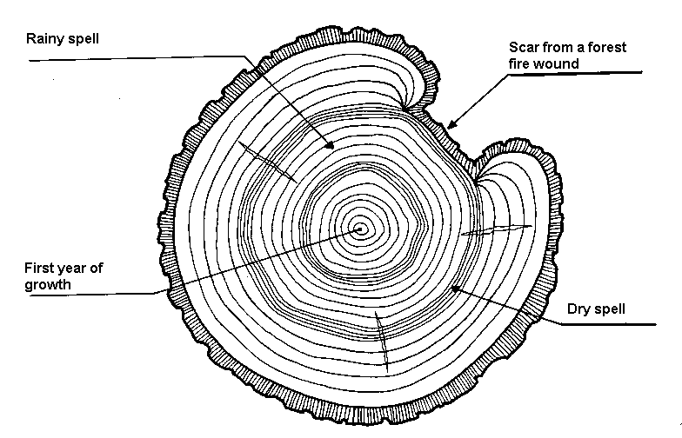
Materials
Tree Ring handout
Sample tree rings with evidence of a variety of events (fire, drought, etc…)
Lab worksheet (teacher created based on tree rings obtained)
Procedure
Warm up: Ask students what they can learn from a tree. Write responses on the board and discuss. Pass out Reading Rings worksheet. Have students match the event on the right with a sample tree ring on the left. The tree rings can be used more than once. Discuss the background information for this lesson.
Activity
- Hand out the Tree Ring Handout. Have the students cut out the core samples at the bottom. Be sure they leave the letter on the core sample so they know which sample they are using.
- Have the students decide which core sample matches the tree ring sample. They do this by laying the core sample across the tree ring looking for a matching pattern of lines. (Be sure that the students understand that core samples do not go father than the core of the tree, so the core sample should not cross the center of the tree.) Ask students which core sample is the one that matches the tree ring.
- Have the students observe the tree ring handout. Then have them assign dates to the important events in the tree’s life. What year did fire scar the tree? (1915) How many years did it take the tree to grow around the remains of a dead branch? (10 years) How long did the drought that began in 1912 last? (2 years).
- Hand out lab worksheet (teacher created). Have the students observe the tree rings arranged around the room and complete the lab questions (teacher created). Teacher may need to contact their local Extension Agent, National Park, or local Forestry official for the tree ring samples.
- Discuss the need for fire in an ecosystem and how it brings balance to an unhealthy ecosystem. Discuss the need for prescribed fire.
Wrap Up – Debate
Survey the students’ feelings on prescribed burns in the National Parks. Have each student research and prepare a debate on the opposite view than they possess (Try to divide the class as evenly as possible- some students may have to write on their own view to keep things even). If the student supports prescribed burns they take the stance against prescribed burns. If the student is against prescribed burns they take the stance for prescribed burns.
Give the students several days to work on the research for their portion of the debate project. Divide the class into debate groups of 4-6 (2 to 3 students from each side). Have each group debate the issue to the whole class.
Assessment
Rubric for debate
Extensions
Take the students on a field trip to a local watershed, for instance, Smith Springs, in Guadalupe Mountains National Park. Have the students look for signs of a fire in the area’s past. Have them write down any evidence they find that indicates that a fire has burned in the area.
Ask a firefighter from the local National Park to come to class and discuss the effects of wildfire and prescribed fire in the National Parks. Some questions they should cover include: Are all wildfires bad? Do they let some wildfires burn? Why or why not? What is a prescribed fire? Why do they have prescribed fires? What considerations do they have to look at before, during, and after a prescribed fire?
Tree Ring Handout
Directions: Cut out the core samples labeled A-C at the bottom of this page. Be sure that you do not cut off the letter or dates on the core samples. Match the core sample to the tree ring sample by laying the core sample across the tree ring sample. Be sure that the core sample does not go further than the core of the tree.
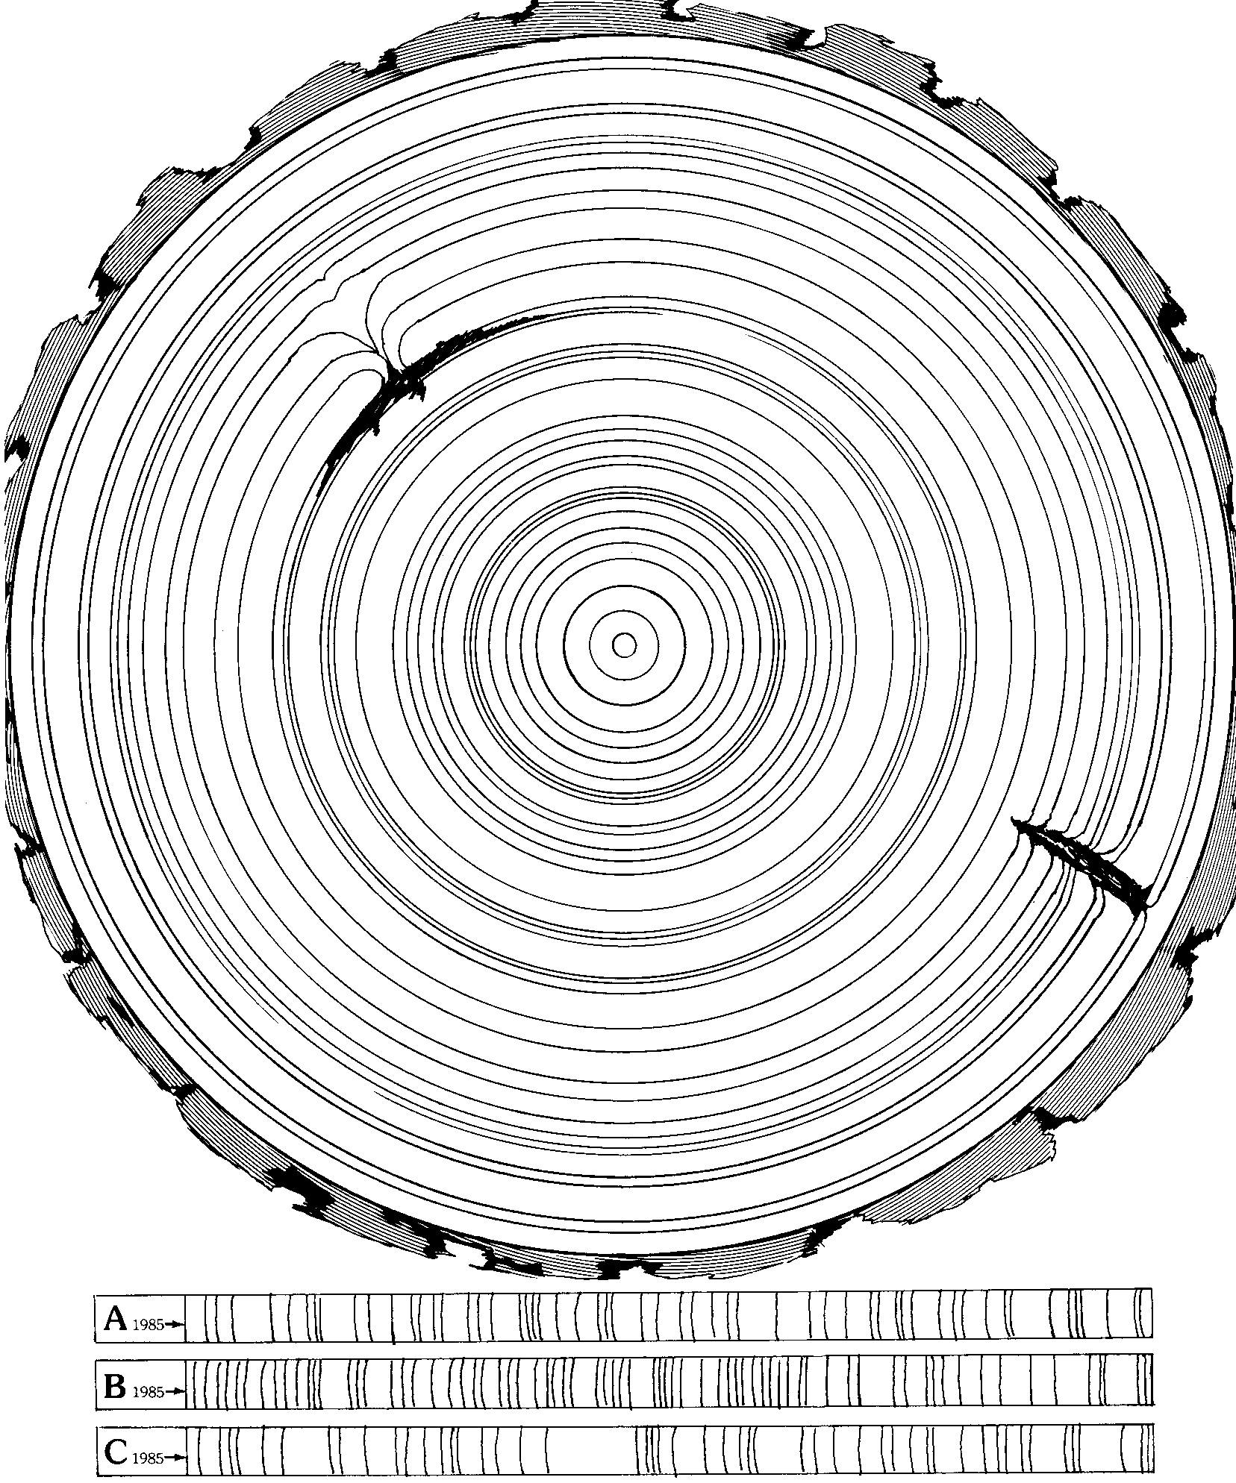

Worksheet adapted from: Ranger Rick’s Nature Scope: Trees are Terrific!
Reading Rings Worksheet
Name: ________________________
Directions: Carefully observe the rings on this worksheet and match them to the events on the opposite side. The rings may be used for more than one event.

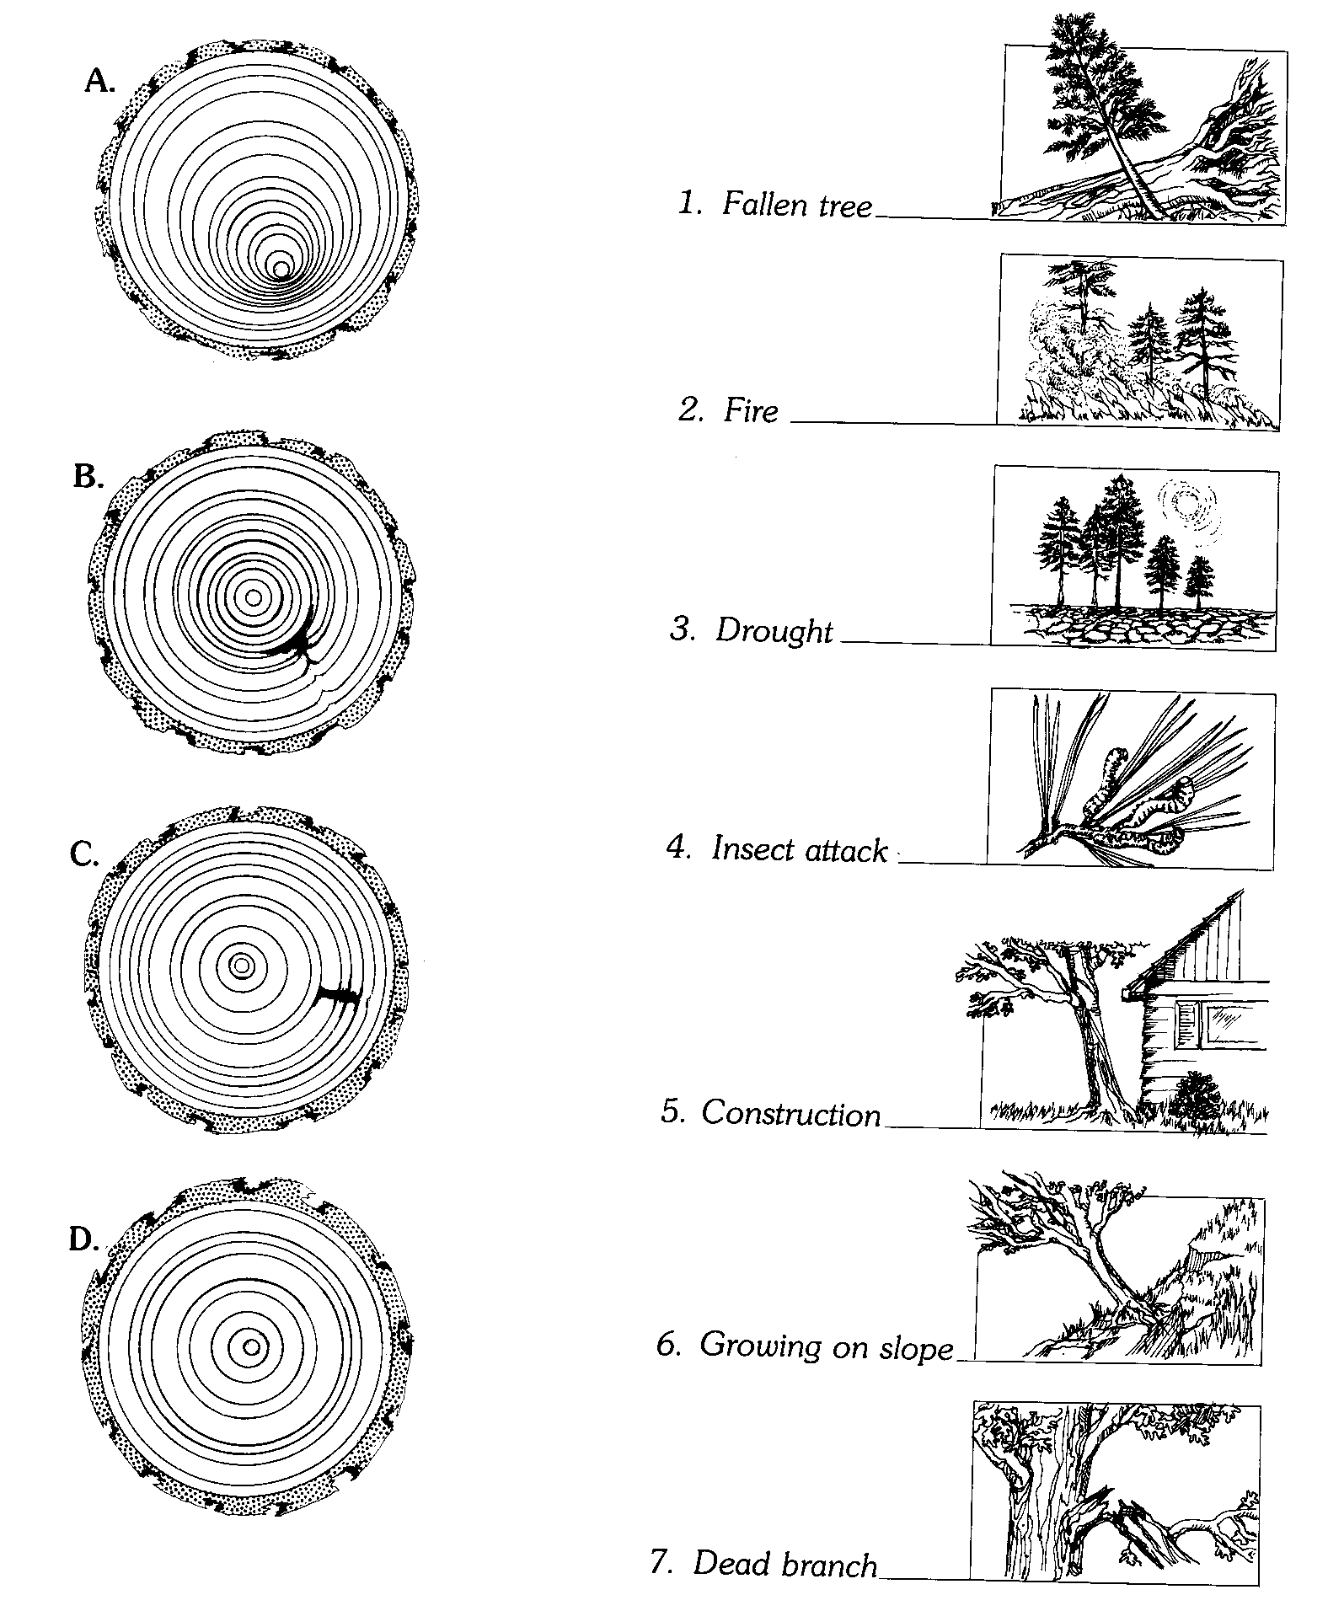
Worksheet adapted from: Ranger Rick’s Nature Scope: Trees are Terrific!
Prescribed Fire
Debate | Self evaluation | Teacher evaluation | Comments
Information: |  | /12
Includes detailed factual information
Supports the assigned viewpoint
Shows evidence of preparing for the opposing side’s arguments
Presentation: |  | /16
Stays calm during the debate
States argument clearly so people understand what is being said
Shows eye contact with the other speaker and audience
Speaks clearly and loudly so audience can hear |  | /4
Teamwork:
Are the efforts of each team member clearly demonstrated, or did it appear to be the work of one or two?
Overall: |  | /12
Has the student fulfilled all the parts of the task?
Has the student used proper grammar and sentence structure?
Has the student cited appropriate resources?
4 no mistakes 3 few mistakes 2 many mistakes 1 incomplete (however is present) 0 not evident or not included

Percentages: Information Presentation Teamwork ________ Overall ________

Conservation
“We must understand that the human and non-human problems are linked. If the forest goes the wildlife goes, and eventually, the ever-increasing human population, no longer able to live in harmony with the natural world, will face starvation.
Yes, there is hope. Especially if we can give hope to children, harness their energy, their concern. We must teach them how to care for the world around them so that societies once again can live in harmony with nature.”
Dr. Jane Goodall
People often use the words conservation and preservation synonymously. However there is a difference. Conservation is the sustainable use and management of natural resources including wildlife, water, air, and earth deposits. Natural resources may be renewable or non-renewable. Conservation of natural resources usually focuses on the needs and interests of human beings, for example the biological, economic, cultural, and recreational values such resources have. Conservationists accept that development is necessary for a better future, but only when the changes take place in ways that are not wasteful. Preservation, on the other hand, attempts to maintain the present condition of areas that are so far untouched by humans. This is due to the concern that mankind is encroaching onto the environment at such a rate that many untamed landscapes are being given over to farming, industry, housing, tourism, and other human developments, and that we are losing too much of what is “natural.” No matter what your beliefs are on the area of preservation, you cannot deny the fact that humans have a tremendous impact on our natural environment. Many of us enjoy outdoor activities that are consequently harmful to the environment if we are not careful and aware of our surroundings.
This unit will focus on ways people can enjoy the wilderness in an environmentally friendly way. In the first activity, We’re All Connected, students will see the interrelationships of plants and animals in an ecosystem. In the second activity, Are You Ready?, the students will learn how to prepare for backcountry travel. In the final activity, Where Do We Camp?, students will learn how to select an appropriate campsite in a desert environment.

We’re All Connected
A personal connection with the natural world nurtures a commitment to protect it.
Summary: Students will participate in a game designed to help them gain an understanding of how the natural world functions and our ability to change this world. Students are reminded that humans are a part of the natural world and thus should be committed to protecting it.
Duration: 1 class period
Setting: Classroom
Vocabulary: ecosystem, stewardship, pollinate, aquifer, ecotone, edge
Standards/Benchmarks Addressed: SC1-E1, SC1-E2, SC2-E1, SC3-E1, SC4-E1,
SC4-E2, SC4-E5, SC5-E2, SC6-E1, SC6-E2, SC6-E3, SC6-E6, SC9-E2, SC11-E1, SC11-E2, SC11-E3, SC11-E4, SC11-E5, SC11-E6, SC11-E10, SC15-E2, SC16-E1, SC16-E2

Objectives
Students will:
- describe connections between the plants and animals of an ecosystem.
- describe behaviors that will help ensure the protection of our natural resources.
- gain a better understanding of their own environment.
Background
Ecology is the study of interactions between living things and their environments. Ecology comes from the Greek word oikos, which means home. The word ecosystem refers to the system of interactions between living and non-living things. Over the past 30 or 40 years, ecosystem has been defined in a variety of ways. Sometimes it is described in terms of the interactions and sometimes in terms of the area where the interactions occur. The use of the term here means a system that has a source of energy (the sun) and includes living and nonliving components. The living components include plants and animals, including human beings. The nonliving components include soil, rocks, water, air, and other physical features.
An ecotone is a zone where two ecosystems overlap. An edge is an area where two or more communities meet abruptly. In local communities there are many edges. This may result from an abrupt change in soil type or other natural causes, or as a result of human activities or fire. Edges attract humans. Because of this, it is in the edge that we see the greatest human impact.
The most accessible edge in your community may be the edge of the school ground. Other edges can be stream banks, lake shores, marsh edges, forest meadows, and ocean beaches. In such places there is the possibility that humans will change the ecotone with damaging consequences for wildlife and plants. Changes may include such things as marshes being drained or filled for construction or agriculture. Natural forests are often cut down for homes and lawns. Streams can be dammed and rivers channelized for boating or shipping. Human litter and other refuse on a lakeshore are also changes. These changes are often an indicator of other human-created problems. Fish-kills and prolonged absence of waterfowl are often indicators of contaminated water.
Plants, insects, animals, and humans owe their existence to one another. Insects pollinate plants and provide food for small animals; plants provide food and shelter for both animals and humans. Plants also help filter water that is then stored in mountains, streams, lakes, and aquifers. When one member of the web of life has been altered or eliminated, other living things are invariably affected.
People are an integral part of the Earth’s ecosystem and the health of ecosystems is intertwined with the viability of human communities. Like all living beings, people require the use of resources. From the air we breathe to our food, water, shelter, clothing, arts, and communication networks, we consume resources to live. Just try to imagine something in your home that is not grown or mined. We tend to forget the fact that natural resources usually support a country’s economy. Our goal in managing the ecosystem should be the wise and reasonably paced use of our resources to assure their availability far into the future. Individuals can take actions to make a difference.
Materials
Plant and animal cards
Double-sided tape
Ball of yarn
Scenario cards
Procedure
Students need to adopt reasons for caring for our natural world. By helping students understand the impact of “just one little piece of litter” we assist them in developing stewardship in caring for the environment.
Warm up: Teachers will write the following items on the board and ask students to guess the life expectancy (time it takes to degrade) of each item.
- Paper (2-4 weeks)
- Banana peel (3-5 weeks)
- Wool cap (1 year)
- Cigarette butt (2-5 years)
- Disposable diaper (10-20 years)
- Hard plastic container (20-30 years)
- Rubber boot sole (50-80 years)
- Tin can (80-100 years)
- Aluminum can (200-400 years)
- Plastic six-pack holder (450 years)
- Glass bottles (thousands or millions of years)
Get feedback from the students regarding the time it takes for each of these items to degrade. Discuss the impact this makes in our ecosystem and in our dumps!
Activity: Students will play a game that demonstrates the connection between plants and animals in an ecosystem.
Students will be given a plant or animal card to stick to their shirts. Students will form a circle. In the middle of the circle (on the floor) lay the following cards: sun, water, soil, and air. The leader can start the ball of yarn. They must look around the circle and find another plant or animal that they need, or that needs them, in order to survive. The person holding the yarn describes this connection and then throws the yarn to that person representing the plant or animal. (ex. “I need the downed log for a home.” “The owl needs me for food.”) Play goes around the circle until everyone is holding a section of the yarn. No one should let go of the yarn. In some cases people may have received the yarn more than once. Have group members observe the web of connections they have made. Discuss what the web demonstrated about connections in an ecosystem (don’t forget the human connection).
Have each student think about one item from the middle of the circle (sun, water, soil, and air) and describe one connection he or she has to this resource (ex. “I need sun in order to photosynthesize”).
Next, have a student read a scenario card. The group should discuss the question. The person who reads should drop their string to show how an impact of one part of the web affects another part (ex. If a camper plays in a small desert water hole, it becomes polluted for the animals that drink there). Anyone with a card that would be affected should also drop their string.
Wrap Up: Have students summarize what they have learned from the game. Students should brainstorm positive methods of ecosystem management and how they support the natural resources.
Assessment
Students will create a poster that demonstrates an ecosystem management concept. They will present this to the class.
We’re All Connected
SUN | WATER
AIR | SOIL

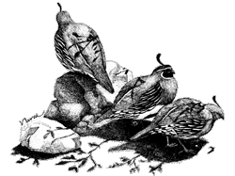  Gamble’s Quail |  | 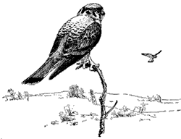  American Kestrel |  | 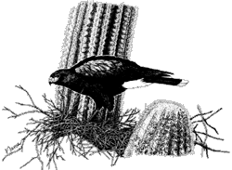  Harris’ Hawk
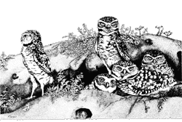  Burrowing Owl |  |   Golden Eagle |  | 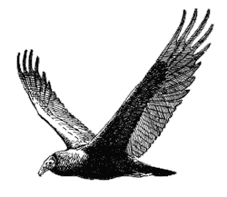  Turkey Vulture
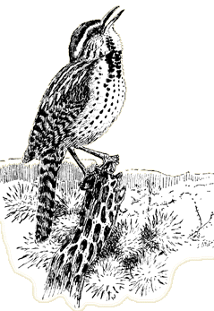  Cactus Wren |  | 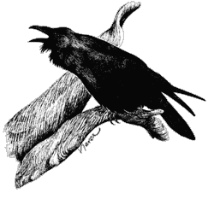  Common Raven |  | 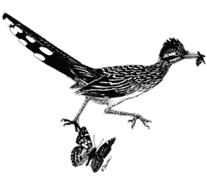  Greater Roadrunner
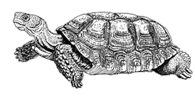  Desert Tortoise |  | 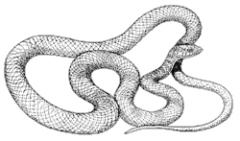  Western Coachwhip |  | 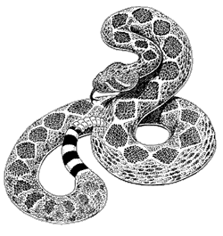  Western Diamondback Rattlesnake
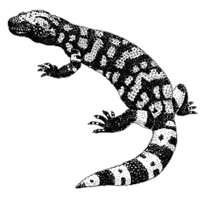  Gila Monster |  | 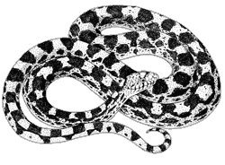  Gopher Snake |  | 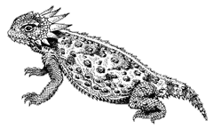  Horned Lizard
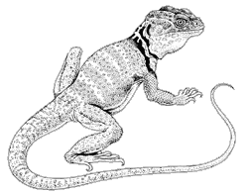  Collared Lizard |  | 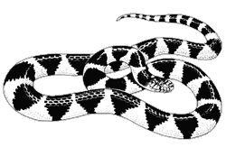  Desert Kingsnake |  | 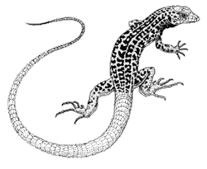  Checkered Whiptail Lizard
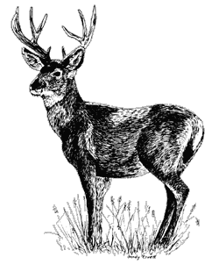  Mule Deer |  | 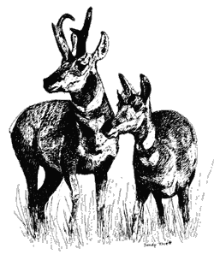  Pronghorn |  | 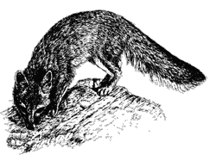  Grey Fox
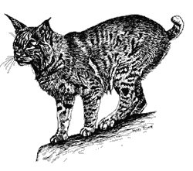  Bobcat |  | 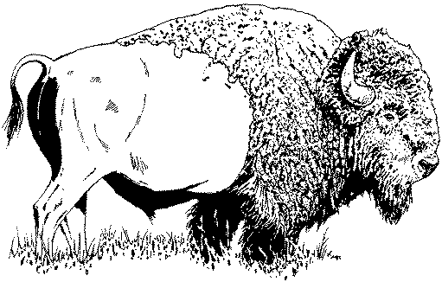  Bison |  | 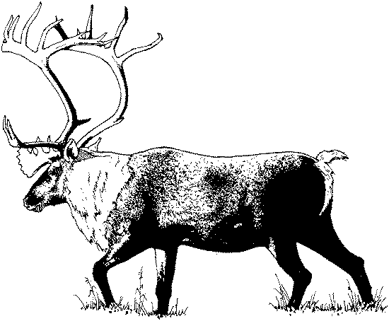  Elk
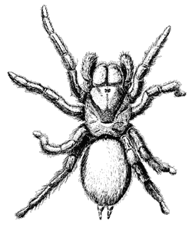  Desert Tarantula |  | 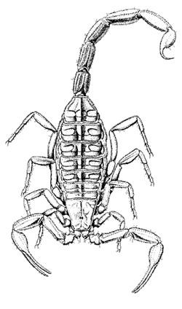  Bark Scorpion |  | 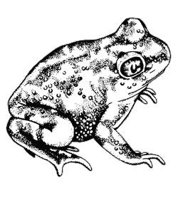  Couch’s Spadefoot
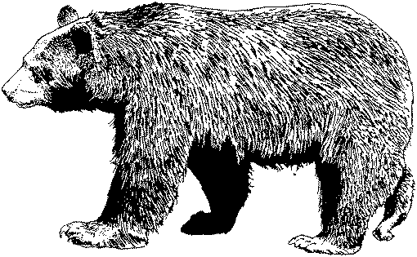  Black Bear |  | 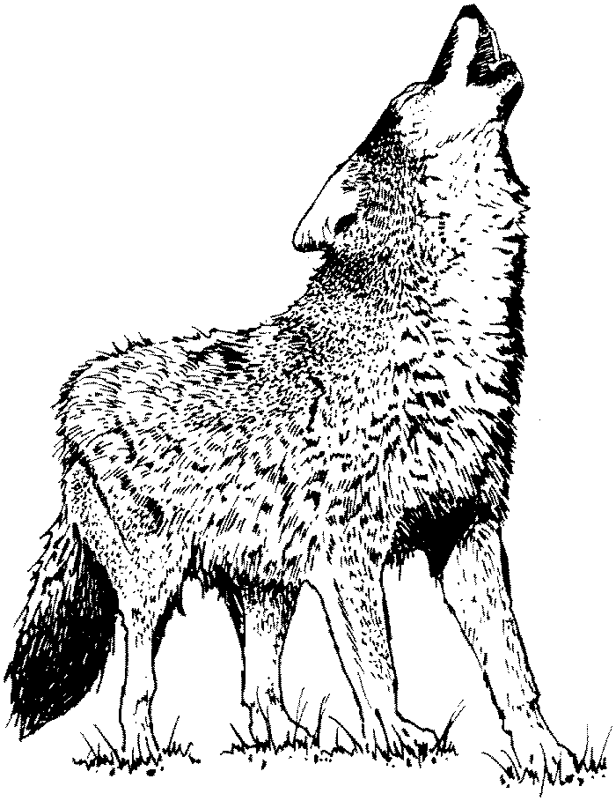  Mexican Gray Wolf |  | 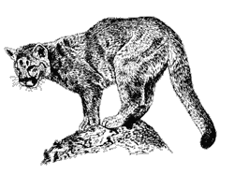  Mountain Lion
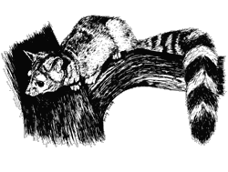  Ringtailed Cat |  | 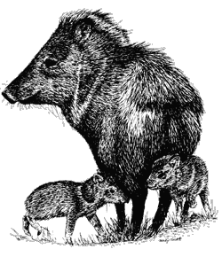  Javelina |  | 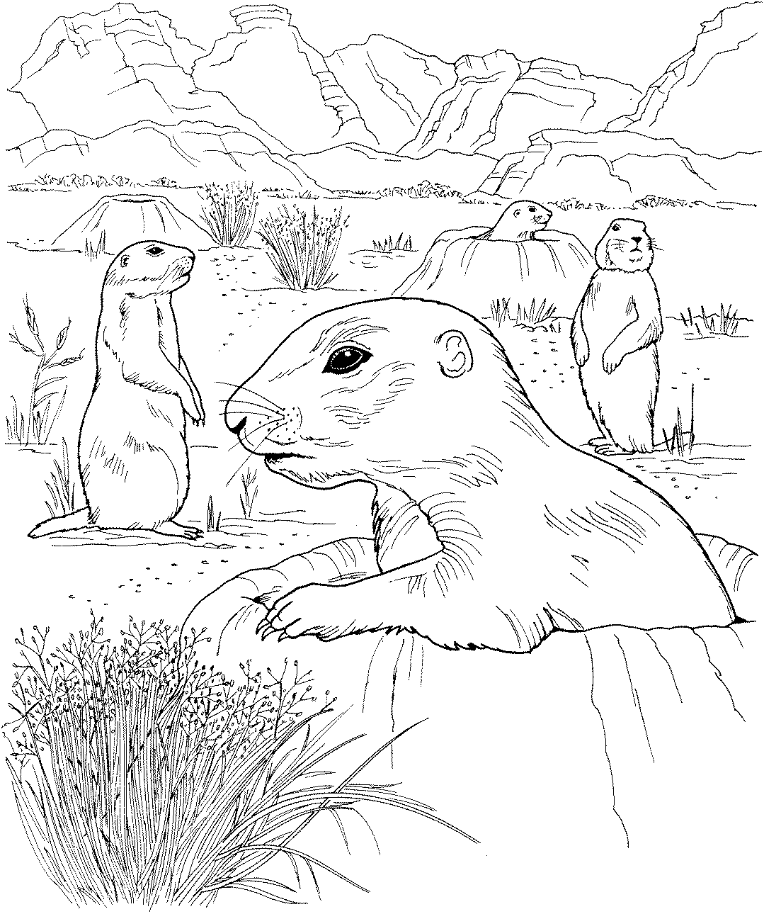  Black-tailed Prairie Dog
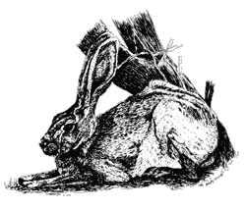  Black-tailed Jack Rabbit |  | 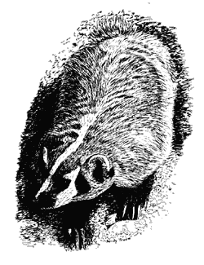  Badger |  | 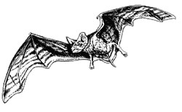  Mexican Free-tailed Bat
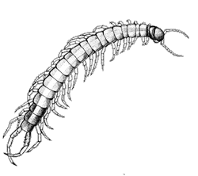  Centipede |  | 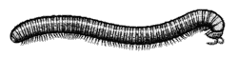  Millipede |  | 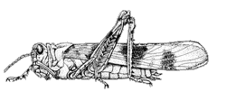  Banded Wing Grasshopper
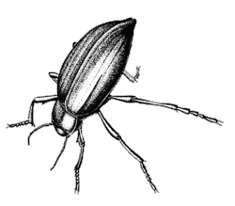  Pinacate Beetle |  | 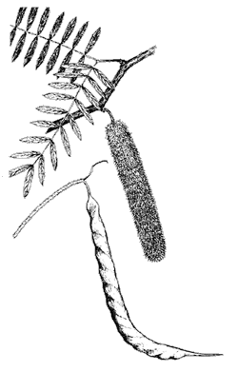  Honey Mesquite |  | 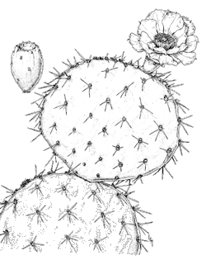  Engelmann Prickly Pear
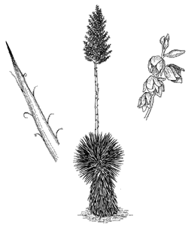  Soaptree Yucca |  | 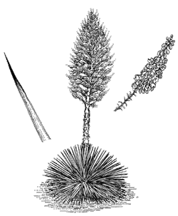  Spanish Bayonet |  | 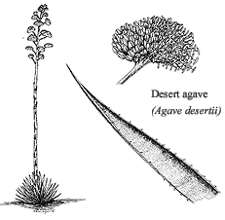  Desert Agave

Grey Fox  Urocyon cinereoargenteus  Mammal  Size: 3-4 ft. long; 7-15 lbs.  Coloring: Cinnamon colored sides and neck, with a silvery-gray back, a black ridge down its back with a black tip on its tail  Diet: Rodents, insects, small vertebrates, fruits, and vegetables  Did you know that a Grey Fox:  - is the master of the ambush?  - is a very intelligent animal? |  | Pronghorn  Antilocapra americana  Mammal  Size: 3 ft. tall, 5 ft. long: 90-130 lbs.  Coloring: Buff colored with two white bands across the throat, white under-parts, and a prominent white rump patch  Diet: Grasses and forbs  Did you know that the Pronghorn:  - sheds the hard, hairy sheath of its horns and retains its bony core?  - is the fastest mammal in North America? |  | Mule Deer  Odocoileus hemionus  Mammal  Size: 3 ft. tall, 5 ft. long; 100-400 lbs.  Coloring: Dark gray in winter, reddish-brown in summer with a large white rump patch which surrounds a small black tipped tail  Diet: Woody shrubs and trees, also grasses  Did you know that Mule Deer:  - are named for its large ears?  - only males have antlers?
Elk  Cervus elaphus  Mammal  Size: 8 ft long, 5 ft antlers; 400-1000 lbs.  Coloring: Reddish-brown with dark hair on its neck with a pale yellow rump patch surrounding a small white tail  Diet: Grasses  Did you know that the Elk:  - only lose antlers in midwinter, and begin regrowth within a month?  - associate in herds of 25 or more? |  | Bison  Bos bison  Mammal  Size: 6 ft. at shoulder; 950-2650 lbs.  Coloring: Dark brown with an even dark thick hair that surrounds its head and face  Lifespan: 18-25 years  Diet: Grasses  Did you know that the Bison:  - can run up to 35 miles per hour?  - have more hair on their head because they face into the cold and wind? |  | Bobcat  Lynx rufus  Mammal  Size: 3 ft. long; 15-35 lbs.  Coloring: Reddish-tan coat scattered with dark spots and stripes, a tipped-tail with a white underside  Diet: Rabbits, rodents, insects, birds, and occasionally a young deer or pronghorn  Did you know that the Bobcats:  - have spots on ears for kittens to follow?  - have a naturally “bobbed” tail?
Spadefoot  Scaphiopus couchi  Amphibian  Size: 3 inches  Coloring: Greenish, yellowish, olive frog with irregular blotches of black, brown, or dark green. White belly without markings.  Lifespan: 6-12 years  Diet: Insects  Did you know that the Spadefoot:  - has a call that sounds like a sheep?  - has eggs that hatch in one day? |  | Bark Scorpion  Centruroides exilicauda  Arthropod  Size: 2-3 inches  Coloring: Tannish brown with darkly marked ridges  Lifespan: 2-5 years  Diet: Insects and other scorpions  Did you know that Scorpions:  - sting with a powerful venom?  - carry their babies on their back?  - are nocturnal? |  | Desert Tarantula  Aphonopelma chalcodes  Arthropod  Size: 3 inches  Coloring: Copper color with a reddish abdomen and black legs  Lifespan: 25 years (female), 10-12 (male)  Diet: Insects, small lizards, and rodents  Did you know that Tarantulas:  - have large fangs that inject venom into their prey?  - are preyed upon by skunks and coyotes?
Harris’ Hawk  Parabuteo unicinctus  Bird  Size: 21 inches, 51 inch wingspan  Coloring: Dark brown with chestnut shoulder patches, a long black tail with white at its base and tip  Diet: Rodents, rabbits, and birds  Did you know that Harris’ Hawks:  - hunt in groups?  - have a loud, rasping call? |  | American Kestrel  Falco sparverius  Bird  Size: 10 inches long, 23 inch wingspan  Coloring: Mostly brown, with rust brown on back and tail, black and white head  Lifespan: 11 years  Diet: Insects, mice, lizards, and snakes  Did you know that the Kestrel:  - hovers in midair?  - male offers food to female during courtship? |  | Gambel’s Quail  Callipepla gambelii  Bird  Size: 10-12 inches long  Coloring: Male-brown with various bars and markings, black patch on breast, reddish sides, and large plume on its head. (Female differs slightly)  Diet: Seed, fruit, insects, and mesquite buds  Did you know that the Gambel’s Quail:  - has a total of 10 call types?  - can survive extremely cold temperatures?
Turkey Vulture  Cathartes aura  Bird  Size: 26-32 inches long; 72 inch wingspan  Coloring: Small naked red head with two-toned blackish wings and paler flight feathers  Diet: Carrion, garbage, and offal  Did you know that the Turkey Vulture:  - utters faint hisses, grunts, and barks when alarmed?  - will vomit as an act of self-defense? |  | Golden Eagle  Aquila chrysaetos  Bird  Size: 30-40 inches long, 84 inch wingspan  Coloring: Dark with slight lightening at base of tail with a wash of gold on the hind-neck, legs and talons are golden  Lifespan: 18-40 years  Diet: Rabbits, birds, grouse, and waterfowl  Did you know that the Golden Eagle:  - has a yelping bark (seldom heard)?  - uses same nest for many years? |  | Burrowing Owl  Athene cunicularia  Bird  Size: 8-11 inches long  Coloring: Brown, spotted, and barred with two white eyebrow marks above two yellow eyes  Diet: Large insects, rodents, and birds  Did you know that the Burrowing Owl:  - when disturbed sends off an alarm that imitates a rattlesnake?  - returns to the same nest year after year?
Greater Roadrunner  Geococcyx californianus  Bird  Size: 20-24 inches long  Coloring: Dark with white markings, stream-like plumage, off-white lower-down with black stripes, with blue legs and beak  Diet: Insects, lizards, rodents, and fruit  Did you know that the roadrunner:  - can run up to 15 miles per hour?  - is a member of the cuckoo family? |  | Common Raven  Corvus cryptoleucus  Bird  Size: 19-21 inches long  Coloring: Glossy black feathers with white bases if ruffled on neck and breast, with black feet, legs and bill  Diet: Omnivorous, carrion, insects, plants  Did you know that the raven:  - can mimic human speech?  - likes shiny things and often steals them? |  | Cactus Wren  Campylorhynchus brunneicapillus  Bird  Size: 7-9 inches long  Coloring: Brownish with heavy spotting that gathers into a cluster on upper breast, white stripe over eye and white spots on outer tail, dark beak, light legs and feet  Lifespan: 7 years  Diet: Insects, fruit pulp, and seeds  Did you know that the Cactus Wren:  - has a call that sounds like “chug, chug”?
Western Diamondback Rattlesnake  Crotalus atrox  Reptile  Size: 30-84 inches long  Coloring: Gray, brown, pink, or yellowish with light brown to black blotches on its back  Lifespan: 20-25 years  Diet: Rodents, rabbits, lizards, and birds  Did you know that this rattlesnake:  - is called “coon tail” for the rings on its tail?  - causes the most number of serious snakebites in the US? |  | Western Coachwhip  Masticophis flagellum  Reptile  Size: 3-8 ft. long  Coloring: Tan, gray, pink, black, and even a reddish-brown color  Diet: Rodents, birds, eggs, lizards, insects, and carrion  Did you know that the Coachwhip:  - has been clocked moving at 3.6 MPH?  - seizes and swallows prey without killing it? |  | Desert Tortoise  Gopherus agassizii  Reptile  Size: Up to 14 inches  Coloring: Brown to gray with a yellowish underside  Lifespan: 35-40 years  Diet: Grasses and cacti fruit  Did you know that the Desert Tortoise:  - can live without water?  - is protected in all areas?
Horned Lizard  Phrynosoma spp.  Reptile  Size: 2-5 inches  Coloring: Brown, flat, toad-like body with thorn-like projections at rear of head  Diet: Insects (especially ants)  Did you know that the Horned Toad:  - squirts blood from its eyes as defense?  - uses its large, flat body as a solar collecting panel? |  | Gopher Snake  Pituophis melanoleucus  Reptile  Size: 4-9 ft. long  Coloring: 33–66 light to dark brown or reddish blotches on a yellow, tan, or cream colored background, dark stripe runs from in front of the eye to angle of jaw  Lifespan: 20-25 years  Diet: Rodents, rabbits, birds, and eggs  Did you know that the Gopher Snake:  - is sometimes mistaken for a rattlesnake? |  | Gila Monster  Heloderma suspectum  Reptile  Size: 2 ft. long  Coloring: Bright pink/orange and black, usually in reticulated pattern and beaded look of dorsal scales  Lifespan: 20-30 years  Diet: Rodents, rabbits, lizards, and eggs  Did you know that the Gila Monster:  - is one of only two venomous lizards in the world?
Checkered Whiptail Lizard  Cnemidophorus spp.  Reptile  Size: 2-6 inches  Coloring: Tan, olive, or brown with lighter stripes or spots of yellow or white  Diet: Variety of invertebrates and insects  Did you know that Whiptails:  - are most active in the morning?  - reproduce (in 30% of subspecies) without a male lizard? |  | Desert Kingsnake  Lampropeltis getulas  Reptile  Size: 3-6 ft.  Coloring: Dark brown or black snake with narrower bands of yellow, white, or cream around body; smooth and glossy  Diet: Lizards, birds, frogs, eggs, and snakes  Did you know that the Kingsnake:  - includes the rattlesnake as part of its diet?  - seldom strikes when threatened but discharges a musk? |  | Collared Lizard  Crotaphytus collaris  Reptile  Size: 8-12 inches  Coloring: Tan, bright green, olive, brown, bluish, or yellowish body with many light spots and two black collars around neck  Diet: Grasshoppers, insects, and lizards  Did you know that the Collared Lizard:  - is diurnal (hunts during the day)?  - runs on two back legs with front two tucked against chest?
Mountain Lion  Puma concolor  Mammal  Size: 6-7 ft. long; 100-200 lbs.  Coloring: Tawny coat is a monotone shade with lighter areas under its belly and inside legs, sometimes has a black tipped tail  Lifespan: 15 years  Diet: Deer and other hoofed animals  Did you know that Mountain Lions:  - roam a wide area up to 200 sq. miles?  - rarely are seen by humans? |  | Mexican Grey Wolf  Canis lupus  Mammal  Size: 5-6 ft. long; 50-175 lbs.  Coloring: Gray with scattered black and dark brown hair, dark tips on ears and areas on face  Lifespan: 10-15 years  Diet: Deer, elk, and other large prey  Did you know that the Grey Wolf:  - is an Endangered Species?  - has long legs for running distances? |  | Black Bear  Ursus americanus  Mammal  Size: 5-6 ft. long; 200-500 lbs.  Coloring: Comes in many colors from pure white to totally black. In West usually in brown, cinnamon, or tan  Lifespan: Up to 27 years  Diet: Fruit, nuts, insects, meat, and garbage  Did you know that the Black Bear:  - can sprint more than 25 miles per hour?  - stores fat for winter hibernation?
Black-tailed Prairie Dog  Cynomys indovicianus  Mammal  Size: 1-2 ft. long  Coloring: Brownish, cinnamon color with a black tipped tail  Lifespan: 8 years  Diet: Grasses, leaves, roots, and seeds  Did you know that the Prairie Dog:  - live together in towns?  - live in burrows? |  | Javelina  Pecari tajacu  Mammal  Size: 3-4 ft. long; 40-50 lbs.  Coloring: Black and gray bristles blend to form a “salt and pepper” color with a lighter band of hair around its neck  Lifespan: 15 years  Diet: Mesquite beans, fruits, and cactus  Did you know that the Javelina:  - can go days without water?  - is not a pig but looks like one? |  | Ringtailed Cat  Bassariscus astutus  Mammal  Size: 1-2 ft. long; 1-2 lbs.  Coloring: Grayish-brown with a fluffy black and white ringed tail, with white ringed large black eyes  Diet: Rodents, fruit, birds, reptiles, and insects  Did you know that the Ringtailed Cat:  - is nocturnal?  - uses its long tail for balance?
Mexican Free-tailed Bat  Tadarida brasiliensis  Mammal  Size: 4 inches  Coloring: Dark brownish black with a lighter underside  Diet: Moths and other insects  Did you know that the bat:  - migrates to Mexico every winter?  - travels up to 200 miles a night? |  | Badger  Taxidea taxus  Mammal  Size: 2-3 ft. long, 30-45 lbs.  Coloring: Dark “badges” offset white cheeks and a white stripe that extends from its nose, between ears, to the shoulder area  Diet: Large rodents, gophers, and reptiles  Did you know that the badger:  - has been recorded traveling together with coyotes?  - has loose versatile skin? |  | Black-tailed Jack Rabbit  Lupus californicus  Mammal  Size: 2 ft. long, up to 6 inches long (ears)  Coloring: Gray with black tips on its ears with a black stripe that runs along the top of the tail to the rump  Diet: Grasses and forbs  Did you know that the Jack Rabbit:  - uses its long ears to help cool its body?  - can run very fast?
Banded-wing Grasshopper  Acridinae achurum  Insect  Size: 1-2 inches long  Coloring: Hind wings can be red, orange, yellow with white bands on drab brown forewings  Diet: Plants and leaves  Did you know that the Grasshopper:  - uses its color to blend into its background?  - can leap over 20 times its body length? |  | Millipede  Orthoperus ornatus  Arthropod  Size: 4-5 inches long  Coloring: Dark golden brown  Diet: Decaying organic material  Did you know that the Millipede:  - spends most of its time underground?  - if threatened exudes foul tasting chemicals from its body? |  | Centipede  Scolopendra polumorpha  Arthropod  Size: 4-5 inches long  Coloring: Brown and tan  Diet: Insects, arthropods, lizards, and small rodents  Did you know that the Centipede:  - actually pinches, not “bites”?  - injects venom into prey?
Engelmann Prickly Pear  Opuntia engelmannii  Plant  Size: Mounds up to 5ft.tall, and 2-3 times wider  Coloring: Blooms on green pads are bright yellow, has a rich purplish-red fruit  Blooming Season: May near end of Spring  Did you know that the Prickly Pear:  - fruit is edible by animals and by humans?  - pads can get over a foot wide? |  | Honey Mesquite  Prosopis glandulosa  Plant  Size: 10-30 ft.  Coloring: Two pinnae with smooth or hairy bright green leaflets  Blooming Season: Spring and sometimes midsummer  Did you know that the Honey Mesquite:  - is used to make beautiful furniture?  - seeds are dispersed by trucks transporting cattle? |  | Pinacate Beetle  Eleodes spp.  Insect  Size: 1 inch in length  Coloring: Glossy black  Diet: Carrion, animal scat, plants, and wood  Did you know that the Beetle:  - uses antennae as receptors to detect food, locate egg laying sites, and assess temperature and humidity?  - Is part of largest group of insects on Earth?
Desert Agave  Agave desertii  Plant  Size: 12-20 ft tall, 1 ft, in diameter  Coloring: Leaves are light gray to bluish-gray with marginal teeth, the flowers are bright yellow  Blooming Season: Summertime  Did you know that the Desert Agave:  - forms in ring-shaped colonies?  - is extensively harvested by desert peoples? |  | Spanish Bayonet  Yucca filamentosa  Plant  Size: 8 ft. tall, 3-6 ft. in diameter  Coloring: Bluish-green rosette with creamy white flowers  Blooming Season: Beginning of summer  Did you know that the Spanish Bayonet:  - are pollinated by a moth?  - have some flowers tinged with purple? |  | Soaptree Yucca  Yucca elata  Plant  Size: 23 ft tall  Coloring: Flowers are a creamy white on a large green stalk with green leaves  Blooming Season: May and June  Did you know that the Soaptree Yucca:  - leaves are used as a basketry fiber?  - leaves can grow up to 2 feet long?

We’re All Connected
Scenario cards
A family has chosen to make camp on the edge of a pristine meadow. They stay for a week and when they leave you see a rock fire ring, several logs that had been used for benches, and a well worn area in and around the campsite.  Questions:  - How will this scene attract more campers to the area?  - How might increased usage by campers affect the meadow’s community of life? | Your group has been hiking all day in the desert. You camp near a small desert water hole. Some of the campers decide a refreshing dip in the pond is just what they need.  Questions:  - How might the campers affect the animals that use this location at night to get their water?  - What should you do and what, if anything, should you say to the other campers?
A group of campers go out for an afternoon hike. They spot an area filled with beautiful flowers. Later that day they all return home with a handful of flowers as a souvenir.  Questions:  - Why should the flowers be left in their natural setting?  - How else might campers be able to capture the beauty of nature without leaving an impact on the community? | It’s time for supper. It is your job to collect the firewood. You pick up the axe and head out. A few yards down the trail you find a tree and begin to hack away. Finally you have a few pieces. You also decide to peel away some bark in order to get the fire started.  Questions:  - Might these actions affect the trees and the environment?  - What alternatives are there to cooking with fire?

Are You Ready?
What do you need to consider when planning a trip to the wilderness?
Summary: Students will participate in an activity designed to help them gain an understanding of the importance of planning ahead in order to ensure safety and minimal impact on the environment.
Duration: 1 class period
Setting: Classroom
Vocabulary: environment, conservation, preservation
Standards/Benchmarks Addressed: SC1-E1, SC2-E1, SC3-E1, SC4-E1, SC4-E5, SC5-E2, SC6-E1, SC6-E2, SC6-E3, SC6-E4, SC6-E5, SC11-E2, SC11-E5, SC11-E6, SC11-E8, SC16-E1, SC16-E2

Objectives
Students will:
- explain the concept of conservation.
- explain the concept of preservation.
- explain how education and planning help reduce impact on the environment.
Background
Those who are concerned with protecting the environment often use the words conservation and preservation. Although these two terms are often confused and are used to mean the same thing, differences exist.
Conservation is the sustainable use and management of natural resources including wildlife, water, air, and earth deposits. Natural resources may be renewable or non-renewable. The conservation of renewable resources like trees involves ensuring that they are not consumed faster than they can be replaced. The conservation of non-renewable resources like fossil fuels involves ensuring that sufficient quantities are maintained for future generations to utilize. Conservation of natural resources usually focuses on the needs and interests of human beings, for example the biological, economic, cultural, and recreational values such resources have. Conservationists accept that development is necessary for a better future, but only when the changes take place in ways that are not wasteful.
Preservation, in contrast to conservation, attempts to maintain in their present condition areas of the Earth that are so far untouched by humans. This is due to the concern that mankind is encroaching onto the environment at such a rate that many untamed landscapes are being given over to farming, industry, housing, tourism, and other human developments, and that we are losing too much of what is “natural.” The mindset of preservationists can range from protection of nature for purely human-centered reasons to preservation regardless of their usefulness to humans. The latter follows the belief that every living thing has a right to exist and should be preserved.
Regardless of where you stand on your beliefs towards preservation, we cannot deny that plants, insects, animals, and humans owe their existence to one another. When one member of the web of life has been altered or eliminated, other living things are invariably affected.
People are an integral part of the Earth’s ecosystem and the health of ecosystems is intertwined with the viability of human communities. Like all living beings, people require the use of resources. From the air we breathe to our food, water, shelter, clothing, arts, and communication networks, we consume resources to live. Just try to imagine something in your home that is not grown or mined. We tend to forget the fact that natural resources usually support a country’s economy. Our goal in managing the ecosystem should be the wise and reasonably paced use of our resources to assure their availability far into the future. Individuals can take actions to make a difference.
Materials
Pictures of the desert
Travel cards
Low Impact Techniques handout
Survival Backpack handout
Prep
Teacher will bring a backpack packed for an imaginary day hike of your choice.
Procedure
Warm up: Teacher will explain to the students that they will be going on an imaginary hike. Tell students that they will use the Survival Backpack handout to draw pictures of what they will need to take. Students may ask where they are going but explain that they will have to guess.
Allow students enough time to complete their drawings and then reveal to them the location of the imaginary hike. Show them destination pictures (pictures of a desert location or any location you have chosen). Explain the purpose of the trip (fishing, wildlife viewing, etc.). The teacher will then unpack his or her bag to show the equipment necessary for a successful hike.
Ask the students to “unpack their packs” and consider the following questions.
- How well do the contents of your pack prepare you for your trip?
- How well do the contents of your pack ensure your safety? (proper clothes, maps, compass, small flashlight, water filter, firstaid kit, etc.)
- How well do the contents ensure minimal impact to natural resources?
- How well do the contents ensure your trip will meet your goal?
Ask the group to consider these questions.
- How would the contents of your pack change with different destinations?
- What other information would you need in order to pack properly for a trip?
- What is the value of knowing this information before packing?
Activity: Review Low Impact Techniques.
- Pass out event and solution cards. Each student will get one card. The object of the game is to match the event with the solution.
Key for game: 1 & 11, 2 & 9, 3 & 13, 4 & 15, 5 & 12, 6 & 16, 7 & 14, 8 & 10
- Once the students have paired up, each pair will plan a way to teach the plan ahead concept.
- Have each pair take turns teaching the concept to the group.
Wrap Up: As a group:
- Discuss why trip planning is so important (ensures safety, allows the accomplishment of your trip goals, allows minimal impact on natural resources).
- What elements should be considered when trip planning (identify goals, skills and ability, gain knowledge of the area you plan to visit, choose proper equipment and clothing)?
- Discuss the concepts of conservation and preservation and how they affect us.
Assessment
Students will work in groups to research topics related to the wilderness, conservation, or preservation. Students will present their findings to the class.

Are You Ready?
Conservation/Preservation Rubric | Self Evaluation | Teacher Evaluation | Comments
Written: |  | /16
Identify at least three reasons why trip planning is important.
Describe key elements of successful planning and preparation.
Explain the concept of conservation or preservation.
Explain the relevance of conservation or preservation as it applies to your area of research.
Presentation: |  | /4
Presentation quality, organization, information, and appeal
Teamwork: |  | /4
Are the efforts of each team member clearly demonstrated?
Responsibility: |  | /4
Turned in on due date and presented in class with visual aids.
4 - no mistakes 3 - few mistakes 2 - many mistakes 1 - incomplete (however is present) 0 - not evident or not included

Percentages: Visual _____ Written _____ Presentation _____ Responsibility _____ Teamwork _____ Overall _____
Are You Ready?
Travel Cards
Event Card 1  You and your family are walking along a trail when you suddenly come up to a fenced off area and a sign that reads, “Private Property.” Now what? | Solution Card 13  The planner of this hike had come to this area two weeks ago and found several alternative sites. Therefore, after hiking another 15 minutes you find the perfect spot.
Event Card 2  You haven’t brought a stove, and the area you came to visit has been heavily used. To make matters worse there’s a fire ban and everyone’s hungry. | Solution Card 9  Because this was only an overnight camping trip, someone brought prepared food along. As night falls everyone gathers around for sandwiches and fruit and to watch for falling stars.
Event Card 3  It is getting late and you haven’t reached your destination yet. You are tempted to set up camp here on the trail, what do you do? | Solution Card 15  After another hour of an uncomfortably dry hike, you run across another hiker who pulls out a water filter designed to remove bacteria from open water sources. You take a break by a small pond and filter enough water to finish your hike. Make a note to purchase a water filter or purification tablets before your next hike.
Event Card 4  You thought everyone in the group brought plenty of water, but it has been a long hot trip. With a fire ban in effect and a low supply of water, what do you do? | Solution Card 11  The planner of this hike had reviewed a map several weeks ago and realized he needed to contact the owner of the land. Therefore, he now has a signed permission statement to cross the private property.

Are You Ready?
Travel Cards
Event Card 5  Your new hiking boots have rubbed a blister on your heel. Your backpack is feeling extremely heavy and you’re not sure if you can make it to the campsite. | Solution Card 16  While planning your trip you read safety tips and found out that lightning is attracted to the highest point and that water and metal are conductors. You hike to the lowest spot and crouch down. Remove your metal frame, stay away from water and tall trees, and insulate yourself from the ground by sitting on your pack.
Event Card 6  After a beautiful day the clouds begin to roll in. You can see lots of lightning. You estimate you have about ten minutes until the storm reaches you. | Solution Card 12  Encourage everyone to check “hot spots’ while you take a break. Change your socks often and keep your feet clean and dry. Remember to carry an adhesive felt-like material that acts like a second skin to help prevent rubbing.
Event Card 7  You felt energized when you left this morning but now your backpack feels like it’s loaded with stones. You’re so tired you feel like stopping right here. | Solution Card 10  When you were planning the hike you figured that people hike an average of 2 miles an hour on flat surface. You realized that you should add an extra hour for the steep terrain. Encourage everyone to take it steady and slow. You have plenty of time to reach camp.
Event Card 8  Your hike is two miles long and is a very steep trail. Your campsite is still a long ways off, but everyone is having to walk very slowly. | Solution Card 14  Your heavy backpack has made it impossible to reach your destination.  Plus, you’ve had a miserable day. Next time, keep in mind that your pack should be no more than a fourth of your body weight. Take only items necessary and divide them among several packs.

Low Impact Techniques
- Plan ahead and prepare – Proper planning and preparation increases the opportunity for a positive learning experience and helps ensure a safe trip. Poor planning can lead to a miserable experience or, worst of all, a rescue event.
Tips in planning ahead:
  - Write down your expectations of the trip.
  - Assess the skills and abilities of the members of your group.
  - Get information about the area you plan to visit (get maps, etc.)
  - Stay away from areas susceptible to flash flooding.
  - Carry plenty of drinking water.
  - Check weather conditions.
  - Talk with the local land managers regarding any regulations, permits, etc.
  - Choose appropriate equipment and clothing.
  - Anticipate food usage (and the waste).
  - (Meal planning is essential. Planning for lightweight snacks and one-pot meals can reduce the dependency on campfires, reduce trash, and reduce pack weight.)
Outdoor Essentials:
- Extra clothes
- Extra food
- Camera
- Pocketknife
- Matches and fire starters
- Sun and insect protection
- Watch
- Water bottles
- Maps and compass
- First-aid kit
- Stove
- Rain gear
- Trowel for digging a cathole
- Strainer for removing food particles from dishwater
- Axes and saws are not needed. A Low Impact fire is built by collecting downed wood.
- Hike and camp on durable surfaces – Hikers should concentrate activities in heavily used areas. The goal is to enjoy the experience while minimizing the damage to the land. Damage can occur when hikers trample surface vegetation or communities of organisms beyond recovery. Choose one well-designed route. In pristine areas it is important to spread the use and impact. Two primary factors influence how off-trail travel affects the land: durability of surfaces and vegetation, and frequency of travel. Surface durability refers to the ability of surfaces to withstand wear. Frequency increases the likelihood of an area being trampled. Durability of the surface is an important consideration. Rocks, sand, and gravel are highly durable. Ice and snow make good choices for travel as long as there is sufficient depth and firmness to prevent vegetation damage. Making careful decisions about traveling across vegetation is vital to prevent damage to fragile vegetation. A general rule is to spread out to avoid creating a path that would encourage others to follow. In desert environments, cryptobiotic crusts that consist of tiny communities of organisms are extremely vulnerable to foot traffic. One footstep can destroy cryptobiotic crust for decades. In this case it is best to follow in one another’s footsteps, thereby affecting the smallest area possible. In the desert water is a scarce resource for all living things. Don’t disturb the water in any way. Even the smallest water hole is a home to tiny desert animals. Selecting a campsite is the most important aspect of low-impact use. Avoid camping close to water and trails (a good rule of thumb is at least 200 feet away) in order to allow access routes for wildlife. The object is to confine impact to places that already show use and avoid enlarging the area of disturbance. In a remote area, spread out tents, avoid repetitive traffic routes, and move the camp each night.
You should also consider wearing soft shoes and minimizing the activity around the kitchen. Before leaving, rake matted grassy areas with a stick and brush out footprints. In deserts beware of camping in areas susceptible to flash flooding and never camp on cryptobiotic soil or on islands of vegetation. In any situation never scrape away the organic litter in a site. The litter acts as a cushion, reduces erosion, and releases plant nutrients. The removal of rocks and gravel may destroy lichens and varnish that will not grow back within our lifetime.
- Leave what you find – Minimize site alterations by finding a good campsite not making one. Avoid damage to living things. Never cut, trample, or nail things into trees. Don’t take on the mindset of “I’ll just pick a few.” Natural objects of interest should be left so others can experience the discovery. In many protected areas it is illegal to remove natural objects or cultural artifacts. Knowledgeable campers take a picture instead.
- Properly dispose of any waste (pack it in, pack it out) – Trash and litter in the backcountry ranks high as a problem. This type of human impact can greatly detract from the naturalness of an area. It is possible to leave most potential trash at home if you take the time to repackage food supplies. Never consider burning your trash. Areas are often closed to fires and some desert settings have a scarcity of firewood. Food scraps must be packed out. Under no circumstances should they be discarded or buried. Human food is not natural for wild animals. Their natural feeding cycles and habits become disrupted when fed by humans. Sanitation is another consideration. Dishwater should be strained and food particles sealed and packed out. Broadcast the water over a large area for quick evaporation and minimal impact. In most areas human waste can be buried if done correctly. However, places such as narrow river canyons or caves may require the waste to be packed out.
- Minimize the impact of campfires – The most important consideration to be made when deciding to use a fire is the potential damage to the backcountry. Consider the fire danger, restrictions, and the supply of materials when deciding. If building a fire cannot be avoided choose an area where wood is abundant. It is always best to use an existing fire ring. Allow the wood to burn completely to ash and then put the fire out with water, not dirt. Scatter the remains over a large area away from camp. Keep the area looking as natural as possible. Pack out any litter.
- Be considerate of others – Allow all visitors to enjoy their outdoor experience. Most people come to the outdoors to listen to nature therefore excessive noise and unleashed pets will take away from everyone’s experience. In some areas pets may be prohibited. Consider keeping the noise level down by using headphones. Be courteous to other groups by yielding to both equestrians and hikers. Before passing others, politely announce your presence. When taking a break, make sure you are on a durable surface. Remember, it is up to us to keep our wilderness areas healthy and beautiful in order to ensure their use for future generations.
- Respect wildlife – One of the most important aspects to keep in mind is that you are a visitor in their home. It is best to learn about wildlife through quiet observation. A good rule of thumb is that if your actions or presence causes wildlife to alter their normal habits then YOU’RE TOO CLOSE. Consider carrying binoculars, a spotting scope, or a telephoto lens to view wildlife. You may want to keep your group small to minimize your impact. Quick movement and loud noises are stressful to animals. Touching, feeding, or getting too close to an animal can put you or the animal in danger. If you find an animal in trouble, notify a ranger. Wildlife that obtain human food become nuisance animals that are often killed by cars or predators. Animals need access to their water source. Allow a buffer zone of at least 200 feet. Although swimming in lakes and streams may be fine, in desert areas where water is scarce, leave water holes unpolluted so animals may drink from them. Special care should be taken in bear country. Kitchens should be kept clean. Food must be hung at least 12 feet off the ground and 6 feet away from the trunks of trees. Consider using bear-proof containers in order to prevent destroyed packs as the bear searches for the source of food odors.
Name: _________________________

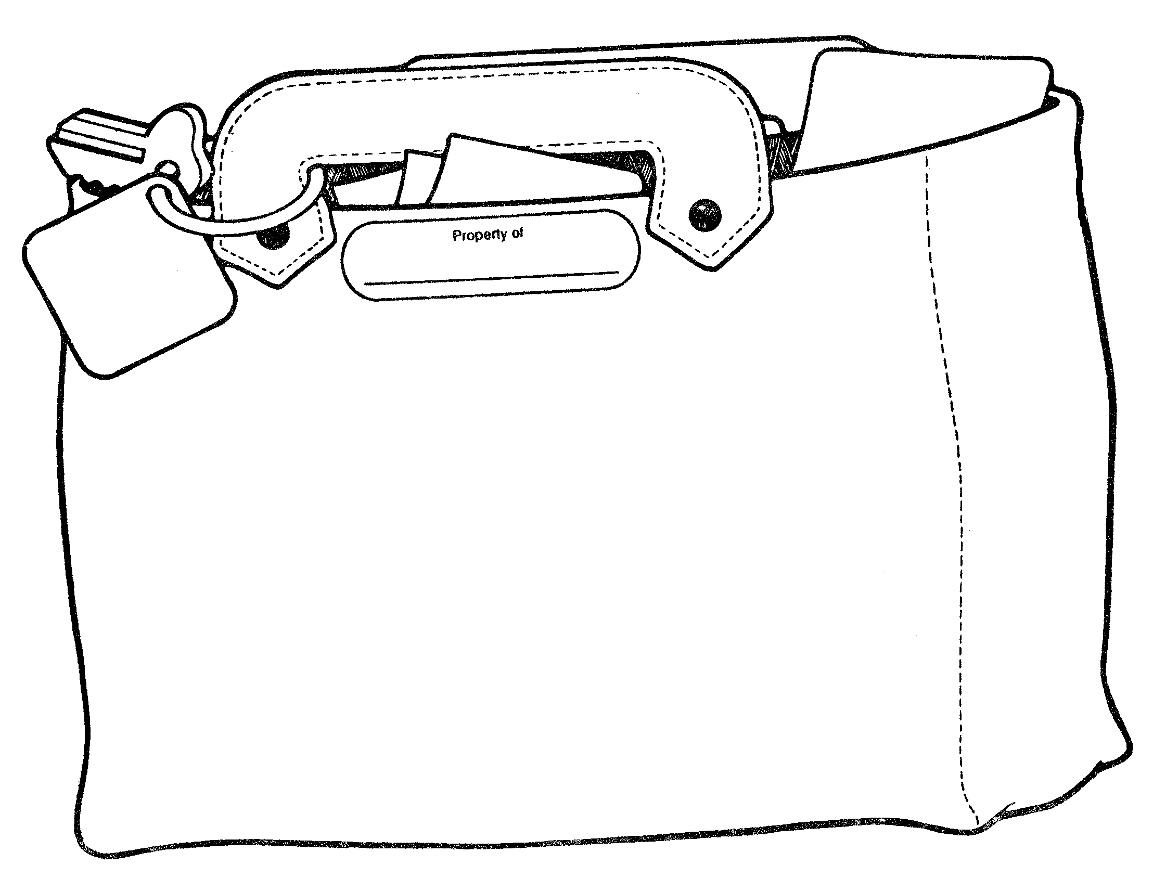
Directions: Draw the items necessary for your day hike experience.

Where Do We Camp?
What do you need to consider before you select
a campsite in a desert environment?
Summary: This lesson is designed to help students understand how to select an appropriate campsite in a desert environment.
Duration: 1 class period
Setting: Classroom
Vocabulary: durable surface, cryptobiotic soils
Standards/Benchmarks Addressed: SC1-E1, SC2-E1, SC2-E2, SC2-E3, SC4-E1, SC4-E5, SC6-E1, SC6-E2, SC6-E3, SC6-E4, SC6-E5, SC6-E6, SC6-E7, SC11-E6, SC11-E10, SC12-E2, SC14-E2, SC14-E3, SC15-E2, SC16-E1, SC16-E2

Objectives
Students will:
- determine the best location for a campsite.
- apply Low Impact Techniques to campsite selection decisions.
Background
Those who are concerned with protecting the environment often use the words conservation and preservation. Although these two terms are often confused and are used to mean the same thing, differences exist.
Conservation is the sustainable use and management of natural resources including wildlife, water, air, and earth deposits. Natural resources may be renewable or non-renewable. The conservation of renewable resources like trees involves ensuring that they are not consumed faster than they can be replaced. The conservation of non-renewable resources like fossil fuels involves ensuring that sufficient quantities are maintained for future generations to utilize. Conservation of natural resources usually focuses on the needs and interests of human beings, for example the biological, economic, cultural, and recreational values such resources have. Conservationists accept that development is necessary for a better future, but only when the changes take place in ways that are not wasteful.
Preservation, in contrast to conservation, attempts to maintain in their present condition areas of the Earth that are so far untouched by humans. This is due to the concern that mankind is encroaching onto the environment at such a rate that many untamed landscapes are being given over to farming, industry, housing, tourism, and other human developments, and that we are losing too much of what is “natural.” The mindset of preservationists can range from protection of nature for purely human-centered reasons to preservation regardless of their usefulness to humans. The latter follows the belief that every living thing has a right to exist and should be preserved.
Regardless of where you stand on your beliefs towards preservation, we cannot deny that plants, insects, animals, and humans owe their existence to one another. When one member of the web of life has been altered or eliminated, other living things are invariably affected.
People are an integral part of the Earth’s ecosystem and the health of ecosystems is intertwined with the viability of human communities. Like all living beings, people require the use of resources. From the air we breathe to our food, water, shelter, clothing, arts, and communication networks, we consume resources to live. Just try to imagine something in your home that is not grown or mined. We tend to forget the fact that natural resources usually support a country’s economy. Our goal in managing the ecosystem should be the wise and reasonably paced use of our resources to assure their availability far into the future. Individuals can take actions to make a difference.
Materials
A copy of the activity sheets
Adhesive colored dots
Procedure
Warm up: How many of you go camping? When you go camping do you pay close attention to the location of your campsite and its proximity to waterways, meadows, and trails? Do you notice what is on the ground around and under your tent?
Activity
- Hand out the activity sheets. Divide the class into groups of 3-4. Explain that each group is part of a larger group on a camping trip to a pristine desert wilderness. Before beginning the activity the group must decide on the total number of people camping in the group. Keep in mind that this wilderness allows no more than 10 campers per group.
- Distribute the tents (dots) to each group. Two people share a tent:
  - 10 campers = 5 tents.
- Have the students place their tents (dots) on the activity sheet in appropriate camping places.
- Review the background on Low Impact Techniques and discuss.
- Discuss the locations of each groups’ tent sites. Are they appropriate spots or not now that we have covered the Low Impact Techniques?
- Now have the students rearrange the tent locations if the discussion has caused them to change their mind. Students should explain the reasons for any changes.
- Summarize these key points for camping in a pristine area:
  - Choose a non-vegetated, highly resistant surface for tents and kitchens.
  - Choose durable routes of travel between parts of camp.
  - Avoid cryptobiotic soils.
  - Limit your stay to no more than two nights.
Wrap Up: Have students build a diorama of an appropriate desert campsite. They must include tents and kitchens set up in appropriate locations, a trail, a stream or river, and cryptobiotic soil. Students must also write the rationale behind their campsite location based on their diorama.
Assessment
Rubric for campsite and rationale
Where Do We Camp?
Desert Camp Diorama | Self Evaluation | Teacher Evaluation | Comments
Diorama criteria: |  | /24
Depicts a desert habitat.
Depicts tents and kitchens in appropriate locations.
Includes a stream or river and cryptobiotic soil.
Includes a visible trail.
Uses a variety of natural materials to depict the desert environment.
Includes a written rationale for the campsite location based on the diorama.
Presentation |  | /8
Presenter followed appropriate speaking rules (eye contact, voice, appeal, enthusiasm)
Presentation quality, organization, appeal, and information
Overall: |  | /4
Has the student fulfilled all the parts of the task?
4 no mistakes 3 few mistakes 2 many mistakes 1 incomplete (however is present) 0 not evident or not included

Percentages: Diorama Presentation Overall ______
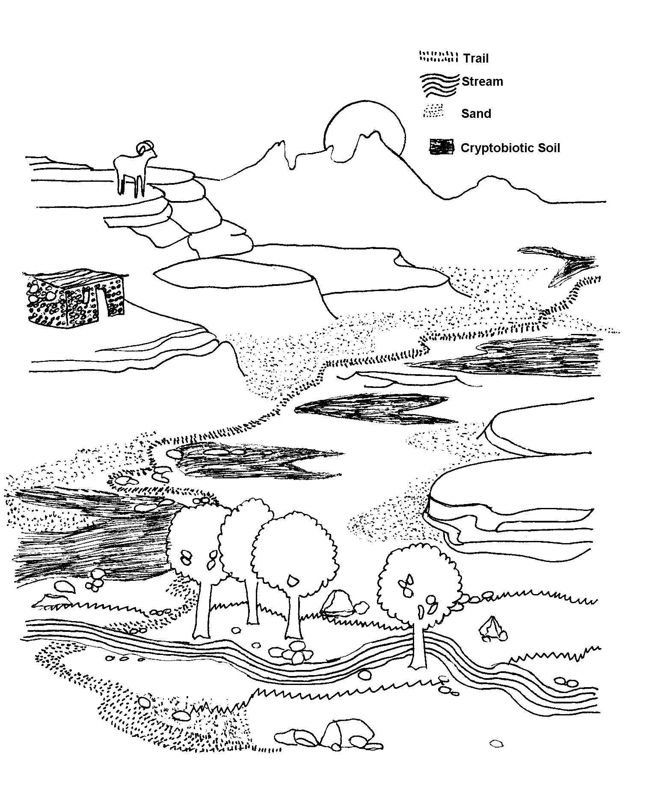
Where Do We Camp?
CONTENT STANDARDS WITH BENCHMARKS

Science

Unifying Concepts and Processes
CONTENT STANDARD 1:
Students will understand science concepts of order and organization.

SC1-E1
Students will apply information about the predictability and organization of the universe and its subsystems.

SC1-E2
Students will apply prediction to scientific problems and events.

CONTENT STANDARD 2:
Students will use evidence, models, and explanations to explore the physical world.

SC2-E1
Students will identify and organize evidence needed to predict changes in natural and artificial systems.

SC2-E2
Students will organize phenomena into hypotheses, models, laws, theories, principles, and paradigms.

SC2-E3
Students will design and develop models.

CONTENT STANDARD 3:
Students will use form and function to organize and understand the physical world.

SC3-E1
Students will explain function by referring to form and explain form by referring to function.

CONTENT STANDARD 4:
Students will understand the physical world through the concepts of change, equilibrium, and measurement.

SC4-E1
Students will illustrate that constancy and change are properties of objects and processes.

SC4-E2
Students will illustrate that energy and matter can be transformed and changed but the sum remains the same.

SC4-E3
Students will use elementary scientific devices to measure objects and simple phenomena.
SC4-E4
Students will employ mathematics to quantify properties of objects and phenomena.

SC4-E5
Students will relate the contributions of external and internal forces to change in the form and function of objects, organisms, and natural systems.

Science as Inquiry
CONTENT STANDARD 5:
Students will acquire the abilities to do scientific inquiry.

SC5-E1
Students will use the scientific method within the classroom and school environment.

SC5-E2
Students will employ equipment, tools, a variety of techniques, and information sources to gather, analyze, and interpret data.

SC5-E3
Students will explain that scientific theories emphasize evidence, have logically consistent arguments, and use scientific principles, models, and theories. Well-accepted scientific theories are formulations of apparent relationships or underlying principles of certain observed phenomena that have been verified to a very high degree.

CONTENT STANDARD 6:
Students will understand the process of scientific inquiry.

SC6-E1
Students will use different kinds of methods, including observation, experiments, and theoretical and mathematical models to answer a variety of scientific questions.

SC6-E2
Students will use their own understanding of science to guide their scientific investigations.

SC6-E3
Students will use criteria for sound scientific investigations to verify the truth of the results of their own and others’ investigations.

SC6-E4
Students will choose appropriate methods and analytic techniques for specific science problems and investigations.

SC6-E5
Students will use technology and scientific methods to gather evidence to enhance the accuracy of their findings.

SC6-E6
Students will describe the results of investigations with teachers, peers, parents, and others.

SC6-E7
Students will explain that scientific investigations can result in new ideas, objects, methods, techniques, and procedures for investigation.

SC6-E8
Students will explain that in areas where there is not a great deal of experimental or observational evidence, it is typical for scientists to differ with one another about the theory, hypothesis, or evidence being investigated.

Physical Science
CONTENT STANDARD 7:
Students will know and understand the properties of matter.

SC7-E1
Students will identify the characteristic properties of elements and compounds such as density, boiling point, and solubility.

SC7-E2
Students will explain that the characteristic properties of an element or compound are independent of the amount (size) of the sample.

SC7-E3
Students will discriminate between elements based on the characteristic ways in which they react with other elements to form compounds that are different substances with unique characteristic properties.

CONTENT STANDARD 8:
Students will know and understand the properties of fields, forces, and motion.

SC8-E1
Students will explain that when an object is not being subjected to a force, the object will continue to move at a constant speed and in a straight line.

SC8-E2
Students will describe quantitatively how an object’s position, speed, and direction explain motion.

SC8-E3
Students will compare and contrast gravity to other forces in the world and universe.

CONTENT STANDARD 9:
Students will know and understand the concepts of energy and the transformation of energy.

SC9-E1
Students will apply knowledge about energy and energy transformation to science problems.

SC9-E2
Students will explain how chemical reactions can take place in time periods ranging from less than a second to millions of years.

SC9-E3
Students will explain how chemical reactions involve concentration, pressure, temperature, and catalysts.

Life Science
CONTENT STANDARD 10:
Students will know and understand the characteristics that are the basis for classifying organisms.

SC10-E1
Students will use information about living things including:
- The roles of structure and function as complementary in the organization of living systems.
- Cells as the fundamental unit of life.
- The functions of cells which sustain life.
- Cell division.
- The use of nutrients by cells.
- The role of heredity and environment in the characteristics of individual organisms.
- That small genetic differences between offspring and parents may accumulate in succeeding generations and may or may not be advantageous for the species.
- Disease as a breakdown in the structures or function of an organism.

SC10-E2
Students will categorize organisms according to reproductive and other characteristics.

CONTENT STANDARD 11:
Students will know and understand the synergy among organisms and the environments of organisms.

SC11-E1
Students will distinguish among organisms based on the way an organism regulates its internal environment in relation to changes in its external environment.

SC11-E2
Students will describe how organisms obtain and use resources, grow, reproduce, and maintain a stable internal environment while living in a constantly changing external environment.

SC11-E3
Students will predict behavior in relation to changes in an organism’s internal and external environments.

SC11-E4
Students will use knowledge of population characteristics to distinguish specific populations.

SC11-E5
Students will categorize organisms based on the function they serve within their ecosystem.

SC11-E6
Students will examine the impact humans have had on other species and natural systems over time.

SC11-E7
Students will illustrate the impact that overpopulation might have on various regions of the world.

SC11-E8
Students will analyze consumption of nonrenewable resources based on population factors (birth rate, death rate, and density).

SC11-E9
Students will illustrate the role of personal control of basic needs on health outcomes.

SC11-E10
Students will model responsible health behaviors for peers and others.

SC11-E11
Students will demonstrate the impact of nutrition and exercise on personal health.

Earth and Space Science
CONTENT STANDARD 12:
Students will know and understand properties of earth science.

SC12-E1
Students will explain how Earth’s materials can be transformed from one state to another.

SC12-E2
Students will experiment with the uses of Earth’s materials as resources.

SC12-E3
Students will model natural processes that shape the Earth’s surface.

SC12-E4
Students will observe, measure, and record weather changes that occur daily.

SC12-E5
Students will explain how fossils are formed and how fossils provide evidence of the complexity and diversity of life over time.

SC12-E6
Students will use a rectilinear coordinate system such as latitude and longitude to locate points on the surface of Earth.

SC12-E7
Students will describe the interaction between the Earth’s lithosphere, hydrosphere, atmosphere, and biosphere.

CONTENT STANDARD 13:
Students will know and understand basic concepts of cosmology.

SC13-E1
Students will model the predictable patterns of the sun and planets in the solar system.

SC13-E2
Students will describe the elements of the universe including stars, galaxies, dust clouds, and nebulae.

SC13-E3
Students will explain various scientific theories for the origin of the universe.

SC13-E4
Students will explain how instruments and vehicles are used for space exploration work.

Technology and the History of Science
CONTENT STANDARD 14:
Students will know and understand the differences between the interactions of science and technology.

SC14-E1
Students will design and conduct experiments that distinguish between natural and artificial objects and materials.

SC14-E2
Students will demonstrate trade-offs in safety, cost, efficiency, and appearance related to technological solutions provided through science.

SC14-E3
Students will compare and contrast a variety of scientific and technological solutions to problems.

SC14-E4
Students will examine the role of technology, particularly computers and other electronic advances, in the advancement of science.

CONTENT STANDARD 15:
Students will know and understand the impact between science and technology in society.

SC15-E1
Students will illustrate the impact that work settings have on scientific investigations.

SC15-E2
Students will demonstrate how the direction for scientific investigations is related to social issues and challenges.

SC15-E3
Students will explain how the benefits of science and technology are enjoyed by some groups and not by other groups.

SC15-E4
Students will compare and contrast the science contributions of people with diverse interests, talents, qualities, and motivations from a variety of social and ethnic backgrounds.

SC15-E5
Students will predict new areas of scientific inquiry based on previous research.

SC15-E6
Students will analyze the impact of culture, gender, and other factors on an individual’s choice of science as a career.

SC15-E7
Students will differentiate between ethical and unethical scientific practices and research.

Science in Personal, Social and Environmental Perspectives
CONTENT STANDARD 16:
Students will know and understand the relationship between natural hazards and environmental risks for organisms.

SC16-E1
Students will analyze environmental risks for personal and social costs.

SC16-E2
Students will determine options for reducing and eliminating environmental risks and for coping with natural catastrophic events.

SC16-E3
Students will predict the human and financial costs of slow natural events such as drought and rapid natural events such as earthquakes.

SC16-E4
Students will develop models for prevention of substance abuse including tobacco, alcohol, and other drugs, and to reduce the associated environmental risks.
Ecology Glossary

A

Abiotic factors are non-living parts of an ecosystem.

Adaptation a behavior, physical feature, or other characteristic that helps an animal survive and make the most of its habitat; the way any living thing is fitted to the life it leads.

Algal bloom is a consequence of eutrophication. Masses of blue-green algae choke the life out of a lake or river by depriving it of much needed oxygen. Under extreme conditions this can leave the water completely devoid of fish.

Alluvial fan a fan-shaped deposit of gravel, sand, and silt that forms where a stream flows into a plain and slows down, dropping its load.

Aquifer rock layers that contain water and will release its appreciable quantities into wells or springs.

Arch an alcove formed from erosion perched at the edge of a slick-rocked bowl.

Arid dry.

Arroyo a deep gully cut by an intermittent stream.

B

Biological parameters refers to organisms supported in the water such as bacteria, plankton, and fish.

Biome an area that has a certain kind of climate and a certain kind of community of plants and animals.
Biotic factors the living parts of an ecosystem.

Burrow a hole or tunnel dug in the ground by an animal for habitat or refuge.

Butte a hill that rises abruptly from the surrounding area; it has sloping sides and a flat top.

C

Canyon a narrow chasm with steep cliff sides.

Carnivores secondary or higher consumer in a food chain that therefore eats other animals.

Chemical parameters refer to the chemical make-up of the water such as the amount of dissolved oxygen, phosphate, and nitrate.

Clay soil contains fine particles, and is heavy, cool, and damp.

Columns are left after an arch changes or falls, leaving a layer of more resistant rock caps.

Combustion a chemical change accompanied by heat and light.

Community a group of plants and animals that lives in the same habitat.

Commensalism an interaction between two living things where one species benefits from the relationship and the other is not affected.

Community all populations in a given area.

Competition an interaction among living things where two populations compete for the same resources and territory.

Conservation a scientific discipline that seeks to understand the effects of human activities on species, communities, and ecosystems and to develop practical approaches to preventing the extinction of species and the destruction of ecosystems.

Consumer animals that cannot make their own food, but must eat plants and/or other animals.

Cryptobiotic soils a living soil crust dominated by cyanobacteria, soil lichens, mosses, green algae, microfungi, and bacteria, the knobby black crusts are extraordinarily well-developed, and may represents 70 to 80 percent of the living ground cover. These crusts play an important role in the ecosystems in which they occur. They are found in the Colorado Plateau (Utah, Arizona, Colorado and New Mexico).

Cultural eutrophication is water pollution caused by excessive plant nutrients.

D

Decomposer organisms that feed on the dead bodies of other organisms, breaking them down into simpler substances.

Deforestation to clear away all the trees.

Dehydrated to remove or lose water.

Dendrochronology the method of dating events and conditions based on the number, width, and density of growth rings in old trees.

Deposition is a natural process occurring when materials are carried from one place and deposited in another by such forces as wind, water, and ice.

Desert an area that receives less than 10 inches of rainfall a year and has a very high rate of evaporation.

Desert varnish is a dark coating on rocks found in arid regions. The coating is composed predominantly of fine-grained minerals. Desert varnish is formed by colonies of microscopic bacteria living on the rock surface for thousands of years.

Detritivores an organism that feeds on large bits of dead and/or decaying organic matter. Decomposers use what detritivores leave behind.

Drought a long period of low rainfall.

Dune a ridge or hill of wind-blown sand.

Durable surface rock, sand, and gravel; these surfaces are highly durable and can tolerate repeated trampling and scuffing.

E

Ecology the study of how plants and animals interact with each other and their environments.

Ecosystem all the living organisms in a given area as well as their physical environment—usually made up of many complex interactions.

Environment the sum of all the surroundings affecting something’s development and survival.

Erosion wearing away the land by physical methods such as rubbing and scraping, and carrying away the eroded materials, such as rock particles.

Eutrophication is the process by which lakes gradually age and become less productive.

Evaporation when a liquid turns into vapor or gas.

F

Fire a rapid persistent chemical change that releases heat and light and is accompanied by flames.

Flash flood when water run off overflows the bank of rivers and streams, caused usually by heavy rainfall in a small area.

Forest a large area thickly covered with trees and plants.

Fuel something consumed to produce energy.

G

Grassland a large open area of grass, such as a meadow or prairie.

Groundwater water that fills the spaces between rocks and soil particles underground.

H

Habitat the place where an organism lives.

Hardpans a layer of hard subsoil or clay; caliche.

Herbivores an animal that feeds chiefly on plants.

Humidity the amount of moisture in the air.

K

Karst a type of topography that is formed in limestone, gypsum, and other soluble rocks primarily by dissolution; are characterized by sinkholes, caves, and underground drainage.

L

Leaching the process by which materials on or in soil are dissolved and carried by water seeping through the soil.

Limiting factors are those factors that particularly determine whether an organism lives in an area.

Limnology the study of inland fresh water systems.
Loam contains sand and clay.

M

Mesa a flat-topped elevation with steep sides.

Microhabitat a small area where an organism lives that has different conditions from another small area that might be right next door.

Mutualism an interaction among living things where both species benefit from the relationship.

N

Niche an organism’s way of life, also considered to be an organism’s occupation.

Nonpoint pollution pollution that doesn’t come from a single, identifiable source; includes materials that wash off streets, lawns, farms, and other surfaces.

O

Ocean the body of salt water that covers much of the Earth’s surface.

Overcrowding when too many organisms try to live in one area at one time and use up all the natural resources.

Oxidation is the chemical reaction by which oxygen combines chemically with the elements of a burning substance.

P

pH a measure of the acidity or alkalinity of a solution.

Parasitism an interaction among living things where one species benefits at the expense of another.

Peat soil contains decayed plants and dead plant material.

Photosynthesis the process of using the sun’s energy to turn carbon dioxide and water into sugar.

Physical parameters are conditions that refer to water temperature, stream velocity, and turbidity (clarity).

Playa a flat area at the bottom of a desert basin, sometimes temporarily covered with water.

Point pollution pollution that comes from a particular source, such as from a factory or sewage treatment plant.

Pollinate to fertilize by transferring pollen from an anther to the stigma.

Pollution human-caused change in the physical, chemical, or biological conditions of the environment that creates an undesirable effect on living things.

Population all the species that live in an area and make up a breeding group.

Precipitation water reaching the surface of the Earth (rain, sleet, snow, frost, and dew).

Predation an interaction where one species consumes another.

Predator an organism that feeds off of other organisms.

Prescribed fire the controlled application of fire to wildland fuels in either a natural or modified state, under specified environmental conditions which allow the fire to be confined to a predetermined area and at the same time produce the intensity required to attain planned resource management objectives.

Prescription is a written document detailing all site-specific information needed for a crew leader to successfully carry out a prescribed burn. It should include weather elements involved, fire behavior, smoke management, amount and type of fuel in the area, location of natural and manmade fire barriers, degree of risk and hazards present, burning technique and intensity of fire to be used, burning objectives for the particular area, restrictive measures dictated by law or local custom, fire suppression safety, location of any improvements which could be endangered, areas within the prescribed unit that may need to be excluded from fire.

Prey an organism that is consumed by another organism.

Primary consumers see herbivore.

Primary producers an organism that makes its own food through photosynthesis.

Producer organisms such as plants that make their own food.

R

Rainforest a dense, tropical forest where a lot of rain falls.

Rain shadow rain falls on the sides of mountains that face a water source rather than on the sheltered sides of mountains, creating a desert.

S

Sandy soil contains mostly sand.

Scavengers an animal that feeds on dead or decaying matter.

Secondary consumers see carnivore.

Sediment finely divided solid material that settles to the bottom of a liquid.

Soil the top layer of the Earth’s surface, suitable for the growth of plant life.

Soil compaction is the process of increasing the density of soil by packing the particles closer together causing a reduction in the volume of air.
Stewardship the position, duties, or service of steward. In the National Park setting, stewards are people who help to preserve and conserve the National Park for future generations.

Stony soil contains many rocks.

Succession – the act of following in order.

T

Taiga the artic evergreen forest.

Tertiary consumers see scavengers.

Thermodynamics the relationship between heat and other forms of energy.

Tundra a cold area where there are no trees and the soil under the surface of the ground is permanently frozen.

U

Uncontrolled hunting unregulated hunting that reduces animal populations to a minimum.

W

Wadi a valley, gully, or riverbed that remains dry except during the rainy season.

Water cycle series of movements of water on and below the Earth’s surface; includes storage, evaporation, precipitation and runoff.

Water infiltration rate rate of absorption and downward movement of water into the soil layer.

Weathering a process by which rocks exposed to the weather break down.

Wildfire an uncontrolled, rapidly spreading fire.

Ecology Resources
Amazing Environmental Organization. Retrieved August 6, 2002, http://www.webdirectory.com/

American Water Resources Association. Retrieved July 25, 2002, http://www.awra.org/jawra/papers/J90126.htm

Berkeley’s The Worlds Biome. Retrieved July 15, 2002, http://www.ucmp.berkeley.edu/glossary/gloss5/biome/index.html

Biome Basics. Retrieved July 14, 2002, http://oncampus.richmond.edu/academics/as/education/projects/webunits/biomes/biomes.html

Biomes and Soils. Retrieved July 14, 2002, http://www.tesarta.com/www/resources/library/biomes.html

Biomes of the World. Retrieved July 14, 2002, http://mbgnet.mobot.org/sets/index.htm

Biomes on the Net. Retrieved July 14, 2002, http://www.d300.kane.k12.il.us/SchoolSites/dms/Biomes/Biomes.html

Bowers, J.E., (1989). 100 Desert Wildflowers of the Southwest. Tucson: Southwest Parks and Monuments Association.

Braus, J., (1989). Ranger Rick’s Nature Scope: Trees are Terrific. Washington DC: National Wildlife Federation.

Characteristics of Different Soil Types. Retrieved July 23, 2002, http://homepages.which.net/~fred.moor/soil/formed/f0108.htm

Comparing Tree Rings. Retrieved July 27, 2002, http://www.bsu.edu/teachers/burris/iwonder/realities/activities/ctr.html

Cunningham, R.L., (1990). 50 Common Birds of the Southwest. Tucson: Southwest Parks and Monuments Association.

Cyberzoo: What is a Biome. Retrieved July 14, 2002, http://lsb.syr.edu/projects/cyberzoo/biome.html

Desert Living Tips. Retrieved July 6, 2002, http://www.azrelocate.com/desliv.htm

EarthPulse. Retrieved July 20, 2002, http://www.nationalgeographic.com/earthpulse/

Ecosystems, Biomes, and Watersheds. Retrieved July 15, 2002, http://cnie.org/NLE/CRSreports/Biodiversity/biodv-6.cfm

Encyclopedia Britannica. Retrieved July 12, 2002, http://www.britannica.com

EPA Office of Water. Retrieved July 20, 2002, http://www.epa.gov/owow/monitoring/nationswaters/groundwater.html

Fire Initiative. Retrieved July 27, 2002, http://www.tncfire.org/

Fischer, P.C., (1989). 70 Common Cacti of the Southwest. Tucson: Southwest Parks and Monuments Association.

Gander Academy’s Cave Theme Page. Retrieved July 20, 2002, http://www.stemnet.nf.ca/CITE/cave.htm

Geography4Kids.com. Retrieved August 5, 2002, http://www.geography4kids.com/misc/soil.html

Grolier’s Biomes of The World. Retrieved July 14, 2002, http://biomes.grolier.com/biomes/pg02.html

Ground Water Pollution: A Potential Threat. Retrieved July 25, 2002, http://www.epa.gov.tw/student/caring/ground.htm

Ground Water: The Hidden Resource. Retrieved July 25, 2002, http://edis.ifas.ufl.edu/scripts/htmlgen.exe?DOCUMENT_SS112

Groundwater Biology Home Page. Retrieved July 18, 2002, http://www.geocities.com/~mediaq/index1.html

Identification of Soil Compaction and its Limitations. Retrieved July 23, 2002, http://www.ianr.unl.edu/pubs/soil/g831.htm

Jagnow, D.H., Jagnow, R.R., (1992). Stories From Stones: The Geology of the Guadalupe Mountains. Carlsbad Caverns Guadalupe Mountain Association.

Lambert, D. (1988). The Field Guide to Geology. New York: Facts on File Inc.

Low Impact Camping. Retrieved July 20, 2002, http://www.enn.com/features/2000/04/04182000/quiz_12_low_impact_camping_12043.asp

Lycos Zone: Major Biomes of the World. Retrieved July 14, 2002, http://kids.infoplease.lycos.com/ipka/A0769052.html

Minimal Impact Ethics for Wilderness Use. Retrieved July 20, 2002, http://www.sgwa.org/impact.htm

Murphy, D., (1984). The Guadalupes: Guadalupe Mountain National Park. Paragon Press Inc.Olin, G. (2000). 50 Common Mammals of the Southwest. Tucson: Southwest Parks and Monuments Association.

Prescribed Burns Should We Do It?. Retrieved July 27, 2002, http://r05s001.pswfs.gov/stanislaus/fire/burning.htm. Radford’s Introduction to Biomes. Retrieved July 15, 2002, http://www.runet.edu/~swoodwar/CLASSES/GEOG235/biomes/intro.html

Soil Compaction. Retrieved July 23, 2002, http://www.gov.on.ca/OMAFRA/english/crops/facts/88-082.htm
Soil Compaction: Causes and Consequences. Retrieved July 23, 2002, http://www.extension.umn.edu/distribution/cropsystems/components/3115s01.html

Soil Types and Testing. Retrieved July 23, 2002, http://www.smartgardening.com/Soil_Characteristics_and_Testing.htm

Sources of Water Pollution. Retrieved July 25, 2002, http://www.intac.com/~mystic/pages/multsources.html

The Aquatic Blue Yonder. Retrieved July 14, 2002, http://www.ucmp.berkeley.edu/glossary/gloss5/biome/aquatic.html

The Science of Dendrochronology Web Pages. Retrieved July 27, 2002, http://web.utk.edu/~grissino/

The World’s Biomes. Retrieved July 14, 2002, http://www.ucmp.berkeley.edu/glossary/gloss5/biome/

Tread Lightly. Retrieved July 20, 2002, http://www.treadlightly.org/

Tree Rings List of Links. Retrieved July 27, 2002, http://homepages.kcbbs.gen.nz/af/cys_tree.htm

University of Puget Sound: Biomes of the World. Retrieved July 15, 2002, http://www.ups.edu/biology/museum/worldbiomes.html

US Environmental Protection Agency. Retrieved August 10, 2002, http://www.epa.gov/ow/

Wendy’s Conservation Home Page. Retrieved July 20, 2002, http://www.geocities.com/RainForest/6243/index.html

West, S. (2000). Northern Chihuahuan Desert Wildflowers. Helena, MT: Falcon Publishing Inc.

World Wide Fund for Nature-WWF: Virtual Wildlife Wild Place. Retrieved July 15, 2002, http://www.panda.org/kids/wildlife/idxregmn.htm

